Material for attendees of the Gas Energy Supply companies to accompany a talk given
by
Stephanie Trotter, OBE, President & Director CO-Gas Safety 18.12.15
INDEX TO HANDOUT
All about carbon monoxide (CO) and how testing is difficult…………………………..2-3
Research showing how prevalent CO poisoning is………………………………………4-5
Energy UK’s research and campaign about CO 2015-16………………………………..6-7
CO-Gas Safety comments on Energy UK’s research & campaign…………………….7
How Stephanie Trotter became interested in safety and New Law Journal article...8-10
How and why CO-Gas Safety was launched………………………………………………10
Mirror article about Sue Westwood-Ruttledge CO victim June 2015………………...11-16
Flyer for our CO-Awareness competition for primary school children………………17
Index to yellow booklet combining the experience of Consumer Safety
International (CSI) and CO-Gas Safety in 2000…………………………………………...18
Lindy Maher’s account of the tragedy in Tenerife……………………………………….19-20
Holidays: risks of the trade Times article 1999 by Stephanie Trotter ………………21-22
Articles about the Corfu tragedy and poor handling by Thomas Cook……………..23-25
Press pack cover CO-Gas Safety 2006
showing some children who have died of CO………………………………………….......26
with the charities running the first ever CO Awareness week in
chronological order of their founding ……………..………………………………………...27
Stephanie Trotter’s one page CV……………………………………………………………,,,28

What is carbon monoxide (CO), where does it come from and why is it so lethal?
CO may be emitted from any faulty cooking or heating appliance powered by any fuel that burns (gas, coal, oil, wood etc.). If there is sufficient air at the flame, carbon dioxide (CO2) is produced, not CO. CO2 is a greenhouse gas but CO is lethal because less than 2% can kill in between one and three minutes (see page 26 Table 23 at http://www.hse.gov.uk/foi/internalops/hid_circs/technical_osd/spc_tech_osd_30/spctecosd30.pdf
CO is lethal because the haemoglobin in the blood takes up CO in preference to oxygen. (Please note that whereas CO2 has two molecules of oxygen to one of carbon, CO has only one molecule of oxygen to one of carbon.)
Human senses cannot pick up CO, which is another reason it is so dangerous. Sometimes other products of combustion also escape, which do smell but not necessarily. People can describe this as a ‘gassy’ smell. Concerned consumers ring the gas emergency number.
The Gas Emergency Service
The Gas Emergency Service (provided by the Gas Distribution Network – GDNs) tell the consumer to turn everything off and open the windows so by the time the First Call Operation (FCO) arrives the CO may have dispersed unless it was coming from next door or from an unsuspected appliance, e.g. a wood burner. The GDN then visit and if necessary, turn the appliance or the gas off in that property. Thankfully the FCOs do have Personal Alarm Monitors or PAMs or Gasco seekers which can also pick up CO so the employees are protected. However, this doesn’t protect the consumer because the appliances are off and windows open generally when the FCO is present and there is no testing of gas appliances by the gas emergency service.

Recommendations by HSC in 2000
In 2000, the Health and Safety Commission (now Executive) recommended that the GDN has and uses equipment to test appliances for CO but Government has failed to implement this excellent HSC recommendation.
In 2000, the Health & Safety Commission (now Executive) also recommended a levy on the gas suppliers (we would prefer the whole fuel industry) to pay for publicity about the dangers of CO and for research.
Again this excellent HSC recommendation has not been implemented.
Testing for CO – why this can be misleading
CO dissipates in a live body very quickly so a person needs to seek an urgent blood or breath test. If this is negative, it is not wise to assume that your home or workplace or car etc. is safe from CO and this is why tests of appliances and air in a house are urgently needed to ensure safety. Please note that CO can be emitted from next door (e.g. through a joint chimney or roof space) or another flat. Dominic Rodgers, aged 10 died from CO from next door in 2004. In 2007, Esmy Ighodalo aged 27 died from CO emitted from a mains gas central heating boiler in another flat.

Investigations can be undertaken by CORGI Services but cost at least £1,800-£3000. If CO is suspected and if a legal action is contemplated, it is vital that this investigation is undertaken before any suspected appliances are worked on (other than to turn them off). Working on an appliance will change the evidence. Landlords and installers are well aware of this and often undertake work very quickly thereby destroying evidence. This contributes to an illusion that CO is rare when it’s quite common.
Please note that in our considerable experience most Gas Safe Registered installers will not undertake this test (indeed they will change the appliance and evidence instead) and provide the parts per million of CO to the person affected. Without this, GPs don’t take CO seriously.
CMDDA1 and the difficulty in finding someone qualified to test gas appliances for CO. There are now at least 1,000 people qualified under CMDDA1 who are qualified to test gas appliances for CO and record CO found in writing. The problem is that people do not know what to ask for. Also at the time of writing (December 2015) the only way to find someone qualified under CMDDA1 is to undertake an advanced search on the Gas Safe Register. You then put in your post code and find a firm offering ‘fumes investigation’. You then need to contact the firm and ask if they have an employee qualified under CMDDA1 and ask how much this will cost (from around £88 to £550 in our limited experience).
Please note that such a test by someone qualified under CMDDA1 is not good enough for a court case but can be a useful filter or for a first test & to obtain correct medical treatment.
In effect this has hidden the number of CO incidents. There is no automatic testing of dead bodies for CO even in cases of unexplained death. The Gas Safety Trust is undertaking tests of all dead bodies for CO in three Coronial areas. In the future data loggers (costing about £75) could be used and new technology is being invented all the time. Also more research is being undertaken (see https://uk.news.yahoo.com/breathe-easy-atmotube-pocket-sized-200859611.html# and http://atmotube.com/. The time for denial is rapidly ending.
In our opinion the fuel industry should learn from the Corfu case that bad publicity can be extremely damaging to profit and reputation.
CO-Gas Safety has been lobbying for prime time TV warnings since 1995 also for properly funded data and victim support and for the gas emergency service to carry & use equipment to test gas appliances for CO.
CO-Gas Safety asks the representatives of the gas suppliers to read this material, our leaflet, our press pack and the reports of the Corfu tragedy. We also ask that they take these vital safety issues back to their directors and send a memo in writing to them, if only to cover their own backs. Action is needed & for proper action to happen there needs to be funding.
The GDNs have been helping for some years but in our opinion the gas suppliers have done the absolute minimum both morally and in terms of funding.
Gas safety and CO is a problem throughout the world. See the investigation by the Dutch Safety Board in November 2015 http://www.onderzoeksraad.nl/uploads/phase-docs/1080/ffe8e9293c28summary-koolmonoxide-en.pdf
You Tube film https://www.youtube.com/watch?v=EgL74t_COV0

Surely gas safety and carbon monoxide are actually a huge opportunity to export best practice?

EMBARGOED UNTIL 00.01 MONDAY 2 OCTOBER

E096:06 2 October 2006

LORD HUNT CALLS FOR renewed ACTION ON GAS SAFETY

At a gas safety stakeholder forum today, Monday 2 October, hosted by the Health and Safety Executive (HSE), Lord Hunt of Kings Heath will make clear that complacency on gas related carbon monoxide (CO) poisoning is not an option.
Research commissioned from University College London by HSE to inform its gas safety review highlights the dangers of CO poisoning in people’s homes, coupled with a lack of public awareness of the risks.

The early findings of the research include:
  - 23% of homes had one or more defective gas appliance;
  - 8% of homes were judged to be at risk of dangerous levels of CO;
  - 45% of homes had received no information on the dangers of CO; and
  - A higher prevalence of problem appliances was found in the homes of vulnerable people (young, old, those in receipt of benefits).

Opening the forum, Lord Hunt will call on the 100 plus delegates to do what is necessary to raise awareness. He will say:

‘The early findings of this research show there is no room for complacency. It is simply not right for the current situation to continue. It is critical that people are made more aware of the risks of CO poisoning and how to avoid the dangers.

‘It is essential that this lack of awareness is addressed. I call on gas safety stakeholders to work with HSE in this gas safety review to come up with a set a proposals that will put in place a modern and effective gas safety regime.’

Very recent research by Smart Compliance

Smart Compliance has developed and patented a carbon monoxide monitor which is able to communicate remotely via SMS, reporting on its status and alerting landlords to carbon monoxide incidents, tampering, or power outages. The potential benefits for public safety, and for the saving of public money across the UK’s social housing stock, are hugely valuable.

Current carbon monoxide monitoring in the social housing sector is subject to regional variations but the basic approach is the same, requiring monitors to have physical compliance checks to ensure they are working properly and haven’t been tampered with.
“Our device is able to change the way landlords, especially those responsible for large numbers of tenants, achieve their targets for carbon monoxide monitoring, said Director Billy Mitchell. “The Smart Compliance unit reports to a central database and securely forwards all necessary information wherever the data is required – even to a smart phone held by a maintenance team or building manager.

“The efficiency with which this system makes it possible to provide greater tenant safety, and unarguable compliance with current and likely future regulation, is ground-breaking. Furthermore, the reduction in man-hours currently devoted to checking traditional monitors, and in the very high cost of call outs to false alarms, will make this modern, high-tech system highly appealing to forward-thinking landlords across the housing spectrum, and to local authority and social housing finance directors.”

The Smart Compliance system is currently being sponsored by the Energy Innovation Centre in a series of pilots involving social landlords around the UK.

“Even within the limit scale of our current pilot schemes, we have potentially saved two lives within the last 4 months. One only has to calculate what the statistics would be if the system was to be rolled out over tens or hundreds of thousands of homes to see just how valuable remote monitoring can be.

In terms of constant low levels of CO within homes our projects have discovered that out of 143 homes , 19 have a constant low level between 10-49 ppm (13.9%) and another has 188 properties with 17 having constant low levels of 10-49ppm (9%)averaged over a week. (www.smart-compliance.co.uk billy@smart-compliance.co.uk )

Carbon Monoxide Be Alarmed!
Too many people in the UK die needlessly or become seriously ill because of carbon monoxide poisoning. According to the Department of Health, 50 people die each year from carbon monoxide poisoning and another 4,000 are treated in hospital. However, the true number is likely to be much higher as the early symptoms can easily be mistaken for flu or tiredness.
Carbon Monoxide – Be Alarmed! is a national campaign that aims to cut the number of deaths and injuries caused by carbon monoxide. Since 2008, the campaign has encouraged people to install and maintain audible carbon monoxide alarms in their homes.
The Carbon Monoxide – Be Alarmed! campaign is run by Energy UK on behalf of British Gas, EDF Energy, E.ON, npower, ScottishPower and SSE, in partnership with the Dominic Rodgers Trust. It is supported by a wide range of charities and other organisations.
Carbon monoxide poisoning can affect people’s mental ability before they are aware that there is a problem. Any effort that increases the body’s need for oxygen only makes the problem worse, rapidly leading to collapse and potentially death.
The six main symptoms of carbon monoxide poisoning are:
- Headaches
- Dizziness
- Nausea
- Breathlessness
- Collapse
- Loss of consciousness
Summer festival campaign 2015
Carbon Monoxide Be Alarmed launched its 2015 summer campaign with a festival toolkit targeting festivals across the country. The toolkit has been adapted for each festival.
Carbon monoxide (CO) is produced from various activities that take place at festivals; BBQs, bonfires, shisha pipes and gas cookers or heaters - so ensuring festival goers are aware of CO dangers is vital. Our toolkit provides media with all the information needed to protect festival fans from carbon monoxide poisoning including press releases, content for their website and suggested tweets.
Our campaign has also conducted research suggesting that 82 per cent of music festival fans were unaware of the dangers of carbon monoxide (CO) poisoning.
Carbon Monoxide launch winter 2015-2016
Carbon Monoxide Be Alarmed! launched its winter campaign on 29 October 2015 with Nadine Coyle, ex Girls Aloud star and a victim of carbon monoxide poisoning. Nadine was live on Good Morning Britain talking about her personal experience with carbon monoxide poisoning and urging people to buy a CO alarm. Our campaign launch has been a great success, it has been widely covered in print, broadcast and online media. Leigh Greenham, director of CoGDEM, has also contributed to the campaign being interviewed alongside Nadine.
Research carried out for the campaign this year has found that:

- 30 million people living in the UK are currently at risk from carbon monoxide poisoning.
- Nearly half of all people living in the UK fail to have their boiler checked annually.
- 70% of people did not know their CO alarms had an expiration date.

CO Be Alarmed! supported this year’s Carbon Monoxide Awareness Week with a national press release, social media activity and an alarm giveaway. The campaign activity will continue in 2016 with a Parliamentary Reception, more CO alarms giveaways and a summer festival campaign.
www.co-bealarmed.co.uk
@COBeAlarmed
press@energy-uk.org.uk
……………………………………………………………………………………………………………
COMMENTS BY CO-GAS SAFETY ON ENERGY UK’S RESEARCH AND CAMPAIGN

CO-Gas Safety welcomes the research and the campaign outlined above.
Energy UK’s findings were that:-

.
- 30 million people living in the UK are currently at risk from carbon monoxide poisoning.
- Nearly half of all people living in the UK fail to have their boiler checked annually
- 70% of people did not know their CO alarms had an expiration date.

CO-Gas Safety argues that these findings alone are compelling evidence for the need for prime time TV warnings plus action on many other problems that we have pointed out in the past and in this material.

.

How Stephanie Trotter first became interested and involved in safety issues
Stephanie’s son was injured on a children’s activity holiday in 1991. Soon after 4 teenagers drowned in Lyme Bay while on an activity holiday. Stephanie wrote the following article published in the NLJ.

NEW LAW JOURNAL
144 NLJ 454
01 April 1994
Activity holidays and the law
Stephanie Trotter
Stephanie Trotter is a barrister
COPYRIGHT (c) 1994 BUTTERWORTH & CO (PUBLISHERS) LTD

On March 22 last year, eight teenagers launched their canoes and set off from the St Albans centre in Lyme Regis to paddle to Charmouth two miles away. The group was swept out to sea and some hours later two girls, Claire Langley and Rachel Walker, and two boys, Simon Dunne and Dean Sayer, were dead from hypothermia.
Joseph Stoddard, manager of the St Albans centre, and Peter Bayliss Kite, director of Active
Learning and Leisure (which operated out of the centre), and Active Learning and Leisure Limited have been charged with manslaughter and committed for trial to Winchester Crown Court.

This incident attracted a great deal of media attention but it is the continued effort of the four sets of canoe parents and their Member of Parliament, David Jamieson, which has sustained a campaign to persuade the Government to regulate, inspect and licence children's activity centres .

There have been other fatalities. In 1991, Hayley Hadfield, aged 11 and away from home for the first time, was taken on a night hike by an unqualified instructor. She was told to take a short cut down a steep wooded slope. Hayley hesitated but was threatened with being left behind. She slipped, crashed her head against a tree, and was fatally injured. There was no stretcher and no emergency procedure.

Ludlow magistrates' court found adventure boss Vaughan Phillips and his company guilty of an offence under the Health and Safety at Work Act 1974 and fined them each £15,000. It was reported that the magistrate, Harry Hatchard, was so shocked by Phillips' lack of action and callous behaviour after the accident that he said, "I'm not allowed to impose imprisonment - if I was I would find it hard to avoid."

John Patten, the Secretary of State for Education, has described the canoe tragedy as an "isolated incident".
But when he said this he had been informed of a strikingly similar near miss which occurred in May 1993. A party of children were wave surfing off the Welsh coast and were swept out to sea. They were only saved because the alarm was raised and the lifeboat arrived in time.

People who work in the industry report that some centres are unscrupulous about safety, equipment and emergency procedures. Nick Tyler, who was given a job as an instructor after he answered an advertisement for a cleaner, recalls, "I had no qualifications other than a life saving certificate I'd got when I was twelve. I took children surfing with a force eight gale blowing and four to five foot waves; and some of the instructors couldn't even swim."

Children's activity holidays are a booming industry and outdoor activities are part of the national curriculum.
"It is entirely illogical that children learning mathematics in a secure school environment must have a properly qualified teacher while those learning to abseil on a mountainside are allowed to be 'taught' by someone who can barely abseil themselves," argues Julie Hadfield, mother of Hayley.

In November 1993, John Patten issued a four point plan which will for the first time list activity centres (probably around 3,000) and arrange for the Health and Safety Executive to inspect some centres over the next two years. The plan also restates the existing law to make schools more aware of their responsibilities. Further guidelines will be issued in future.

The canoe parents are not satisfied with the four point plan and want a national and compulsory licensing system. John Patten has maintained that the present law is sufficient, yet MP David Jamieson has described it as a "black hole". What is the present law and does it do enough to protect children?

CRIMINAL LAW
The Health and Safety Act at Work 1974. A prosecution may be brought under this statute. Section 2(1) states, "It shall be the duty of every employer to ensure as far as is reasonably practical the health, safety and welfare of all his employees." This duty is owed to "persons not in his employment who may be affected thereby" (s 3(1)). Breach of an approved code of practice is admissible in evidence (s 17).
Section 10 sets up the Health and Safety Commission and the Health and Safety Executive. The duties imposed on the Commission include making arrangements to carry out research and to submit to the relevant authority proposals for making regulations (s 11).

The Health and Safety Executive (and local authority inspectors) have power to issue two sorts of notice. An improvement notice requires an employer to take remedial action (s 21). A prohibition notice requires the employer to stop certain activities and is issued where the inspector believes there is an imminent risk of serious injury which needs to be put right immediately (s 22). However, these notices are usually only issued after an incident has occurred. Section 20 gives an inspector power to enter premises if he has reason to believe it is necessary for him to do so. (Reasonable belief is ultimately a question of fact to be tried on the evidence and the grounds on which the person acted must be sufficient to induce in a reasonable person the required belief. McArdle v Egan [1933] All ER R 611.)

Manslaughter. A charge of man-slaughter may be brought where death results from an unlawful act. (See Archbold Criminal Pleading Evidence and Practice 1994 edition para 19-90.)

If the killing is a result of the accused's unlawful omission, a charge of manslaughter may arise by way of breach of duty or gross negligence. (See R v Sulman and Prentice (1993) The Times, May 21, CA.)

The question whether a body corporate can be found guilty of the common offence of manslaughter remains an open question according to Archbold (1993 edition para 1-83, and see R v P&O European Ferries Ltd (1993) Cr App R 72 in which the trial judge, Turner J, decided in the Crown Court that as a matter of English law a corporation could be found guilty of manslaughter. But this decision is persuasive only).

CIVIL LAW
An action may be brought in tort for negligence, and/or breach of statutory duty under the Health and Safety at Work Act 1974 where death or injury has occurred (s 47(2) and (6)).

An action for breach of an express or implied term in a contract could also be brought, although because of privity, parties would have to be carefully selected.

Failure to comply with guidelines may be adduced in evidence in a civil case.

The law does therefore provide some redress and John Patten has taken steps to make sure that schools and centres learn from the deaths of the four teenagers. The canoe parents are sure, however, that licensing is necessary. So why does the Government wish to preserve the status quo?

ARGUMENTS AGAINST LICENSING
The present law is good enough
The law provides either punishment or compensation; but it does little or nothing to prevent accidents in other centres. A particularly horrific accident might make a responsible centre more safety-conscious but would it make any difference to the cowboys?

Outdoor pursuits are inherently risky - some accidents and deaths are inevitable
It is true that some accidents are bound to happen but is this a reason for throwing all caution to the wind?
This is particularly true when children's lives are at stake. The risk of injury or death in a car accident is high yet this did not stop the Government from bringing in laws on car seat belts.

There are few injuries and deaths at activity holiday centres anyway
Statistics are kept for the leisure industry generally and there are no plans to separate out accidents occurring at children's activity holidays. Anecdotal evidence suggests that accident books are rarely kept.

There are hundreds of guidelines and these must be sufficient
There are plenty of guidelines. Some are excellent and specific and some are rather vague. John Patten will be adding to these in the light of the Lyme Bay disaster. The problem with guidelines is that they are not compulsory and are often ignored. A licence would provide an opportunity to check up on the people proposing to run these centres, to inform and educate them on safe systems, make spot checks and where necessary punish them and protect the children by withdrawing the licence.

Choosing a centre is a matter for the school
John Patten has restated the law and made it clear that schools are responsible for selecting a reputable centre and certainly they should take their responsibilities seriously. But to rely solely on the expertise of schools does seem unwise. First, would an English teacher or even a games teacher know anything about canoeing? Secondly, there is anecdotal evidence that teachers are offered incentives (for example, free family holidays), to take their school to a particular centre. Finally, many children book in at these centres independently.

Licensing would require complicated legislation
When John Patten met the canoe parents in January to tell them about his four point plan he told them that licensing would require legislation and that there was too much going through Parliament and it would take too long. However, s 15 of the Health and Safety at Work Act 1974 gives the Secretary of State power to make regulations about safety and the regulations made under this section have included licensing. (There are numerous examples of these but the most apposite precedents are the Health and Safety (First Aid)
Regulations 1981, SI 1981/917 and the Asbestos Licensing Regulations 1983, SI 1983/1649.)

The criteria for deciding whether to grant a licence would be too complicated
A centre might give children a taste of canoeing, sailing, abseiling and shooting and it might be difficult to check on these different sports, equipment, governing bodies and student teacher ratios. But if this is demanding, why is the Government content to leave the inspection of centres to school teachers and parents?

A licensing system would cost too much
It will cost something. However, practically everything else we do is licensed, from pubs, clubs and child minders to homes for the elderly and even dog kennels! The centres could be charged a licence fee which would no doubt be passed on to the consumer but a levy of £1.00 per child per day would be likely to cover this and this would add little to the holiday cost.

Licensing would put some firms out of business and costs will escalate
This is probably true but this is exactly what a number of concerned parents and others want. It might be that children would be able to attend the better centres less often but they would be much safer and have a more enjoyable experience. The responsible centres and many local education authorities, workers in the industry, health and safety officers, schools and parents want the Government to licence these centres.

As ever, the welfare of the child should be paramount - at the moment it is not. But regulations providing inspection and licensing of children's activity centres could be laid before Parliament under s 15 of the Health and Safety at Work Act 1974.

The Activity Centres (Young Persons’ Safety) Act 1995

The campaign by the canoe parents, David Jamieson MP and Stephanie Trotter was successful and there is now an Act, the Activity Centres (Young Persons’ Safety) Act 1995.

How and why CO-Gas Safety was launched

Through this work Stephanie met Molly Maher who had lost her son Gary to carbon monoxide poisoning and whose daughter Sheree was confined to a wheelchair as a result of the same incident in Tenerife in 1985. Molly worked very hard for years to raise awareness and together with David Jenkins of RoSPA and Nigel Griffiths then an MP, CO-Gas Safety was launched at the House of Commons in January 1995 and Stephanie agreed to run it as a full time volunteer.

When Stephanie started she knew nothing about CO. The industry was not keen to talk to her but the victims and their families were. She quickly learned that most people don’t even know what CO is, let alone how quickly it can kill or how to prevent poisoning.

Stephanie also learned that proof is a real problem. Because of the lack of awareness generally GPs don’t know much at all about CO.

http://www.mirror.co.uk/news/real-life-stories/thought-early-dementia-three-years-5930721
MIRROR
Top of Form

I thought I had early dementia but for three years I was poisoned by carbon monoxide
- 19:25, 22 June 2015
- By Angela Cooke

Nine years on, Sue Westwood-Ruttledge is still suffering after-effects including poor memory, fibromyalgia and migraines
Collect / John Gladwin
Fault: Josh and Sue now outside the home
When Christi Shepherd, seven, and her six-year-old brother Bobby died from carbon monoxide poisoning on a Thomas Cook holiday in Corfu, it was a senseless, avoidable tragedy.
The odourless, tasteless, colourless gas from a faulty boiler seeped into their lungs while they were asleep and the horrific details of their deaths in 2006 came to light at an inquest last month.
And when Sue Westwood-Ruttledge heard about their deaths, it brought back awful memories.
For in the same year, she found out that a badly installed boiler in her home had been poisoning her family for three years.
And nine years on, she still suffers after-effects including poor memory, fibromyalgia and frequent migraines while her son Josh, 17, has trouble concentrating.
The only reason her family survived was her husband’s insistence on sleeping with the windows open every night. It was a constant bugbear – but it saved their lives.
“We were so lucky,” says the 42-year-old mum of two. “Every day, toxic fumes built up, but at night, with the windows open, they escaped.
"We had no way of knowing how close to death we were, so when I read about those poor children in Corfu, I could have wept.
“We were poisoned for three years, and even though I understand that the blame lies with plumbers who fitted the boiler, I never stop thinking, ‘Should I have spotted what was happening to us?’”
Sue’s nightmare began in 2003 when she moved into her house in Sale, Greater Manchester, with her now ex-husband Tony* and Josh, then five.
Collect / John Gladwin 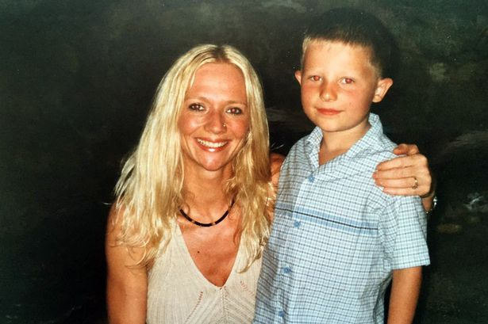
Symptoms: Sue with Josh in 2006
At the time, she was launching her construction business so her days were spent travelling from site to site. At night, with Josh in bed, she'd sit in her office, just yards from the boiler flue, finishing paperwork.
Her dedication paid off and, in 2004, she was nominated for North West Entrepreneur of the Year. But all this hard work came at a price – or so she thought.
“I constantly felt ill,” she says. “I was tired, I’d often feel sick and get headaches that I couldn’t get rid of. I put it down to stress because I was working six days a week.
"Now I know I had the classic symptoms of carbon monoxide (CO) poisoning.”
By early 2005, Sue’s health began to deteriorate and she started experiencing regular dizzy spells, nausea and fatigue. She went to the doctor who found nothing and agreed she was probably working too hard.
But Sue wasn’t the only one who was ill. Josh, now seven, frequently woke with a stomach ache. Sue took him to the doctor, who did tests, but found nothing wrong and hinted her son might be making it up.
“He’d wake up with a stomach ache so often I’d think, ‘Here we go!’ And by the time he arrived home from school, he was fit and well again – that made me think he was trying it on.”
Sue’s assistant Emily* also suffered. One day while the family were out of the house, she was working in Sue’s office but soon felt so unwell she called 999. Salmonella was suspected.
In fact, both Josh and Emily were suffering from CO poisoning. When Josh left the house every day and fresh air hit his lungs, the CO would disperse and he’d feel better.
When Emily worked for long periods in Sue’s office, she became ill. Sue, however, who worked from home, was the victim of constant poisoning.
“By the end of the year, I seemed to have a constant headache,” she says. “I was popping paracetamol like there was no tomorrow and I always felt like I was coming down with flu.
"I was achy and tired and at one point, I remember sitting on the floor in my office with my head in my hands and just sobbing because I didn’t think I could go any more.”
Collect / John Gladwin
Innocent: Josh at the time he was poisoned
Her symptoms were sporadic – she’d feel better for a few days and then the headaches and tiredness hit her.
“I just kept going. I thought I was run-down or had a cold, or was stressed or overworking. My doctor said I was fine, so I wasn’t going to make a fuss.”
But in spring 2006, Sue started to suffer chest pains and, after collapsing on her front doorstep, she was rushed to hospital in an ambulance and kept in for a week while doctors did tests.
“I was terrified,” she says. “It felt like someone was sitting on my chest and I couldn’t breathe. I had pins and needles in my arm and I was convinced I was having a heart attack. I lay in the ambulance thinking, ‘I’m going to die’.”
But over the next six days, it became clear that the doctors had no idea what was causing Sue’s symptoms. She had blood tests, ECGs, chest X-rays, an echocardiogram and, at one point, she ran on a treadmill while doctors monitored her pulse and heart rate.
Her pains were continuous and the only thing that gave any relief was glyceryl trinitrate, a spray used to treat angina - even though doctors had ruled it out.
Medical staff were stumped, so much so that three different consultants asked Sue if she used cocaine. They just couldn’t understand why a fit and healthy woman in her early 30s, with no history of heart disease, would present with classic symptoms of a cocaine user.
“I’ve never taken drugs in my life – I was so shocked,” she says.
Sue left hospital with no answers. Over that summer, she noticed she was becoming more forgetful.
“I was convinced I was starting with dementia,” she says. She’d miss appointments, struggle with facts she’d recently been told, and start the same conversation several times.
"Then, in November 2006, the warranty on the house’s boiler expired so Sue called British Gas and booked a service.
The heating engineer had only been there for only a few minutes when he ordered Sue and Emily to evacuate straight away. He had discovered dangerously high levels of carbon monoxide.
“He immediately disconnected the boiler, opened the windows and took the floor up to trace the path of the pipes under the house,” says Sue.
“He found that the flue on the middle floor was leaking fatal levels of gas into the house due to the wrong equipment being fitted.
“Basically, if my husband hadn’t insisted on opening the windows every night, my family would not have survived.
“Googling my symptoms they were all linked to CO poisoning and a neurologist later confirmed my fears.”
Engineers were called in to investigate before the boiler was immediately replaced.
According to the Carbon Monoxide And Gas Safety Society, there have been at least 677 deaths from CO poisoning in the UK in the last 19 years and over 4,500 near- misses. Yet they believe that many more people go undiagnosed.
“We suspect around 4.5million people are being affected by CO poisoning,” says the charity’s director Stephanie Trotter. “But it’s difficult to prove because the gas leaves the body so quickly.
“A lot of people are currently suffering symptoms but soldiering on because GPs have turned them away, telling them to go home, keep warm and get some rest.
“Too many people live with low-level poisoning without realising it. Headaches, vomiting and tiredness are just a few of the immediate symptoms, but in the long term there can be brain damage, memory loss and a change in personality.”
Because Josh and Sue’s husband spent most of their time out of the house, neither sustained any long-term effects although Josh still has mild trouble concentrating. But Sue is still struggling to cope with her neurological damage.
“My life has changed radically,” she says. “Before the poisoning, I was healthy. Since then, I’ve been diagnosed with Tietze syndrome – swelling of the rib cartilage – and fibromyalgia. I get migraines too.
“I have major problems with my memory. I can’t retain any information – it’s so bad I had to give up my business in 2007.
“Sometimes it’s embarrassing because I’ll forget what people have said to me and I’ll ask questions they’ve already answered. Other times it feels like I’m losing my mind. Just after the diagnosis, I remember getting into the car, looking at the keys and thinking, ‘What should I do with these?’
“Christmas 2008, I bought and wrapped the same present for Josh three times – I couldn’t remember buying it.”
Sue was referred to the memory clinic at Wythenshawe Hospital in Manchester.
After a series of tests, the doctor told her honestly: “If I hadn’t met you and had your results in front of me, I’d guess you were over 80.”
She was told she had symptoms of a patient with severe vascular dementia.
She’s experienced month-long bouts of unexplained nausea as well as periods of disturbed vision. Both have been connected with the CO.
“I’ve had to change my life drastically,” she says. “Losing my business was awful, but I didn’t want to stop working so I’m now a horse photographer.”
Sue called in lawyers and over a few years, a case was made against the builders of her house. But it wasn’t until 2013 that they finally admitted liability for negligence in fitting the flue incorrectly.
Sue, her ex-husband and son were awarded a five-figure payout. But no one has been deemed responsible for her illnesses. “I was told it was too difficult to prove,” she says.
Christi and Bobby’s mum Sharon Wood is now working with Thomas Cook to raise awareness of CO poisoning and Sue also wants to warn of this silent killer.
“It kills 50 people a year in this country, but it’s still not on our radar,” she says.
“My family was lucky, we escaped with our lives. But someone out there is breathing it in now – they’re being slowly poisoned – and the scary thing is they don’t even know it.”
* Names have been changed
- For more info go to co-gassafety.co.uk

How to avoid CO leaks in your home
Get your gas appliances and flues regularly checked by a Gas Safe (formerly Corgi) registered engineer.
Call one out if the flame on your cooker, fire or boiler is lazy yellow or orange (it should be crisp and blue), if you see soot or dark staining around or on appliances, if pilot lights frequently blow out, or if there’s increased condensation inside windows.
Fit an audible carbon monoxide alarm in each room with a gas appliance. Available from around £15 at your local DIY store, supermarket or from your energy supplier. Ensure it’s officially approved to BS:EN50291:2001 or BS:EN50291:2010 and has a Kitemark.
Don’t just rely on “black spot” detectors that change colour when CO is present – they won’t make a sound to wake you up... then it may be too late.

Common symptoms of CO poisoning you need to watch for
- Headaches
- Nausea
- Exhaustion
- Drowsiness
- Dizziness
- Vomiting
- Flu-like symptoms
- Palpitations
- Chest pain
- Collapse without necessarily losing consciousness, followed by unconsciousness and even the risk of death

If you experience any of these symptoms:
- Get fresh air immediately. Open doors and windows, turn off gas appliances and leave the house.
- See your GP immediately or go to hospital – tell them you suspect carbon monoxide poisoning. They can do blood or breath tests.

CO-Gas Safety CO Awareness Competition
Registered Charity Number:1048370
www.co-gassafety.co.uk

Calling all Primary School Teachers
Key Stage 1 and Key Stage 2 pupils
We want YOU!

Please help raise awareness of the dangers of carbon monoxide (CO) poisoning!

CO-Gas Safety is an independent registered charity and is running a after Schools Awareness Competition for a ninth year to highlight the dangers of CO and other dangers from using fuel that burns.

The competition asks pupils to produce an informative, accurate and eye-catching poster, video, model, poem, story or anything that tells the dangers of CO warning of the dangers of Carbon Monoxide (CO) poisoning and/or fumes and/or how to avoid them

Entry is FREE plus great CASH PRIZES!

There will be 10 regional prizes of £150 for the pupil & £250 for the school plus one national winner

Competition for this year closes 31st May 2016

All teaching materials are on the website, including a downloadable Power Point Presentation See http://tinyurl.com/p2q7epp
There will be 10 winners corresponding to the areas are now kindly sponsored by SGN, Wales & West Utilities, Northern Gas Networks and National Grid.

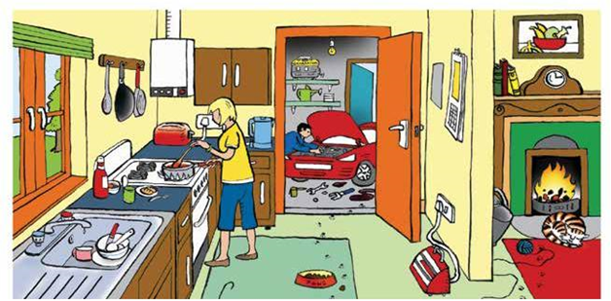

Teachers - You could ask your pupils to spot the CO dangers in this picture. Answers see http://www.co-gassafety.co.uk/competition/answers

The charity is hoping for some brilliant entries to get the message across simply.
© Copyright CO-Gas Safety 2015
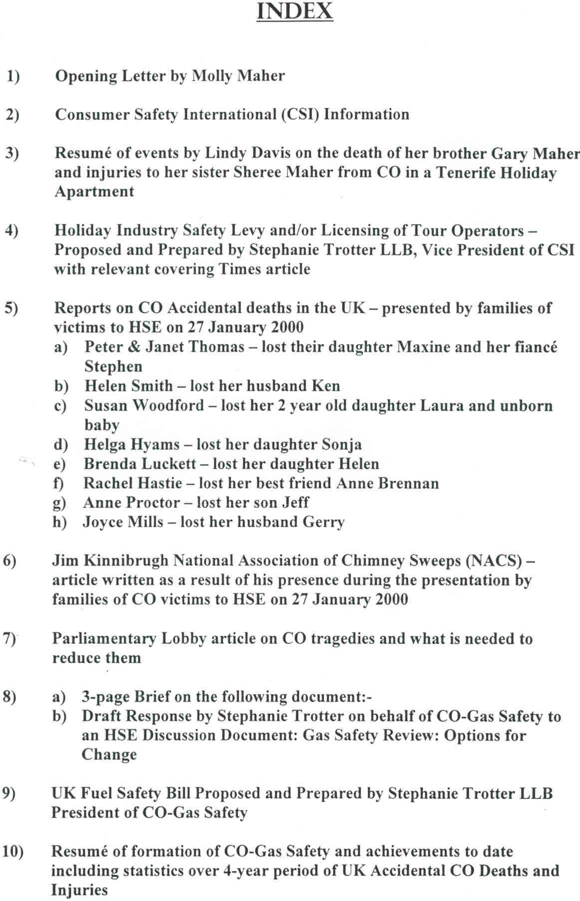

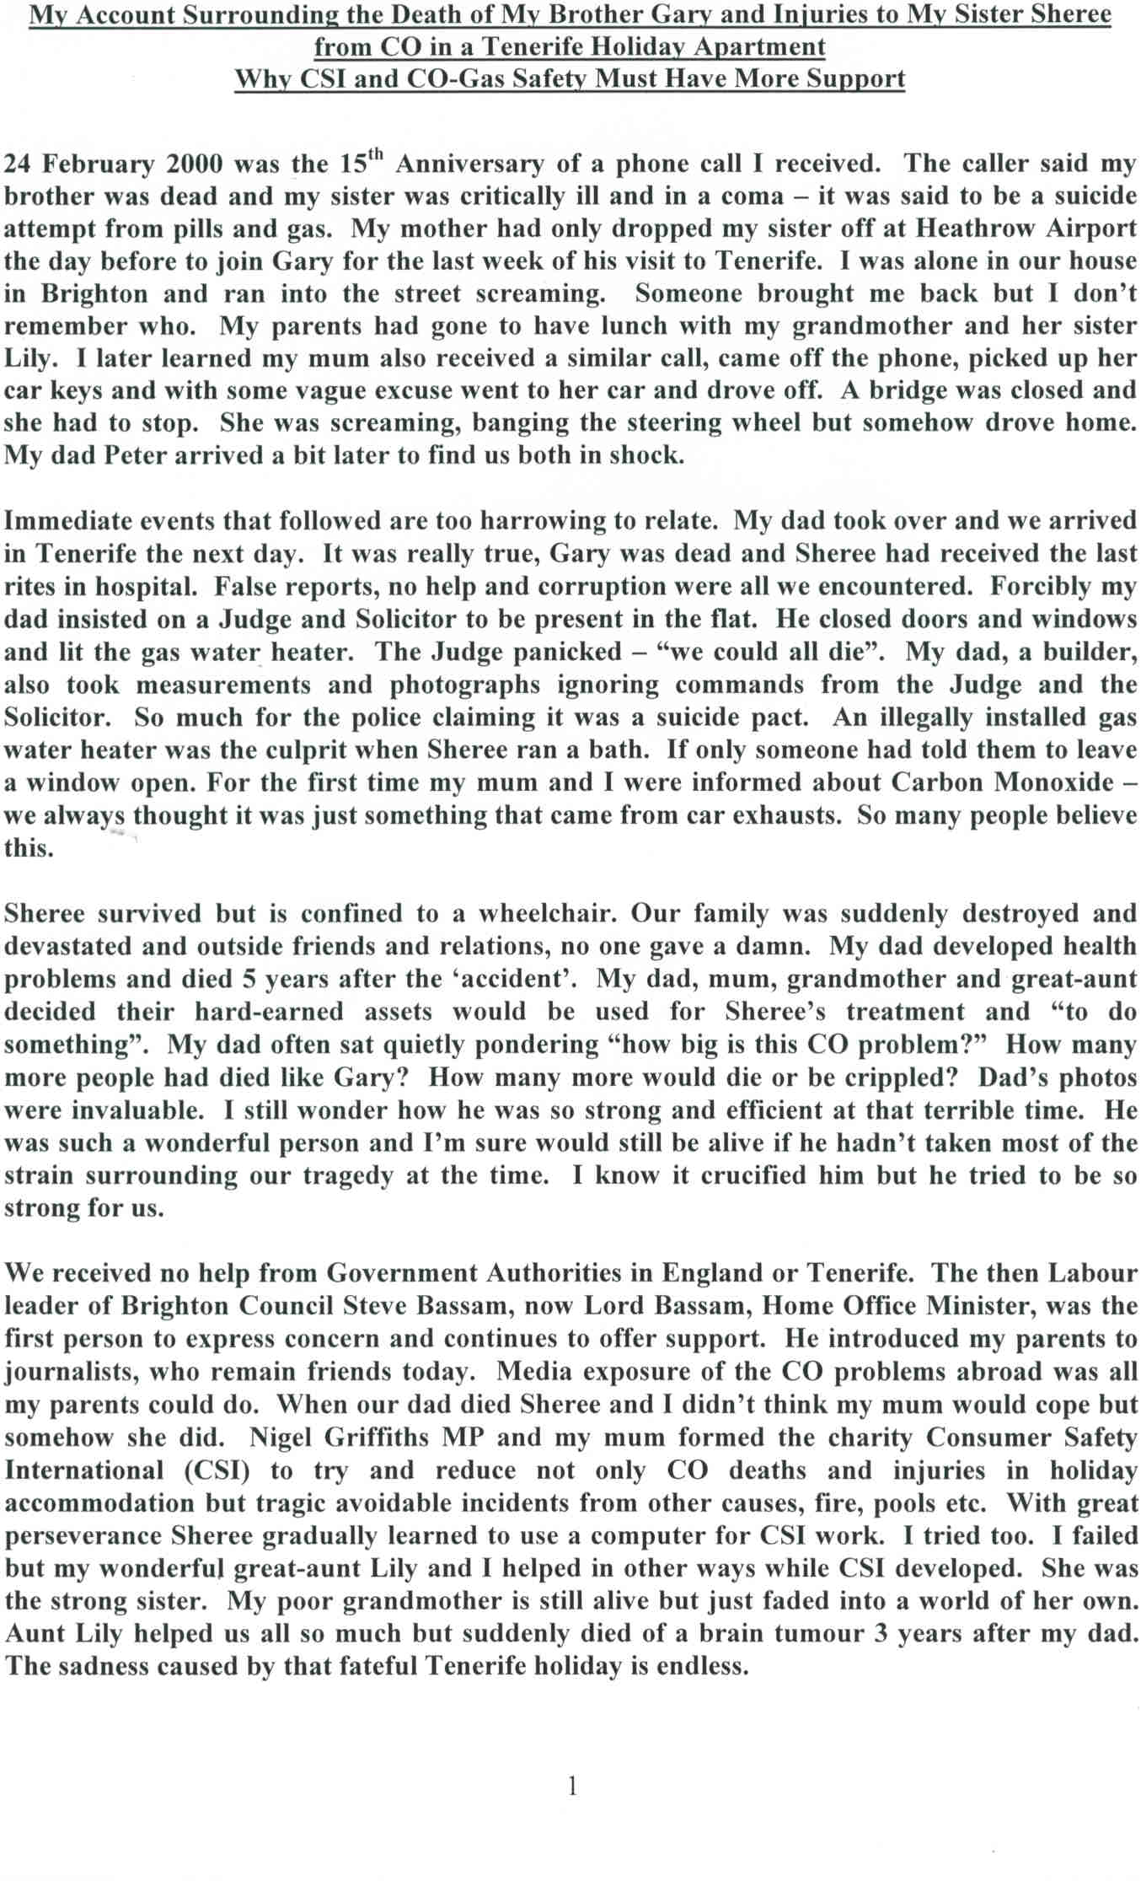

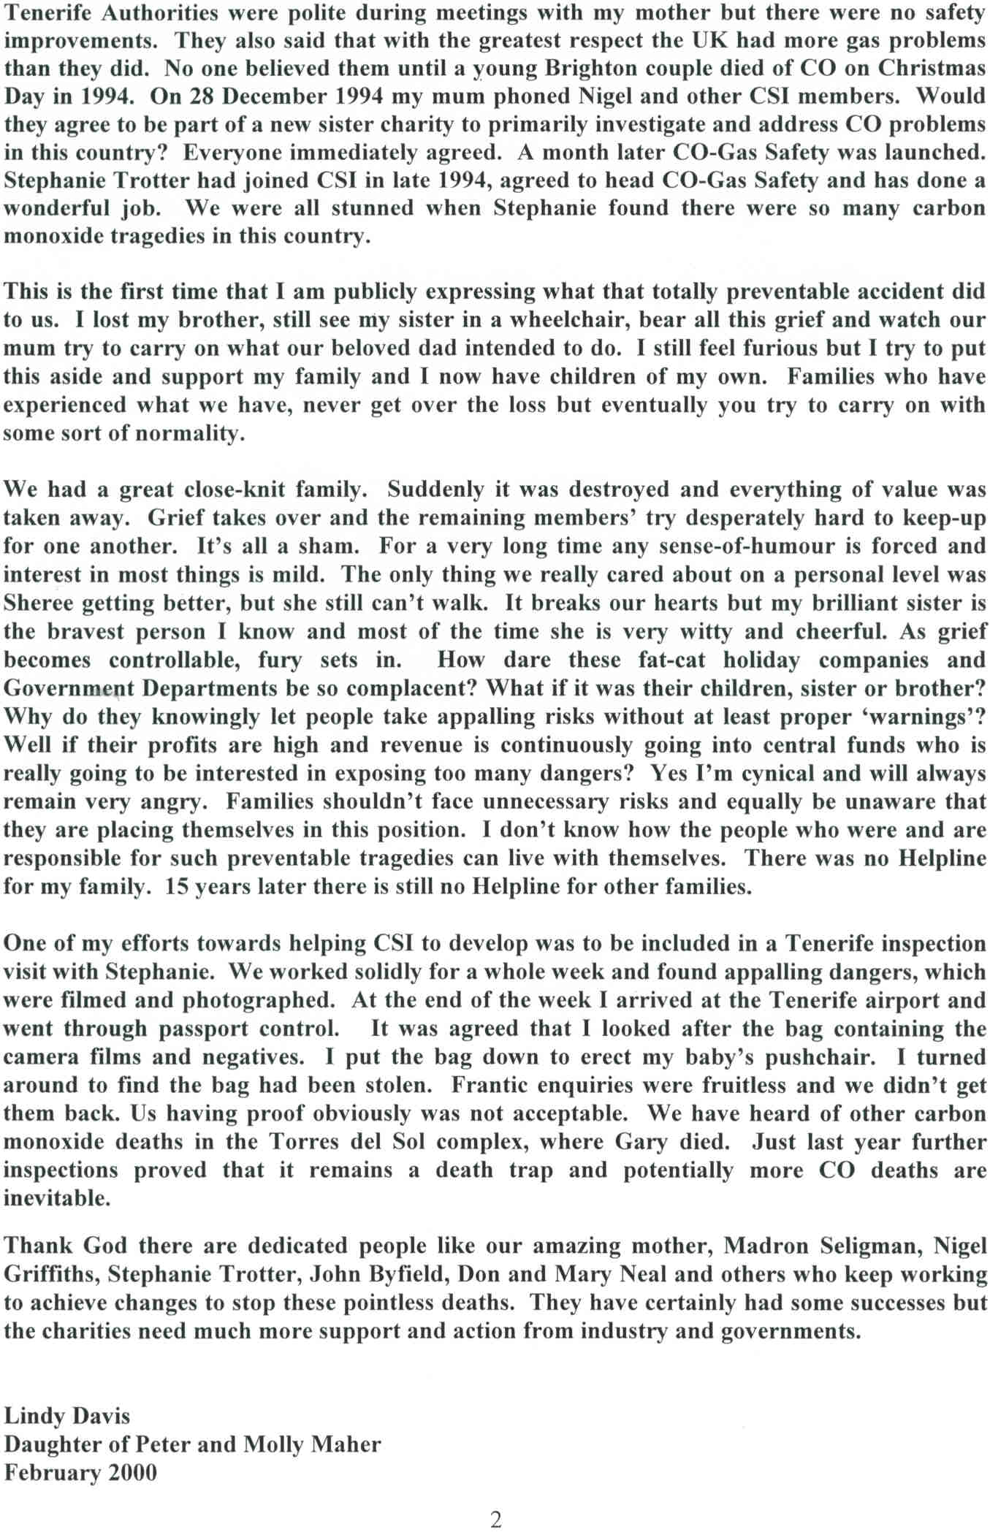

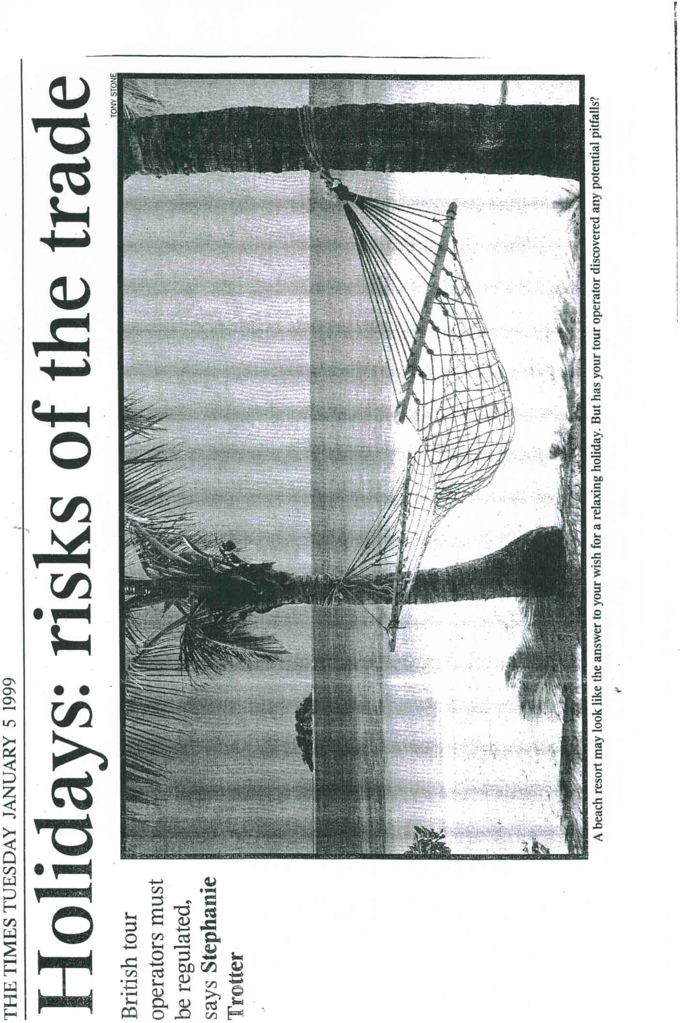

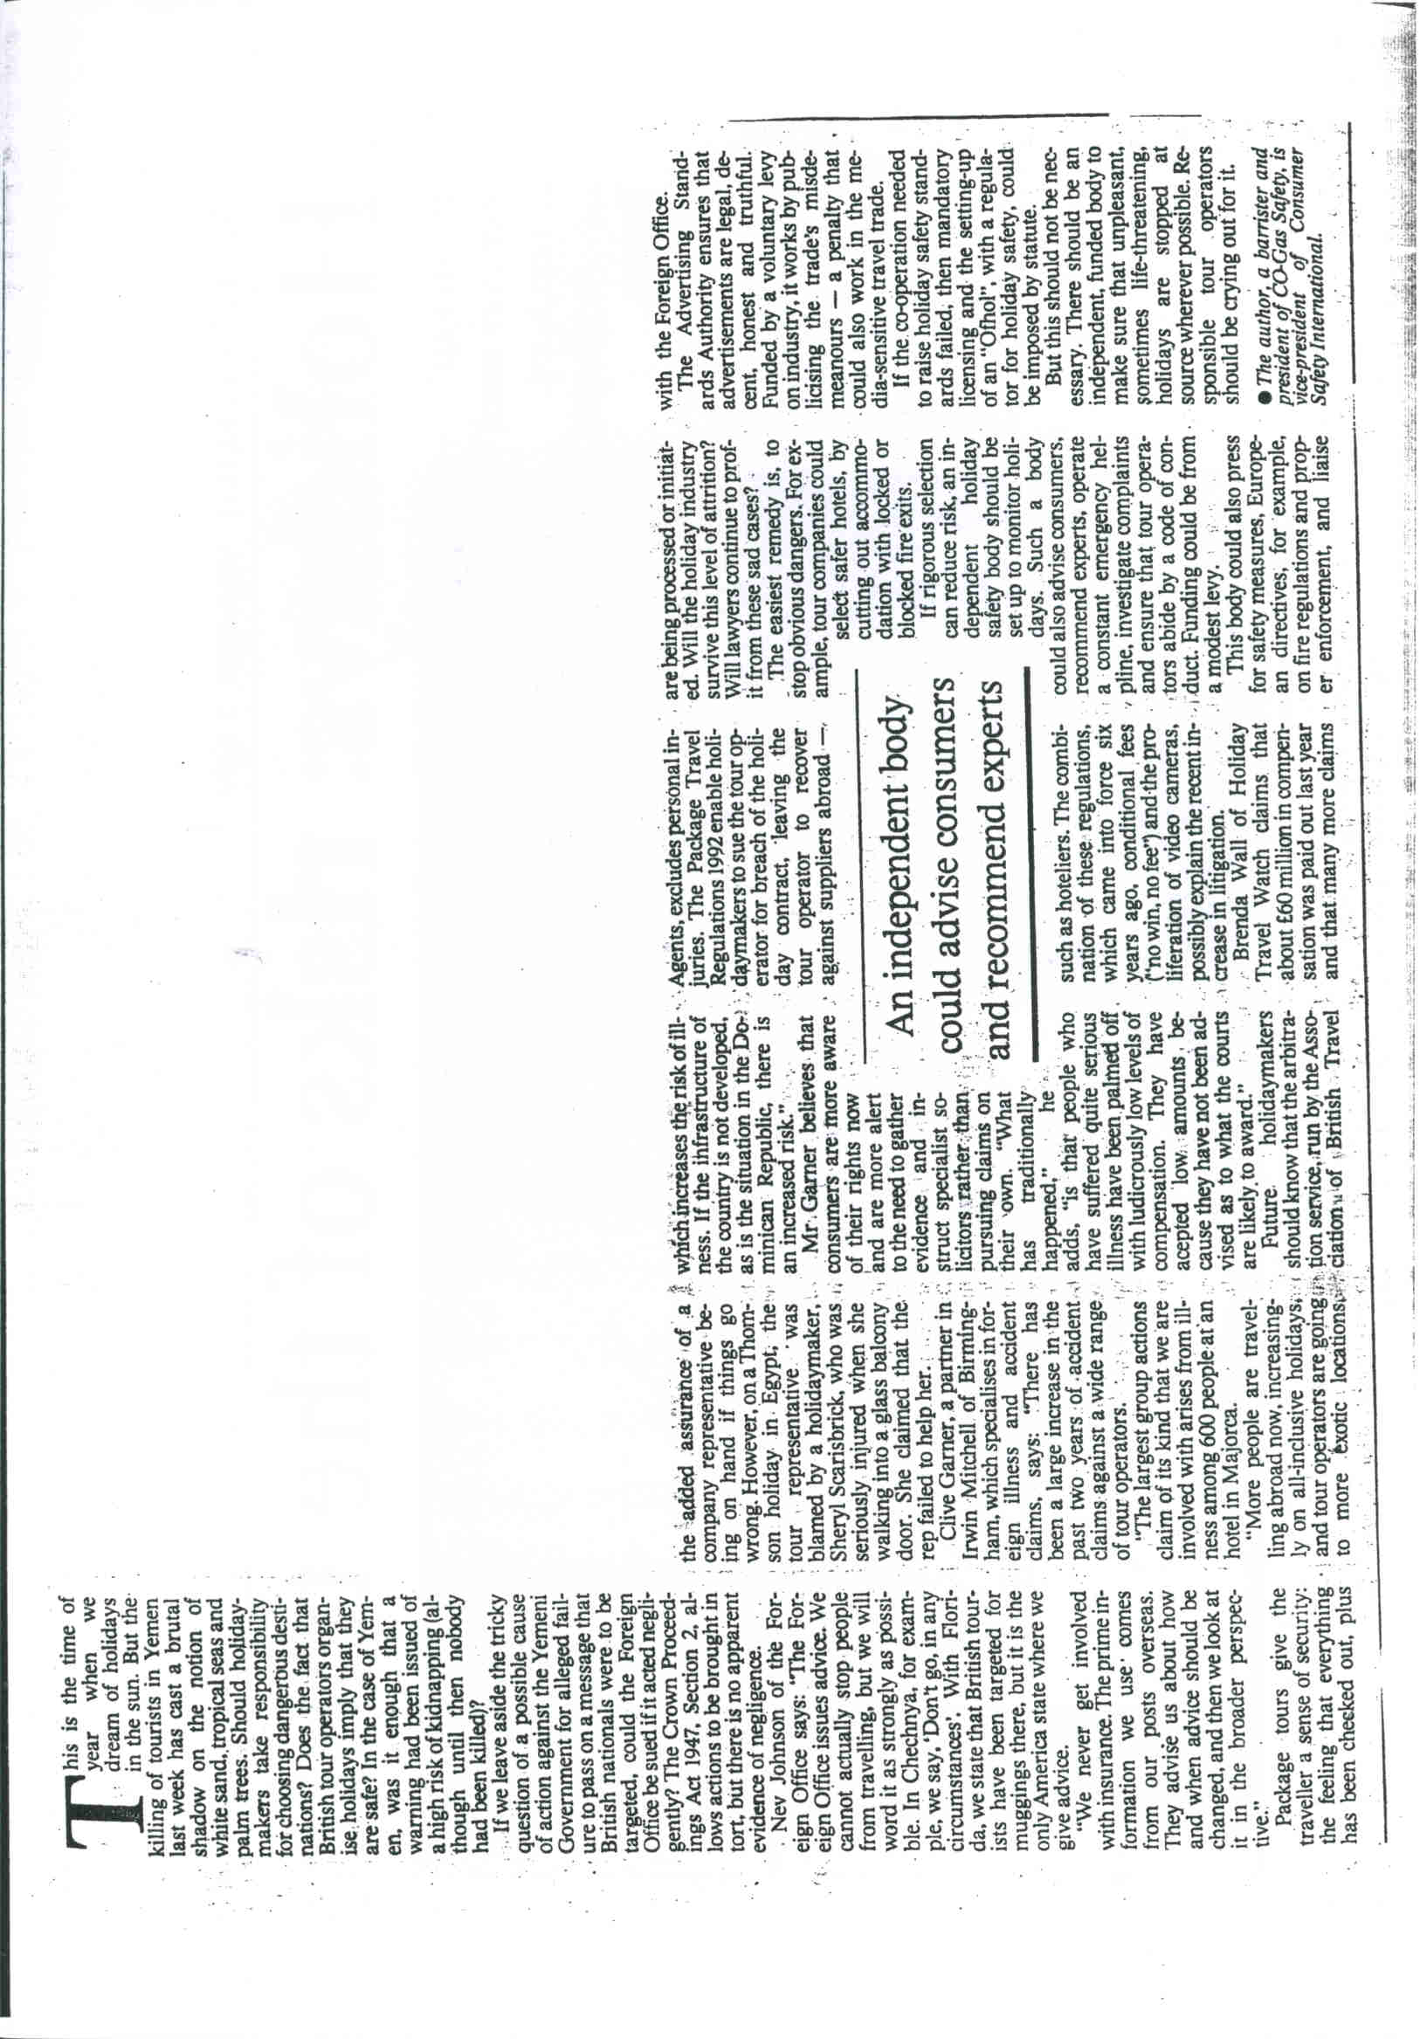

http://www.telegraph.co.uk/travel/travelnews/11912925/Coroner-calls-for-carbon-monoxide-poisoning-legislation-to-prevent-further-deaths.html

Coroner calls for carbon monoxide poisoning legislation to prevent further deaths

Coroner's report into Corfu carbon monoxide deaths calls on Government to push for EU-wide regulations on health and safety
Christi and Bobby Shepherd died in Corfu Photo: P
By Hugh Morris
6:45PM BST 05 Oct 2015
The Government is coming under increasing pressure to act on carbon monoxide poisoning legislation that campaigners say could save holidaymakers’ lives in the future.
In a recent report into the death of two children who died from carbon monoxide poisoning while on holiday in Corfu, coroner David Hinchliff said there was a risk of “future deaths” unless steps were taken to tighten EU-wide regulations.
According to the BBC, which has seen the report, he called on ministers to “draft, instigate and implement EU legislation on gas installation and carbon monoxide safety” that would include accommodation checks by health and safety specialists, not “often inexperienced and overworked” tour reps; publicity campaigns to encourage tourists to travel with portable carbon monoxide detectors; and warnings of the dangers of such poisoning in holiday brochures.
The report followed the inquest into the death of Bobby and Christi Shepherd, aged six and seven, who died at the Louis Corcyra Beach hotel after breathing in fumes from a faulty boiler.
• Can we trust tour operators with our safety?
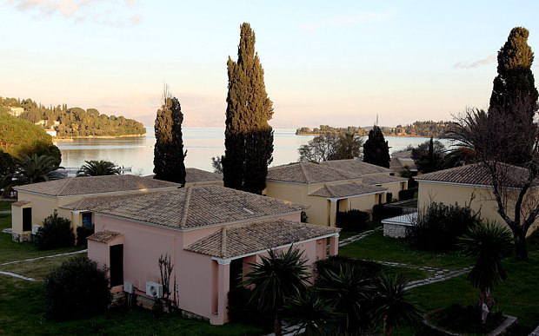
A view of the villa in Corfu where the two children died Photo: Getty
The children, from Horbury, near Wakefield, were on a half-term break with their father, Neil, and his girlfriend Ruth, now his wife, who were both put in a coma by the fumes, when the tragedy occurred.
Thomas Cook, the family’s tour operator, was found to have breached its duty of care. In his report, Hinchliff said Thomas Cook should lead the way in improving safety and raising awareness of the dangers of carbon monoxide across the industry.
Mary Creagh, MP for Wakefield constituency, told the BBC that 43 holidaymakers had died of carbon monoxide poisoning since the children’s deaths.
I regret to say that the political will in Westminster is weak’

Frank Brehany, consumer director, HolidayTravelWatch
“I welcome the fact the coroner is pushing the UK government to institute new carbon monoxide standards in the UK and across Europe and is pushing the holiday industry to better protect travellers.”
She (Mary Creagh MP) said: “The family’s dearest wish is that this sort of tragedy does not happen to anybody else.
A spokesperson for Thomas Cook said the holiday company welcomed the coroner’s report.
“As a company we are now reviewing his report and the suggestions he has made for both the wider travel industry and for Thomas Cook,” the spokesperson said.
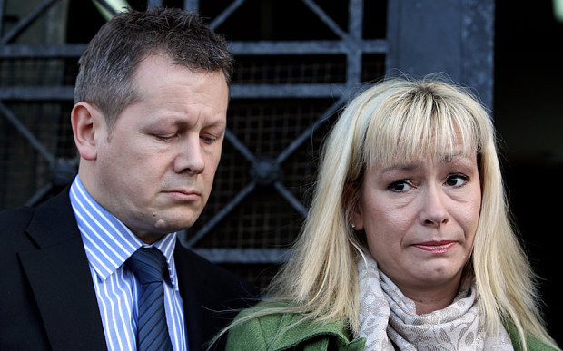
Paul and Sharron Wood, the parents of the two children Photo: Getty
”We will continue to work with the travel industry and ABTA to identify possible improvements that may be appropriate for implementation across the industry. We are already working with Sharon Wood [the children’s mother] on a new initiative to raise awareness about carbon monoxide, in order to tackle some of the issues head on.”
Travel guidance group HolidayTravelWatch called for a new regulation that came into force this week regarding landlords and rented accommodation in the UK to be extended to holiday accommodation, saying that 500,000 holidaymakers a week in the UK are at risk from carbon monoxide poisoning.
Frank Brehany, consumer director, said: “This is extremely disappointing [that the legislation has not been extended to holiday accommodation]. We have been engaged for several years with campaigners, in arguing for a better regulatory environment to protect consumers and homeowners; I regret to say, with some notable exceptions, that the political will in Westminster is weak.
"This Government should now re-open this inquiry and create the conditions for a wider regulatory protection; if they cannot achieve this at Westminster, then they should use all efforts to secure a pan-European solution.”

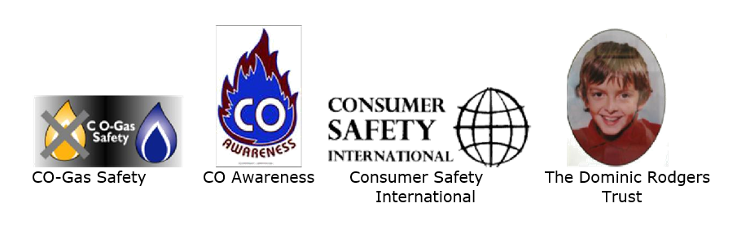
CO Awareness week
Stamp out the silent killer
Press Conference at the House of Lords
Tuesday 5th December 2006 at 10.00 a.m.
Room 4A
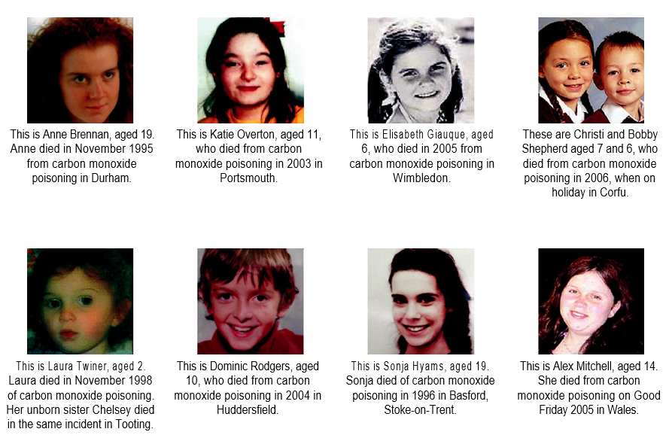
PRESS PACK
The organisations running the first ever CO Awareness Week:-
Consumer Safety International
An independent registered charity set up in 1992 by Molly Maher, Nigel Griffiths MP, (now Deputy Leader of the House of Commons), and the late David Jenkins of RoSPA. Molly lost her son, Gary to Carbon Monoxide (CO) in Tenerife in 1985 and her daughter, Sheree was confined to a wheelchair as a result of the same incident. The charity assists holiday victims. CSI has lobbied to improve holiday safety in Europe and the UK including a European Directive on gas safety and for greater awareness of the dangers of CO. The charity has full cross party support at the House of Commons and European Parliament
Company Registration No. 2751644 Charity Registration No.1014664
CO-Gas Safety
Also founded by Molly Maher, Nigel Griffiths MP, (now Deputy Leader of the House of Commons), and the late David Jenkins of RoSPA, to reduce accidents from CO and other gas dangers and to support gas related accident victims.
The charity was launched at the House of Commons in January 1995 and has been run since then by Stephanie Trotter as a full time volunteer. Trotter is a barrister (not practising at the moment), who previously successfully campaigned for children’s activity holiday centres to be licensed. It was through this campaign that Molly Maher and Stephanie Trotter met. The charity has full cross party support at the House of Commons and European Parliament and is a sister charity to CSI.
Company Registration No. 03084435 Charity Registration No.1048370
The Dominic Rodgers Trust
Set up by Stacey Rodgers in 2004 in memory of Dominic Rodgers, Stacey’s only child who died aged 10 of CO in 2004. Stacey has worked extensively, particularly in Huddersfield to raise awareness of the dangers of CO. Stacey has worked with the other victim based organisations and with Barry Sheerman MP, her constituency MP and also co-chair of the All Party Parliamentary Gas Safety Group.
CO-Awareness
The organisation’s founder is Lynn Griffiths, whose entire family has been affected by CO poisoning set up CO-Awareness in July 2005 and has two main aims. They are: to offer support to people affected by carbon monoxide poisoning and also to raise awareness of this preventable problem among the general public and the medical profession.

Stephanie Trotter OBE - President & Director of CO-Gas Safety

Stephanie Trotter is a barrister (not practising at the moment), who has run the independent registered charity CO-Gas Safety since its launch at the House of Commons in January 1995 with help from other voluntary directors (mainly victims and MPs).

The charity has been supported by a grant from the Department of Health in the past. However, the charity now exists on donations from business etc. Stephanie is a full time volunteer and the charity is run almost entirely by volunteers, apart from a very small amount of assistance to help collate the data of unintentional deaths and injuries from CO, which the charity has been doing since 1995 see http://www.co-gassafety.co.uk/stats_and_analysis.html. The charity is indebted to the many Coroners and their officers who have assisted the charity since 1995.

Stephanie became interested in safety when her older son, Alex, then aged 12 suffered a clot on the brain at a children’s activity holiday centre. The accident was just one of those things but Stephanie was extremely concerned about the wrong First Aid and the centre failed to notify her or her husband of the injury despite a request to do so. Stephanie felt that they were lucky because after brain surgery, Alex recovered. However, she was very concerned about other children attending the centre, especially as the centre did not appear to take her concerns seriously. Stephanie did some research and found there were no controls whatsoever on these centres. After the canoe tragedy (four teenagers drowned in March 1993 in Lyme Bay), Stephanie wrote her first legal article advocating licensing of these centres and this was published in the New Law Journal and read by the Judge in the subsequent manslaughter trial. The Judge in the trial, Mr. Justice Ognall publicly urged the government to license these centres and the Activity Centres (Young Persons’ Safety) Act 1995 was enacted. The need to license was supported by the responsible centres. Through this work Stephanie met Molly Maher, who lost her son Gary to carbon monoxide (CO) in 1985 and whose daughter Sheree was confined to a wheelchair as a result of the same incident while they were on holiday in Tenerife. Molly founded Consumer Safety International, a registered charity to help prevent deaths and injuries on holiday helped by Nigel Griffiths MP and the late David Jenkins of RoSPA. Molly also founded CO-Gas Safety along with the late David Jenkins and Stephanie agreed to run it.

In over 20 years of CO-Gas Safety, Stephanie has helped innumerable victims of CO, gas leaks, explosion and fuel emissions other than CO (we call these CO+) and lobbied Ministers, Government and industry to make simple and practical changes to save lives and preserve health (see http://www.co-gassafety.co.uk/changes_to_save_lives.html). Together with the members of CO+SAVi (victims & victim groups under the All Fuels Action Forum set up by the All Party Parliamentary Carbon Monoxide Group) CO-Gas Safety agreed changes that could become amendments to the Energy Bill. These were professionally drafted paid for jointly by CO-Gas Safety and the Katie Haines Memorial Trust see http://www.co-gassafety.co.uk/our_professionally_drafted_suggestions.html and some of these were put down as amendments in the House of Commons, but were not successful.

Stephanie has also appeared many times on TV, (including NewsNight) radio etc.

January 2015 marked CO-Gas Safety’s 20th anniversary at the House of Lords with over 120 guests.

In 2005 Stephanie and CO-Gas Safety was presented with the CORGI Gas Safety award.

In 2007 Stephanie was awarded an OBE for her work on gas safety.

Stephanie has been greatly assisted by directors, who are mainly victims and MPs. CO-Gas Safety has one industry member, Jonathan Kane of Kane International, which makes flue gas analysers see
https://www.kane.co.uk/
CO-Gas Safety’s patron is Lord Hunt of Kings Heath. CO-Gas Safety has also been greatly helped by a gas expert, gas installers and by the Guild of Master Sweeps who are also deeply concerned at these preventable deaths.
Stephanie’s husband is John Trotter, who is a consultant in Bates Wells & Braithwaite, a firm that specializes in charity law.
After pupillage and about six months of practice at the bar, (mainly crime) Stephanie became a Senior Lecturer at the Inns of Court School of Law (the final year of the Bar examinations – post graduate students mainly from Oxbridge) for nine years. They have two sons, Alex and Paul, now married with children.
Stephanie has many interests including house renovating, sailing, ice skating, gardening and writing. She has done a Roman mosaic course and would like to spend a lot more time on artistic pursuits and playing with her three granddaughters.
© Copyright Stephanie Trotter 2015

