Avoid dying or being injured from carbon monoxide poisoning

Christi and Bobby Shepherd tragically died of carbon monoxide in 2006 in Corfu while on a Thomas Cook holiday.

What is carbon monoxide (CO)?

A deadly gas that can be emitted from faulty cooking and heating appliances powered by any carbon based fuel that burns.
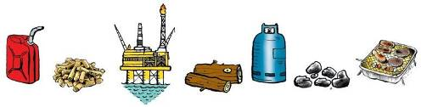

Fuels include gas, coal, wood, petrol, diesel etc.

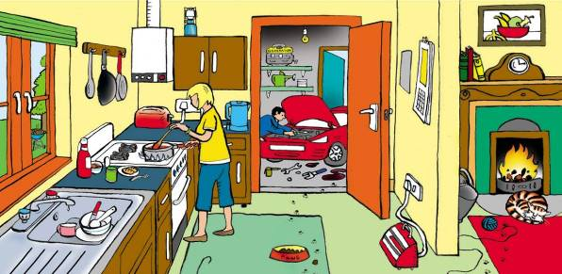

Can you identify potential sources of carbon monoxide in the picture above? For the answers go to http://www.co-gassafety.co.uk/answers.html

CO cannot be sensed using human senses of smell, taste, sight or touch.

Less than 2% of CO in the air can kill in between one and three minutes.

http://www.hse.gov.uk/foi/internalops/hid_circs/technical_osd/spc_tech_osd_30/spctecosd30.pdf

(Paragraph 74 table 23 page 26)
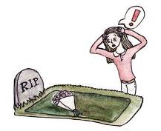

Firemen when talking about CO in smoke (which you can smell) say it takes only three breaths, the first you don’t know

there’s a problem, the second you might suspect there’s something wrong but by the third you are unable to take any action.

CO alone being emitted from cooking and heating appliances has no smell.
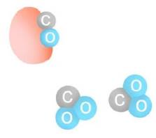

Why is CO so lethal?

Because it binds to the haemoglobin in the blood which normally carries oxygen so it suffocates.

What is the difference between CO and CO2?

CO2 consists of one molecule of carbon and two of oxygen.

CO also contains one molecule of carbon but only one molecule of oxygen. CO is emitted when there is a lack of oxygen at the flame.
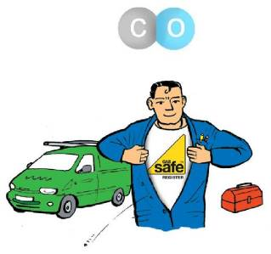

How do you prevent CO in your home?

- Install all cooking and heating appliances correctly according to manufacturer’s instructions using properly qualified people. With gas they must be Gas Safe Registered and qualified to work on your type of appliance.

- Maintain your appliances regularly according to manufacturer’s instructions using qualified people – again with gas much be Gas Safe Registered.

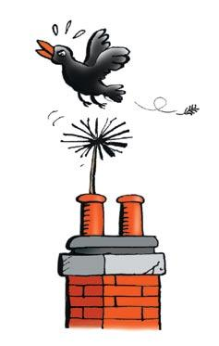
- Have chimneys and flues swept and checked by a sweep
belonging to a recognised trade organisation.

- Ensure adequate ventilation. Don’t block grilles which were put in to ventilate a fire etc.

- As an extra safeguard (e.g. to protect against a bird’s nest falling down the chimney) buy and fit a CO alarm to EN 50291.

Low levels of CO over a long period can make people ill GPs rarely diagnose this as CO.

Please watch our one minute film about Sue who was poisoned – could save your life: http://www.co-gassafety.co.uk/one-survivors-story

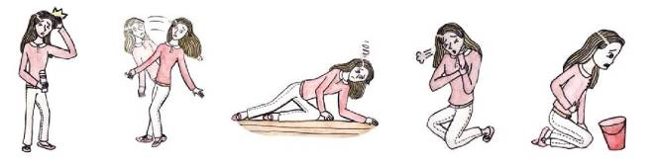
Symptoms of low level poisoning include:-

HEADACHES DIZZINESS TIREDNESS BREATHLESSNESS NAUSEA

and generally feeling unwell similar to many viral illnesses.

Different members of the family can suffer different symptoms
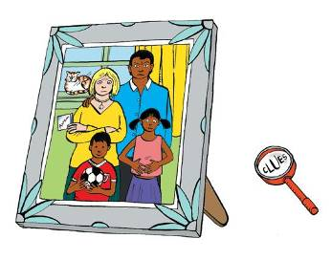
Please make sure you’re safe from CO and other products of combustion.

In an emergency please ring 0800 111 999
for the Gas Emergency Service but
please be aware they do not have the
equipment to test gas appliances for
carbon monoxide emissions.

If you need further information

please visit www.co-gassafety.co.uk

CO-Gas Safety is an independent registered charity run almost entirely by volunteers, offering free and confidential help and advice to victims and their families.

We are especially interested in helping those who have lost a loved one. To get in touch please email office@co-gassafety.co.uk

You can also telephone or text Stephanie Trotter on 07803 088688. If she can’t talk to you, please leave your name, number and email address and she will call you back. Stephanie will do her utmost to contact you and help, especially in emergencies and for anyone who has lost a loved one.
Stephanie will try to be accessible to help you at all times, but if she is not available you can contact a solicitor for free initial legal advice. Please see contact details which we will put up if necessary on our website at www.co-gassafety.co.uk

Account of the Corfu case by Stephanie Trotter OBE
Back in 2006 and before CO was announced as a cause of death of Christi and Bobby, I telephoned the hospital in Greece to suggest testing the dead children and, if the cause of death was CO, I urged that hyperbaric oxygen be given to the father Neil Shepherd and his then fiancé Ruth Beatson. Those I spoke to said they didn’t speak English so a Greek friend kindly tried but also with little success. I telephoned the relatives with the same advice and spoke to Ruth’s father who kindly reminded me about this at the inquest.
Later, I recommended that gas expert Harry Rogers undertake an examination of the boiler that killed the children. Harry gave evidence at the inquest. I also recommended the barrister, Leslie Thomas, now QC. In our opinion, without Harry’s evidence, Leslie’s skill and the parents’ courage and determination and ability to pay Harry, the facts would not have emerged. I also wrote to the police on the 3rd November 2006.

This all arose from our experience of victims who, not knowing what to do, called to ask for independent and impartial help.

The inquest verdict was unlawful killing and the jury found a breach of Thomas Cook’s duty of care. For more on the case, please go to the following links:
http://news.sky.com/story/1488464/thomas-cook-goodwill-payout-to-corfu-family

http://www.independent.co.uk/news/business/analysis-and-features/carbon-monoide-deaths-from-a-tragedy-to-a-corporate-disaster-for-thomas-cook-10259735.html

The Coroner made his recommendations public on 6th October 2015
http://www.co-gassafety.co.uk/corfu-inquest-hm-coroner-david-hinchliffs-reg-28-report-to-prevent-future-deaths/

At the request of the Corfu parents Thomas Cook gave CO-Gas Safety £50,000 in summer 2015 and are setting up a Safer Tourism Foundation see http://www.co-gassafety.co.uk/resources/safer-tourism-foundation

CO-Gas Safety almost certainly has the best data on unintentional deaths and injuries from CO from all fuels in the UK from 1995.
See http://www.co-gassafety.co.uk/stats_and_analysis.html and please download our years of data from 1995 and our pie charts. This is updated yearly.

CO-Gas Safety has lobbied for prime time TV warnings about CO since 1995.
Company Registration No. 03084435 Charity Registration No. 1048370

- Copyright CO-Gas Safety 2016
Sponsored by Kane International

Illustrations of CO symptoms by competition winner Chihiro.
All other illustrations by John O’Leary

