Toxicity of combustion emissions from barbecue fire-lighters

A thesis submitted for the degree of Masters of Science in Mechanical Engineering

by

Zekai Chen, BEng (Hons.)

Department of Mechanical Engineering
University College London

I, Zekai Chen, confirm that the work presented in this thesis is my own. Where information has been derived from other sources, I confirm that this has been indicated in the thesis.

September 2017
Student number: 16003383
Total number of words: 12684

Abstract
More and more people are willing to spend their time on barbecue with their families or friends. The minor size, high energy release, easy to ignite, and it is widely used to ignite the barbecue fuels such as wood and coal. In fact, barbecue firelighters have been the primary choice of barbecue ignition items. In other words, barbecue firelighters are closely related to people’s daily life. The combustion emissions of barbecue fuels have experienced a large quantity of researches. The combustion emissions of barbecue firelighters, in contrast, are rarely studied. Therefore, people hardly know the toxicity of barbecue firelighters’ combustion pollutants.

The primary aim of this research is designing the experiment of testing the barbecue firelighters’ emissions and analyzing the concentration of regulated emissions and identifying the composition of unregulated emissions from barbecue firelighter combustions, then discussing the health impact of these toxic emissions. Six barbecue firelighters which are made of various materials were selected for the whole experiments. Meanwhile, keeping barbecue firelighters’ caloric value as same during the experiment. HORIBA MEXA 9400 and CVS-9100 Exhaust Gas Analyzer was chosen for measuring the concentration and percentage of regulated emissions such as CO, CO₂, NO_{x} and THC. Agilent 7890B/ 5977A GC-MS was used to identifying the composition of unregulated emissions which mainly are PAHs. The experiment results shows that the concentration of regulated emissions associate with the material of barbecue firelighters, meanwhile, six different barbecue firelighters all have high level of CO, CO₂, NO_{x} and THC. The regulated emissions can cause headache, vomiting even respiratory problems and death. As for unregulated emissions, results show that 5 PAHs (acenaphthylene, phenanthrene, anthracene, fluoranthene and pyrene) were found in the emission of these firelighters. These PAHs will damage the lung function of the patient. Besides, mixtures of PAHs are also known to cause skin irritation and inflammation or even cancer.

Acknowledgements
First of all, I am particularly grateful for the assistance given by my supervisor Dr Paul Hellier. His support helped me complete this project. His patient guidance, enthusiastic encouragement and useful critiques helped me a lot when I faced the difficulties in my project. He taught me plenty of useful knowledge not only for this project, but also for my career in the future. His passion and meticulous attitude of work inspired me deeply.

Secondly, I wish to acknowledge the help provided by Mr Christopher Ogbunuzor and Mr Viktor Kärcher, they helped me a lot for using experiment analyzers. The knowledge and advice they shared with me solved many problems of this project. I would also like to extend my thanks to my classmates Yujing Huang and Jialei Li for great help during the experiment time.

Finally, I wish to thank my parents for their support and encouragement throughout my study.
Table of Contents

Abstract 2
Acknowledgements 3
Nomenclature 6
List of tables 7
List of figures 8
1. Introduction 10
2. Literature review 13
2.1 Composition of barbecue firelighters 13
2.2 Emissions of barbecue firelighters 13
2.3 The impact of barbecue firelighter emissions on human health 14
2.4 Experiment methods 20
2.5 Summary 21
3. Materials and methods 23
3.1 Test barbecue firelighters 23
3.1.1 The barbecue firelighter properties 23
3.1.2 Calorimeter experiment 24
3.1.3 Samples for emission analyzers 26
3.2 Emission analyzers 27
3.2.1 Regulated emissions testing 27
3.2.2 Unregulated emissions testing 28
3.3 Experimental setup and procedure 28
3.3.1 Experiment setup 28
3.3.2 Regulated emissions experiment procedure 31
3.3.3 Unregulated emissions experiment procedure 32
4. Results and Discussion 39
4.1 Experiment preparation 39
4.1.1 Barbecue firelighter properties 39
4.1.2 Calorimeter experiment 40
4.2 Regulated emission experiment 42
4.3 Unregulated emissions experiment 58
5. Conclusion 64
6. Future work 66
References 67
Appendices 71

Nomenclature
ALS | Automatic Liquid Sampler
CO | Carbon Monoxide
CO₂ | Carbon Dioxide
CH₄ | Methane
CLD | Chemiluminescent Detector
DCM | Dichloromethane
EPC | Electronic Pneumatic Control
FID | Flame Ionization Detector
GC-MS | Gas-Chromatography and Mass Spectrometry
HC | Hydrocarbon
HCN | Hydrogen Cyanide
He | Helium
LPG | Liquefied Petroleum Gas
N₂ | Nitrogen
NDIR | Non-Dispersive Infrared Absorption
NO_{x} | Oxides of Nitrogen
NO | Nitrogen Monoxide
NO₂ | Nitrogen Dioxide
NH₃ | Ammonia
O₂ | Oxygen
PAH | Polycyclic Aromatic Hydrocarbon
SO₂ | Sulfur Dioxide
THC | Total Hydrcarbon
VOC | Volatile Organic Compound
J | Joule
PPM | Parts Per Million
RSD | Relative Standard Deviation

List of tables
Table 1. The details of Fisher Scientific™ Isotemp™ Stirring Hotplate 24
Table 2. Technical data of IKA Calorimeters C1 25
Table 3. Samples data for experiments 29
Table 4. GC-MS experiment parameters 33
Table 5. The composition of standard sample 36
Table 6. The compositions and properties of test barbecue firelighters 39
Table 7. Barbecue firelighters calorimeter experiment results 40
Table 8. The mass of different barbecue firelighters and its burning time 41

List of figures
Figure 1. Fisher Scientific™ Isotemp™ Stirring Hotplate 24
Figure 2. IKA Calorimeters C1 25
Figure 3. Acetobutyrat capsule and cotton thread 26
Figure 4. HORIBA MEXA-9400 Motor Exhaust Gas Analyzer and HORIBA CVS-9100 Constant Volume Sampler 27
Figure 5. Agilent 7890B/5977A GC-MS 28
Figure 6. Experiment design 30
Figure 7. Parker Balston Model 85 Sintered Metal Filter 31
Figure 8. Regulated emissions experiment design 32
Figure 9. GC-MS experiment process 34
Figure 10. GC-MS results of DCM group. (a) DCM group at the beginning of GC-MS experiment. (b) DCM group after standard group. (c) DCM group after 5 barbecue firelighers group. (d) DCM group at the end. 35
Figure 11. GC-MS experiment results of standard group 36
Figure 12. Comparision among Highlander Solid Fuel, standard group and Quickfire Firelighters. (a) The peak are of Highlander Solid Fuel. (b) The peak area of standard group. (c) The peak area of Quickfire Firelighters 38
Figure 13. Regulated emissions of Nature CO₂ Neutral Firelighters 42
Figure 14. Regulated emissions of Big-K Eco-Friendly Firelighters 43
Figure 15. Regulated emissions of Flamers Firelighter 44
Figure 16. Regulated emissions of Tinderflame Quick Start Firelighters 45
Figure 17. Regulated emissions of Quickfire Firelighters 46
Figure 18. Regulated emissions of Highlander Solid Fuel Tablets 47
Figure 19. CO concentration of barbecue firelighters 50
Figure 20. CO₂ concentration of barbecue firelighters 51
Figure 21. NO_{x} concentration of barbecue firelighters 52
Figure 22. THC concentration of barbecue firelighters 53
Figure 23. Cumulative regulated emissions concentration. (a) CO cumulative concentration. (b) CO₂ cumulative concentration. (c) NO_{x} cumulative concentration. (d) THC cumulative concentration. 55
Figure 24. GC-MS results of Nature CO₂ Neutral Firelighters. (a) Whole experiment results. (b) Peak 152. Firelighters left, standard right. (c) Peak 178. Firelighters left, standard right. (d) Peak 202. Firelighters left, standard right. 59
Figure 25. GC-MS results of Barbecue Firelighters. (a) Big-K Eco-Friendly Firelighters. (b) Flamers Firelighters. (c) Tinderflame Quick Start Firelighters. (d) Quickfire Firelighters. (e) Highlander Solid Fuel Tablets. 61
Figure 26. PAHs in different barbecue firelighters emissions 62
Figure 27. The experimental instruments design 71

Introduction
Barbecue has been a popular genre of food for many years and generations, probably one of the oldest cooking methods. In modern society, there are a variety of ways to barbecue because of different fire using methods. For example, the barbecue grills can be divided into wood and coal grills, gas grills, electric grills, microwave grills and solar grills, obviously they use wood and coal, LPG, electricity, microwave and solar power to make fire. Particularly, wood and coal burning grills have become a must have for the barbecue industry. Although there are many cooking energy can replace wood and coal in many developed countries, it still is one of the most widely used fuels for cooking activity in the modern world. This migration to wood and coal burning grills will continue to take over as the year progresses. In the near future, wood and coal burning grilling will begin to arrive in people’s own backyards as well.

People need to make fire before start barbecue cooking, fire plays an important role in human history. There is archeological evidence shows artificial collection of natural fires dating back 1.5 million years. People in Early Stone Age mainly collected fire through lightning, volcanoes and sparks from rock falls or meteor. During the Neolithic Period (10,000 to 4,000 years old), sparking flints are the earliest evidence of human lighting fire by themselves. Then, our ancestors developed friction fire through their observations, it was a big step for human history. After that, friction methods were most likely the main methods till the metal fire strikers were developed in the Iron Age⁽¹⁾. In modern society, matches and lighters were developed which have small size and easy for using, while matches and lighters are not suitable for ignite wood and coal directly because wood and coal have higher fire points compared with gasoline and kerosene. Thus, people usually pour gasoline or kerosene on wood and coals to make fire. The disadvantage of this method is hard to control the amount of gasoline and kerosene, it could be dangerous for people ignite it in home or outdoors. Lighting a fire in a barbecue grill is, in general, viewed as an easy task, but wrong ways to make fire may easily produce a large amount of smoke or maybe dangerous. Nowadays, Barbecue firelighters are widely used to ignite the fuel at the beginning of the barbecue cooking process. The definition of firelighter is the small solid fuel tablets sold as consumer products and designed to replace kindling in starting a fire, especially start wood or coal fire in homes⁽²⁾. Barbecue firelighter is mainly made up of wood, vegetable wax/ bio-oil, kerosene (paraffin) or urotropine, it also has various types of organic and inorganic compounds like hydrocarbons, water, oxygen and trace elements. Many recent researches of barbecue firelighters also show that its combustion emissions can act as a potential source of VOCs, carbonyls and PAHs. Meanwhile, the food is flavored by the smoking process, and that is why electrical grills cannot make delicious barbecue and replace wood and coal grills.

In this increasingly developed, globalized, industrialized world, human activities are making huge impact on climate and air quality. As energy demand and population increased, plenty of pollutants are being emitted into the air, resulting in severe environmental and human health problems. Nowadays, air pollution is considered to be one of serious handicap to the human health issues. Even the countries which has low focus on air qualities have evidence proved this view. Research showed that exposures to air pollution in both acute and chronic conditions could affect the structural integrity of the human respiratory system directly. Exposures in chemical condition continually will make ciliated epithelial cells necrosis and sloughing off. Besides, air pollution damages nature resources including those which have close relationship with human development. Simply put, air pollution has strong impacts on both human health and the environment⁽³⁾.

Similarly, firelighters produce toxic emissions that have a great impact on human health. Research by AXA PPP Healthcare found that U.K. adults ate three times more barbecue meat than for a normal meal. Furthermore, Australians would spend 5.6 hours for a typical barbecue party, and this number for the English is 3.9 hours. That means people will exposure in barbecue smoke which may contains benzo(a)pyrene and other harmful matters for a long time⁽⁴⁾. Also some research found that human exposure to PAHs mainly by inhalation, ingestion, or skin contact. There is a large number of evidence shows that workers exposed to mixtures of PAHs at coke ovens, cigarette smoke and charcoal-grilled meats have higher risk of lung cancer. Therefore, barbecue emissions may have become a momentous but easily neglected source of health threats to all the people in the barbecue party. Some researches show that the pollutants from charcoal combustion may include VOCs like benzene, which cause irritation to barbecue consumers’ eyes, respiratory tract like throat and nose, headaches, loss of coordination, nausea, damage to liver, kidney and nervous system, etc. Exposure to carbonyl compounds will make skin and mucous membrane burns, irritation of the respiratory system, mood swings, and nausea⁽⁵⁾. The emission of pollutants during burning of wood or coal in barbecues has received significant investigation, while there are little research about the firelighters. The toxic emissions are very different because of the different composition of firelighters. It was noted that combustion pollutants, particularly carcinogenic compounds, could cause health effects on barbecue customers under insufficient ventilation⁽⁶⁾. Therefore, it is important to investigate what are included in the emissions of commercially available barbecue firelighters and how they affect human health. This report mainly focus on identifying the composition of barbecue firelighters regulated (i.e. THC and CO) and unregulated emissions ((individual hydrocarbons, ethanol, aldehydes and ketones, PAHs, nitro-PAH, and soluble organic fraction of particulate matter) by using different measuring methods and instruments. Several the most commonly used barbecue firelighters were tested and compared the consequence of experiment. Although there are a variety of substances in barbecue firelighters emissions, this report only looking for PAHs and toxic gases, and investigate how they affect human health.

Literature review

2.1 Composition of barbecue firelighters
As it mentioned before, pollutants of barbecue firelighters are different because of different compositions. According to the primary shopping website, there are mainly 6 kinds of barbecue firelighters that are widely used in people’s life. Most of them are made of wood/wax and other flammable substances like kerosene. Some ingredients are trade secrets, limited information shows they are made of renewable resources. The commercial name of these firelighters are Nature CO₂ Neutral Firelighters, Flamers Firelighter, Big-K Eco-Friendly Firelighters, Tinderflame Quick Start Firelighters, Quickfire Firelighters and Highlander Solid Fuel Tablets. The details of composition of barbecue firelighters are discussed in 3.1.1.

2.2 Emissions of barbecue firelighters
The composition of firelighters can be divided into four parts, wood, vegetable wax/ bio-oil, kerosene (paraffin) and urotropine. John A. Cooper⁽⁷⁾ found that the priority pollutants measured in smoke from wood combustion sources could be acenaphthylene, fluorene, anthracene/phenanthrene, phenol, benz(a)anthracene, benzofluoranthenes, ethyl benzene, while the carcinogenic compounds observed in smoke from wood combustion sources could be dimethylbenzanthracene, dibenz(a,h)anthracene, benzo(c)phenanthrene, 3-methylcholanthene, benzo[a]pyrene, dibenzo(a,l)pyrene. Mumford, J. L., Helmes, C. T., Lee, X., Seidenberg, J. and Nesnow, S.⁽⁸⁾ found the same results in their research, the mass of benz(a)anthracene is relatively high in wood combustion process according to this research. Schauer, J. J., Kleeman, M. J., Cass, G. R. and Simoneit, B. R.⁽⁹⁾ measured the emissions of firewood from a conifer tree (pine) and two deciduous trees (oak and eucalyptus), they mainly focused on VOCs and PAHs. They found that resolved gas-phase organic compounds are alkanes, alkenes and alkynes, aromatic hydrocarbons, phenol and substituted phenols, aliphatic aldehydes, aliphatic ketones, dicarbonyls.

As for vegetable wax/ bio-oil, Wang, Y. D., Al-Shemmeri, T., Eames, P., McMullan, J., Hewitt, N., Huang, Y. and Rezvani, S.⁽¹⁰⁾ evaluated the performance and analyzed the exhaust emission characteristics of a diesel engine when fueled with vegetable oils. Their experiment mainly focus on CO, CO₂, HC and oxides of NO_{x}. The experiment proved that vegetable oil and its blends are potentially substitute fuels for diesel engine. Similarly, Michael S. Graboski and Robert L. McCormick⁽¹¹⁾ tested regulated emissions of vegetable oil like total NO_{x}, NO₂, total particulate matter less than 10μm (PM-10 or PM), CO and THC.

Kerosene (paraffin) is a combustible hydrocarbon liquid which is derived from petroleum, widely used as a fuel in industry as well as households⁽¹²⁾. Lam, N. L., Smith, K. R., Gauthier, A., and Bates, M. N.⁽¹³⁾ investigated the hazards of kerosene’s combustion products, which contain CO, NO_{x} and SO₂.

When it comes to urotropine (hexamethylenetetramine), John Marc Dreyfors, S. Bart Jones and Yousry Sayed⁽¹⁴⁾ reviewed that when using hexamine at high temperatures over emissions of HCN, NH₃, CO, CO₂, nitrogen oxides, and formaldehyde. The studies reviewed are in general agreement that hexamine thermal decomposition in the temperature range of 300–800°C is characterized by an increase in HCN and a decrease in NH₃ emissions with increasing temperature. At temperatures of 200–300°C hexamine decomposition is reported to produce mainly ammonia and formaldehyde.

2.3 The impact of barbecue firelighter emissions on human health
The toxic emissions of barbecue firelighters mainly come from PAHs, VOCs and toxic gases. PAHs are widespread environmental contaminants formed as a result of incomplete combustion of organic materials such as fossil fuels. Kim, K. H., Jahan, S. A., Kabir, E., and Brown, R. J.⁽¹⁵⁾ summarized short-term and long-term health effects of PAHs. Acute exposure to PAHs has been reported to cause impaired lung function in asthmatics and thrombotic effects in people affected by coronary heart disease. Besides, mixtures of PAHs are also known to cause skin irritation and inflammation. For example, Anthracene, benzo(a)pyrene, and naphthalene are direct skin irritants, while anthracene and benzo(a)pyrene are reported to be skin sensitizers. For long-term or chronic health effects, their research showed the carcinogenicity, teratogenicity and genotoxicity of PAHs. Some PAHs have their potential to bind to cellular proteins and DNA with toxic effects, this kind of biochemical disruption and cell damage can lead to mutations, developmental malformations, tumors, and cancer, particularly of the lung. As for teratogenicity, research shows that ingestion of high levels of benzo[a]pyrene during pregnancy of mice resulted in birth defects and decreased body weight in the offspring. High prenatal exposure to PAHs is also associated with low IQ and behavior problems. Paul A. White⁽¹⁶⁾ studied PAHs such as benzo(g,h,i)fluoranthene, benzo(j)fluoranthene, benzo(a)pyrene, chrysene, dibenzo(a,l)pyrene, fluoranthene, and triphenylene showed high genotoxicity when incubated in the presence of an exogenous metabolic activation mixture.

To be more specific, For acenaphthylene, it is produced by catalytic degradation of acenaphthene. The data of toxicity of acenaphthylene in human are limited, but analogy to structurally-related PAHs, acenaphthylene would be absorbed by lungs and gastrointestinal tract and can lead to the toxicity of systemic. Experiment on animals shows that oral acute toxicity of acenaphthylene will increase aminotransferase levels in blood serum, while the damage to liver and kidneys is limited, but some research shows the damage to the liver and kidneys may be permanent. For oral chronic toxicity, research shows it will decrease ovarian and uterine activity as well as smaller and fewer corpora lutea. As for inhalation chonic toxicity, experiments show that the effect on the lungs which included the bronchial epithelium hyperplasia and metaplasia, this may cause the pneumonia that be the reason killed many animals. Meanwhile, inhalation may cause respiratory failure, respiratory distress and nausea. The research for humans shows acenaphthylene may cause headaches, fatigue and nausea with repeat exposure, and it may cause skin allergy, itching and skin rash, if allergy is aggravated, skin itching and rash will happen even in a low concentration of acenaphthylene situation. Systemic exposure to acenaphthylene at very high concentration may cause headache, restlessness, lethargy. Although it is uncommon to cause hypotension, it may happened when the concentration of acenaphthylene is high enough⁽¹⁷⁾. Unlike regulated emissions, PAHs acute toxicity is rarely reported, it is more frequently associated with chronic problems for example cancer.

As for phenanthrene, it is mostly released by human activities like incomplete combustion of fossil fuels and wood, even from the cigarette smoke or car exhaust gases⁽¹⁸⁾. Phenanthrene can be absorbed by three ways, ingestion, inhalation and dermal contact. Some researches show that phenanthrene may cause cancer. Acute phenanthrene poisoning may cause severe irritation and mucous membranes like eyes burned, experiment shows that phenanthrene fumes may irritate eyes, mouth and throat, and may cause eyes disorder. Other symptoms like headache, weakness, nausea and dizziness. Long-term exposure to phenanthrene will increase the chance of the lung, kidney and bladder cancer. For inhalation exposure, research shows that phenanthrene may cause systemic distribution, the symptoms may include weakness, headache, dizziness and mucous membranes irritation. As for ingestion, research also shows that phenanthrene may be absorbed by gastrointestinal tract⁽¹⁷⁾.

Anthracene is the product of incomplete combustion of petroleum, natural gas and coal, it has been identified in drinking water, ambient air, exhaust emissions from engines, smoke of cigarettes and cigars, and in smoked and barbecue foods. Anthracene can be absorbed from dermal contact and oral, it will affect people’s skin, hematopoietic system, lymphoid system, and gastrointestinal tract. The report of toxicity of anthracene is limited, but some evidences show that anthracene may cause acute dermatitis with symptoms of burning, itching, and edema. Long-term dermal contact will produces pigmentation, cornification of skin surface layers, and telangiectasia. The symptoms of human expose to anthracene have relationship with headache, nausea, dizziness, inflammation of the gastrointestinal tract, slow reactions, and weakness⁽¹⁹⁾.

For fluoranthene, it is a four-ring PAH and one the most abundant PAH pollutants in the environment⁽²⁰⁾, it can be absorbed by inhalation, ingestion and dermal contact, in particularly, inhalation and dermal contact are the primary absorbed routes, it is defined as occupational carcinogen, research shows that human permissible exposure limit is 0.2mg/m³ for 8 hours. When people exposure to fluoranthene, it will burn people’s eyes, skin and mucous membranes. For dermal contact, it may cause skin irritation, burns and dermatitis. If splashed in eyes, it may cause severe damage to eyes and the damage may be permanent. For ingestion toxicity, fluoranthene may have corrosive effects on the gastrointestinal system. Research shows it can be absorbed by gastrointestinal tract. The symptoms of fluoranthene poisoning is nausea, dizziness, tachycardia, cardiac arrhythmias and even respiratory arrest⁽¹⁷⁾.

Pyrene is a colorless solid and its solutions have a slight blue fluorescence. Pyrene is isolated from coal tar, it provides a wide range of conditions of its combustion⁽²¹⁾. The commercial use of pyrene is to make dyes, insecticides, plasticizers, synthetic resin and engineering plastics. As for immunological and lymphoreticular effects, experiment about male iron foundry workers in Poland found that the workers who exposed to high concentration of pyrene had reduced levels of serum immunoglobins. Pyrene can be absorbed by skin and gastrointestinal and respiratory tracts, when the concentration of pyrene higher than 3-5mg/m³, the workers show some teratogenic effects⁽²²⁾.

VOCs are common air pollutants in non-industrial environments. L Mølhave⁽²³⁾ investigated the evidence from experiments that the most frequent effects seem to be consequences of reactions close to the surface of the tissue exposed to air, the responding tis- sues are mucosal membranes in eyes, nose and throat, skin on the face, neck and hands, and the upper and lower airways. Jensen, L. K., Larsen, A., Mølhave, L., Hansen, M. K., and Knudsen, B.⁽²⁴⁾ identified 144 different chemical substances, the results shows saturated aldehydes like formaldehyde has relationship to irritation. In 2011, the US National Toxicology Program described formaldehyde as "known to be a human carcinogen". Others like alkanes will have neurotoxic effect on human health. As for ingestion of aromatic hydrocarbons, irritation, fetotoxic effects, sensory irritation even headache, tiredness may damage human health. Similarly, sensory irritation and lung symptoms may occur when exposure to high level of ketones.

When it comes to toxic gases, CO poisoning is the most common type of fatal air poisoning in many countries⁽²⁵⁾. The most common symptoms of carbon monoxide poisoning may including such as headache, nausea, vomiting, dizziness, fatigue, and a feeling of weakness. Infants may be irritable and feed poorly. Neurological signs include confusion, disorientation, visual disturbance, syncope (fainting), and seizures⁽²⁶⁾. Research also shows carbon monoxide may have sever bad effects on pregnant women. NO is another toxic gas, NO can convert to NO₂ easily, when NO₂ combined with water (present naturally in the lungs) it forms nitric acid, which is a potent irritant and can cause pulmonary edema leading to death. The higher the concentration of NO, the higher it is of NO₂ and therefore the more acid is present⁽²⁷⁾. Therefore, NO_{x} will stimulate the lungs, people who have respiratory problems such as asthma will be more susceptible by nitric oxides. For children, nitric oxides will damage the development of the lungs. It is reported that methane in total hydrocarbons would not affect human health even it reaches at high concentration in the air. Therefore, non-methane total hydrocarbons are usually used to measure the environmental pollution. Non-methane total hydrocarbons have great impact on narcotizing central nervous system. Besides, it will cause skin irritation and inflammation, or even severe dermatitis and eczema.

To be more specific, the toxicity of CO, CO₂, NO_{x} and THC need to be considered since barbecue firelighters have a close relationship with people’s daily life. It is common sense that CO primarily reacts with hemoglobin and HbCO is formed, it will stopping the blood to carrying oxygen and causes adverse effects like human tissue asphyxia. CO is colorless, tasteless and odorless gas with high toxicity, and it always comes from incomplete combustion. CO poisoning usually happens when breathing too much in, and it is hard to detect because CO lacks its own physical or chemical characteristic. Human’s brain and heart have higher metabolic rate, so brain and heart are most susceptible to CO poisoning. The mild symptoms of CO poisoning are described as flu-like symptoms, people may feel weakness, headache, dizziness, vomiting, chest pain, confusion and of course, shortness of breath. Research shows headache is the most common symptom of CO poisoning, around 84% of the victims had headache during their CO poisoning experience. When a person exposure at 800ppm (0.08%) concentration of CO within 45 minutes will feel dizziness, nausea, and may convulsions. When a person exposure at higher concentration of CO, for example, 6400ppm (0.64%), he will convulsions, respiratory failure and death in less than 20 minutes⁽²⁸⁾. Any exposure to air with CO levels higher than 100 ppm (0.01%) is dangerous to human health. CO can also damage human’s brain function, which is called encephalopathy. It may cause some function of behavior damage such as alterations in attention, language function, motor abilities, visual function, learning, short-term memory, and mood⁽²⁹⁾.

As for CO₂, it is widely found in the surrounding environment, even in the air that we breathe. Carbon dioxide poisoning is not occurred infrequently and rarely reported, but it does one cause of the death of the people who working in caves, mine fields and wells⁽³⁰⁾. CO₂ is classified as asphyxiant gas, CO₂ poisoning always occurs when person stay at low concentration of CO₂ for a long time or suddenly into a high concentration of CO₂. When the percentage of CO₂ in the air reaches 3%, people may feel their breath become noticeably deeper and more frequent, when it comes to 5%, breathing becomes extremely hard, headache occurs. When people exposure at high concentration of CO₂, they will feel headache, vertigo, loss of consciousness, vomiting or even death if there is no oxygen for the people immediately. There are barely researches about long-term human health effects of CO₂ poisoning, but CO₂ exposure limits to different occupations have been set at 0.5% (5000 ppm) for an eight-hour period in America. Under this CO₂ circumstances, the astronauts of International Space Station experienced headaches, lethargy and mental slowness, some people felt emotional irritation and sleep disruption⁽³¹⁾.

NO_{x} is the generic term of NO and NO₂ which are contribute to acid rain and other air pollutions. NO_{x} usually comes from fuel combustions, the reaction of nitrogen and oxygen⁽³²⁾. As for NO, the principle of NO poisoning and CO poisoning is the same, they combine with hemoglobin to preventing the blood from carrying oxygen. Mild poisoning patients only have headache, dizziness, palpitations, vertigo, nausea, fatigue and other symptoms. These symptoms will disappear quickly after the patients breathing some fresh air. Moderate poisoning, in addition to the symptoms mentioned above getting worse, patients also showed facial flushing, mucous membrane was cherry red, sweating, fast heart rate, lethargy, restless, indifferent expression, and even coma. If the patient is quickly removed to the fresh air place, the patient can wake up a few hours later, and no more obvious complications and sequelae. When patient exposure to high level of NO, the patient will coma in a short time, reflection disappears, incontinence, body temperature can be increased, breathing faster, blood pressure decreased, the finally died of suffocation. NO₂ will combined with ammonia, water and other substances to form nitric acid vapor and nitrite. Nitric acid and nitrite can stimulate and corrosive sensitive lung tissue, causing pneumonedema in extreme cases. Nitric acid will reacts with alkaline substances to form nitrite in the lung tissue, hemoglobin will changed into methemoglobin, blood pressure decreased, so it may cause or worsen respiratory diseases, such as emphysema or bronchitis, or may also aggravate cardiovascular diseases⁽³³⁾.

THC means all the hydrocarbons in total, it is usually used to describe the quantity of hydrocarbons. Hydrocarbons are a heterogeneous group of organic substances which only contain carbon and hydrogen. The main sources of hydrocarbons include fuel combustion, paint, rubber cement and solvents. Generally, hydrocarbons are divided into two types, one is hydrocarbons with primary aspiration potential such as kerosene, gasoline etc., another one is hydrocarbons with toxicity and potential aspiration like benzene and xylene. Because of the low surface tension and low vapor pressure, hydrocarbon can spread over large area on lung surface and lead to severe necrotizing pneumonia. Meanwhile, hydrocarbons have great effect on respiratory system, central nervous system, gastro intestinal system. For respiratory system, hydrocarbon poisoning happens when patient breathing, the patient will coughing, choking, cyanosis, tachypnea. For central nervous system, after ingestion or inhalation high level of hydrocarbon, the central nervous system will be damaged, the patient will feel dizziness, headache, visual disturbances, memory impairing, sometimes respiratory paralysis and coma may occurs. For gastro intestinal system, research shows these compounds may cause gastric irritation and leading to erosion⁽³⁴⁾.

2.4 Experiment methods
This experiment mainly use method. GC-MS is an analytical method that combines the features of gas-chromatography and mass spectrometry to identify different substances within a test sample⁽³⁵⁾. The sample usually have two states, gas and liquid. This experiment is going to analyze the composition of barbecue firelighter emissions, so the sample will be gas state, but in order to match up the experiment method, the gas state sample will be dissolved in solvent and change into liquid state.

Caplain, I., Cazier, F., Nouali, H., Mercier, A., Déchaux, J. C., Nollet, V., and Vidon, R.⁽³⁶⁾ measured emissions of unregulated pollutants from European gasoline and diesel passenger cars. The unregulated compounds comprised about 100 different VOCs, mainly are benzene, isobutylbenzene, tetradecane, ethyltoluene, 1,3 diethylbenzene, 1,2,3,5 tetramethylbenzene. The experiment used EM640 Brüker GC-MS with 25m×0.35×0.25µm DB5 column, the initial temperature was 35°C (hold 5min). Then increasing 5°C min⁻¹ to 220°C (hold 20 min).

Similarly, S.G. Poulopoulos, D.P. Samaras and C.J. Philippopoulos⁽³⁷⁾ measured regulated and unregulated emissions from an internal combustion engine with ethanol-containing fuels. The target compounds mainly focused on hydrocarbon, CO, ethylene, acetaldehyde, acetone, benzene, ethanol and toluene. The instrument model was Hewlett Packard GC 6890-MSD 5973 with HP-PLOT Q 30 m×0.032× 10⁻³ m column. The initial temperature was 60°C for 4 minutes, and then increasing to 190°C with 25°C/min ratio, finally keeping 190°C for 7 minutes.

As for PAHs, Maria Rosaria Mannino, Santino Orecchio⁽³⁸⁾ measured PAHs in door dust samples which were collected from 4 indoor environments by GC-MS method. The target compounds were acenaphthylene, acenaphthene, fluorene, phenanthrene, benzo(a)anthracene, benzo[b]fluoranthene, benzo(a)pyrene, dibenzo(a,h)anthracene. Analysis was carried out using Shimadzu mod. GC-17A/ quadrupole detector mod. GCMSQP5000 with Equity-5 (30m 0.25 inner diameter, 0.5 mm) fused silica capillary column. The GC temperature program was initial temperature is 40°C for 2 minutes, then increasing the temperature to 100°C at 40°C/ min, to 200°C at 10°C/ min, to 325°C (8 minutes) at 30°C/ min.

Likewise, Wolfgang Jira⁽³⁹⁾ measured PAHs in smoked meat products and liquid smoke by using GC-MS method. The experiment mainly concentrated on benzo(a)pyrene, dibenzo(a,h)anthracene, benzo(a)anthracene, benzo(b)fluoranthene, benzo(k)fluoranthene, indeno(1,2,3-cd)pyrene, chrysene, acenaphthylene, fluoranthene, acenaphthene, phenanthrene and pyrene. PAHs analysis was performed with a HP 5890 II gas chromatograph with a split/splitless injection port. The column dimension was 60 m×0.25 mm inner diameter, 0.25 μm film thickness. The following temperature program was used: isothermal at 80°C for 1 minute, with 20°C/min to 100°C, with 8°C/min to 130°C, with 5°C/min to 320°C, isothermal at 320°C for 10 min.

2.5 Summary
Investigating the composition of different barbecue firelighters is very important to the whole experiments, each research was based on these investigations. Gas chromatography–mass spectrometry method will identify the substances within the barbecue firelighter emissions, but only some peaks and curves will be showed as the consequence of analyzation, which means specific substances need to be identified before using GC-MS method, or setting up the standard group during the experiments. Previous experiments rarely discuss about the standard sample, but the standard sample is really important for comparing the results of GC-MS experiments. Luckily, some researchers had told people what may include in different materials combustion smoke. Thus, a list about what may include in barbecue firelighters can be used for GC-MS experiments. More encouragingly, GC-MS temperature programs of same compositions of barbecue firelighters are more or less similar to the previous experiments’ parameters setup, but not same. GC-MS temperature programs have relationship with the time of peaks appearance, the temperature rise up faster, the time of peaks appearance will shorter. However, the problem of high temperature ratio is some peaks may be very close, and sometimes even overlap. Therefore, the GC-MS temperature programs and other parameters setup need to be confirmed before testing barbecue firelighters’ emissions, which means some pre-experiments are very important.

Materials and methods

3.1 Test barbecue firelighters

3.1.1 The barbecue firelighter properties
Six barbecue firelighters adopted were purchased from Amazon.com for the following experiments. The first one called Nature CO₂ Neutral Firelighters, which are based purely on CO₂ neutral raw materials. The firelighters are produced in Denmark and made of 35% wood fibers and added 65% pure bio oil. The firelighters are suitable for lighting up the barbecue, wood burner, fire place and bonfire. They are odorless and certified with reference to TÜV and the European EN 1860-3 standard⁽⁴⁰⁾. The second one is Big-K Eco-Friendly Firelighters, which have vegetable wax and CO₂ neutral renewable resources, it is a good choice for barbecues, open fires, stoves and campfires⁽⁴¹⁾. The third one is Flamers Firelighter, this kind of firelighters are made from natural, renewable, untreated wood shavings, dipped in a refined paraffin wax, the product is nicely packaged and works really well and most importantly, does not have that nasty paraffin smell of most standard firelighters⁽⁴²⁾. Then followed by Tinderflame Quick Start Firelighters, which are paraffin based and made from recycled cardboard and combustible oils. Besides, Quickfire Firelighters also is one of the most popular firelighters, this kind of firelighters are made from kerosene and wax. The last one is Highlander Solid Fuel Tablets, which are mainly made from urotropine (hexamethylenetetramine).

Before doing the experiments, the heater need to be decided according to the composition of different barbecue firelighters, heater was used for heating barbecue firelighters, simulating the real barbecue condition in a safe way. Most of the barbecue firelighters are made of wood, the ignition point of various wood is around 190°C-260°C. Some of them are made of paraffin wax, which can be ignited around 245°C⁽⁴³⁾. Research showed that kerosene and urotropine can be ignited around 229°C and 410°C respectively. The purpose of estimating the ignition point of different materials was choosing a heater with reasonable temperature range and suitable for doing experiment in laboratory. Fisher Scientific™ Isotemp™ Stirring Hotplate (Figure 1) was chosen for these experiments, the details of hotplate are showed in Table 1⁽⁴⁴⁾. Some pre-tests were made for testing the basic properties of barbecue firelighters, mainly the smoke point and ignition point, the results of the properties of barbecue firelighters are described in 4.1.1.
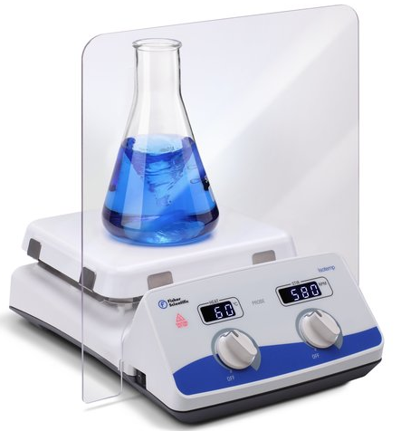
Figure 1. Fisher Scientific™ Isotemp™ Stirring Hotplate

Table 1. The details of Fisher Scientific™ Isotemp™ Stirring Hotplate
surface area heating (cm) | voltage (V) | stirring range (rpm) | electrical requirements  (Hz) | max. temperature (°C) | top plate material
18.4 x 18.4 | 230 | 50 to 1,500 | 50/60 | 540 | ceramic

3.1.2 Calorimeter experiment
The most important principle of experiment is control variables, which means variables that are not studied in experiments need to be controlled, the best way to control them is keep these variables at same conditions or values. Six different barbecue firelighters are made of different materials. Thus, the only variable is different materials, others such as the shape of barbecue firelighters, temperature, the mass or volume of barbecue firelighters and combustion pressure etc. all need to be controlled. However, it is unreasonable that keeping different barbecue firelighters as same mass or volume, because different materials have different density and other physical properties. Therefore, this experiment need to use calorimeter to measure the energy release per gram of different materials, then keeping the energy release at same value to control the experiment variables. IKA Calorimeters C1 (Figure 2) was used in this experiment, The IKA Calorimeters C1 static jacket oxygen bomb calorimeter symbolizes a massive step in calorimeter technology development by featuring a high degree of automation in a compact design. It operates under the instruction of DIN 51900 and ISO 1928. The method of temperature readings refer to the typical isoperibol method of Regnault Pfaundler, the technical data are listed in Table 2⁽⁴⁵⁾.
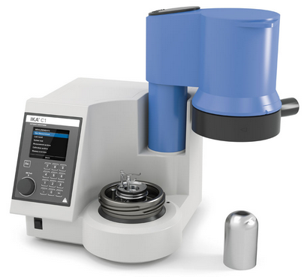
Figure 2. IKA Calorimeters C1
Table 2. Technical data of IKA Calorimeters C1
measurements/h static jacket | 4
permissible ambient temperature max. (°C) | 40
temperature measurement resolution (K) | 0.0001
reproducibility static jacke (RSD) | 0.15%
rec. flow rate at 18°C (l/h) | 55
flow rate min. (l/h) | 50
measuring range max. (J) | 40000
oxygen operating pressure max. (bar) | 40
cooling medium permissible operating pressure (bar) | 1.5
type of cooling | flow
cooling medium | tap water

Two calorimeter accessories were used in this experiment, IKA C10 Acetobutyrate capsules and IKA C 710.4 cotton thread (Figure 3). Filling the capsules with barbecue firelighters, then connect the cotton thread to the calorimeters. A reminder that, the gross calorie value of capsules and cotton thread is 18697J/g and 50J/cotton twist respectively, each capsule has different weight so may has different calorie value, thus, each capsule which will be used need to be weighted and calculate the calorie value, these number need to be set in the calorimeter before experiment started.

In this experiment, each kind of barbecue firelighters was tested twice in order to verify the results and make sure the results were correct. The experiment results are listed in 4.1.2.
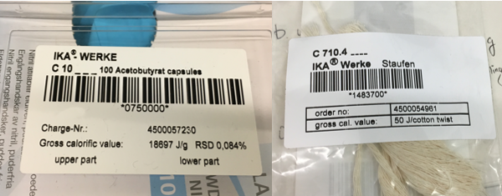
Figure 3. Acetobutyrat capsule and cotton thread

3.1.3 Samples for emission analyzers
Six different barbecue firelighters’ calorie value had been measured, which means the samples for the emission analyzers can be made. As it mentioned before, in order to control variables of following experiments, keeping caloric value of each barbecue firelighters to be same. Another target of these samples is it must burn for more than 3 minutes for instruments collections, theoretically, it would be great if these samples can burn as long as possible.

The first group that was tested is Nature CO₂ Neutral Firelighters, its caloric value can be calculated as the average value of the number, that is:
$$\frac{27970+28798}{2}=28384J/g$$The mass of Nature CO₂ Neutral Firelighters is 5.7813g, so the caloric value is:
$$5.7813×28384=164096J$$
The results of these samples can be seen in 4.1.2

3.2 Emission analyzers

3.2.1 Regulated emissions testing
As is mentioned above, the emissions of barbecue firelighters may include regulated emissions and unregulated emissions. The present emissions regulation mainly focuses on primary pollutants like HC, CO and NO_{x}. Other potential pollutants emissions such as VOCs, carbonyls and PAH etc. is considered to be of such a low level but they do have damage on human health, and these kinds of pollutants are unregulated. Regulated emissions such as CO, CO₂, THC and NO_{x} need to be measured by exhaust gas analyzer. The testing system is made up of emission analysis system, control system and other parts. The exhaust gas analysis system in the test includes MEXA-9400 Motor Exhaust Gas Analyzer and CVS-9100 Constant Volume Sampler of the Japanese Horiba Company (Figure 4). Accurate, repeatable and creative, HORIBA's MEXA-series analytical systems are widely used for the industry as the analyzing standard for emissions analysis⁽⁴⁶⁾. The analyzer is specifically designed to sample and continuously measure the concentration of exhaust gas. HORIBA Automotive Emissions Analyzers includes 6 independent analyzers to measure CO, CO₂, THC and NO_{x} over a wide dynamic range. CO and CO₂ analyzer uses NDIR measuring principle, the measuring range over 5000ppm. THC analyzer uses FID method, which measure range is 10-5000pmm. The NO_{x} analyzer uses CLD to measure the concentration of this gas, the measure range is 20-10000ppm.

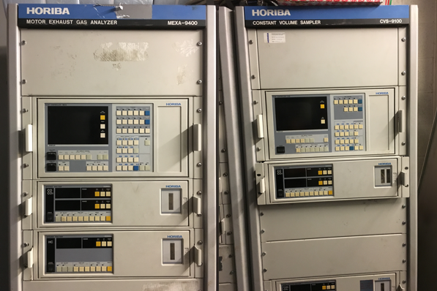
Figure 4. HORIBA MEXA-9400 Motor Exhaust Gas Analyzer and HORIBA CVS-9100 Constant Volume Sampler

3.2.2 Unregulated emissions testing
Unregulated emissions analyzing was using GC-MS method. Agilent 7890B GC and Agilent 5977A MS was used as the emission analyzer (Figure 5). The Agilent 7890B Gas Chromatograph (GC) and 5977A Mass Spectrometry System is the most widely used GC-MS system for research and analyzing, because it provides performance which is not possible in previous GC-MS systems. The 7890B GC features accurate temperature controls and precise injection systems – plus enhanced EPC modules for the best retention times. Besides, the 7890B GC and 5977A MSD internal communication continuously and form a unified system that supports the highest efficiency for this experiment⁽⁴⁷⁾.
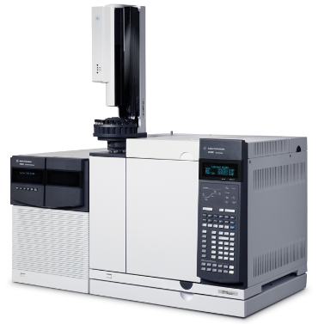
Figure 5. Agilent 7890B/5977A GC-MS

3.3 Experimental setup and procedure

3.3.1 Experiment setup

3.3.1.1 Samples setup
There were six kinds of barbecue firelighters need to be measured in the experiment. Each of them will be prepared for regulated emissions test and unregulated emissions test. According to the controlled variables principle, no matter the samples were used for exhaust gas analyzer or GC-MS analyzer, the caloric value of the samples need to be controlled at 164096J. The barbecue firelighters were weighted and the results can be found in Table 3. Relative error can be calculated by using following equation:
$$relative error=\frac{\left|theoretical mass-pratical mass\right|}{theoretical mass}×100\%$$

Table 3. Samples data for experiments
name | theoretical mass (g) | practical mass for regulated emissions test (g) | relative error | practical mass for unregulated emissions test (g) | relative error
Nature CO₂ Neutral Firelighters | 5.7813 | 5.7823 | 0.02% | 5.7820 | 0.01%
Big-K Eco-Friendly Firelighters | 5.3346 | 5.3350 | 0.01% | 5.3352 | 0.01%
Flamers Firelighter | 5.0038 | 5.0044 | 0.01% | 5.0049 | 0.02%
Tinderflame Quick Start Firelighters | 4.9146 | 4.9155 | 0.02% | 4.9152 | 0.01%
Quickfire Firelighters | 4.0879 | 4.0893 | 0.03% | 4.0888 | 0.02%
Highlander Solid Fuel Tablets | 5.3431 | 5.3438 | 0.01% | 5.3453 | 0.04%

As can be seen from Table 3, the relative error of each barbecue firelighter sample is small, which means the samples’ mass is close to the theory calculation results and it is convincible that using these samples for the next experiments.

3.3.1.2 Instruments setup
Some instruments of experiments had been chosen, for example, the hotplate. The design of the experiment is using the hotplate to heat barbecue firelighters and make it burned, the special barbecue firelighters, Quickfire Firelighters and Highlander Solid Fuel Tablets, would be ignited by the lighter on the hotplate. Then a funnel would be used for collecting the barbecue firelighters emissions, mainly the smoke when barbecue firelighter was burning. After that, the smoke would pass through a filter and went into a pipe for HORIBA exhaust gas analyzer or a syringe to making the samples for GC-MS experiment, HORIBA exhaust gas analyzer has a pump so that the pump will pulling the smoke flow through these instruments, therefore the design is feasible. As for GC-MS experiment, one side of the filter connected with funnel and the pipe, the other side of the filter was sealed by septa. Septa could prevent gas leakage and because it was made of rubber, so the syringe could be inserted into the septa to collect the emissions. The experiment instruments can be shown in Appendices and the schematic diagram can be seen in Figure 6. Barbecue firelighter would be ignite in the petri dish, and the filter would be held by an iron holder. The entire burning process would be done under an evacuator, operator would wear the gas mask, so the experiment would be safe to the operator.
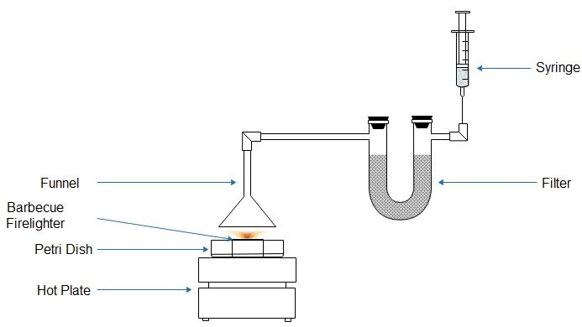
Figure 6. Experiment design

The funnel that was used is a stainless steel funnel. Before connecting all the components together, there were two funnels to choose, one is 50mm diameters funnel and another one is 80mm. Finally, the latter one was used because it would collect more emissions than the former one. The stem diameter of this funnel is 13.8mm and the stem length is 50mm. The connection of funnel and pipe did not use any connectors, because the diameter of the pipe is 14mm, just a little bit bigger than the funnel’s stem. Thermal expansion and contraction principle was used for connecting the funnel and the pipe, they fixed very well and there was no leaks between the funnel and the pipe.

As for the filter, Parker Balston Model 85 Sintered Metal Filter (Figure 7) was used to filtrate particles such as paraffin steam, particulate matter and the carbon included in the barbecue firelighters emissions. The filter container is made of 316 stainless steel with two molded Viton gaskets. Maximum temperature and pressure is 204°C and 14 bar respectively. It is suitable for low pressure applications.
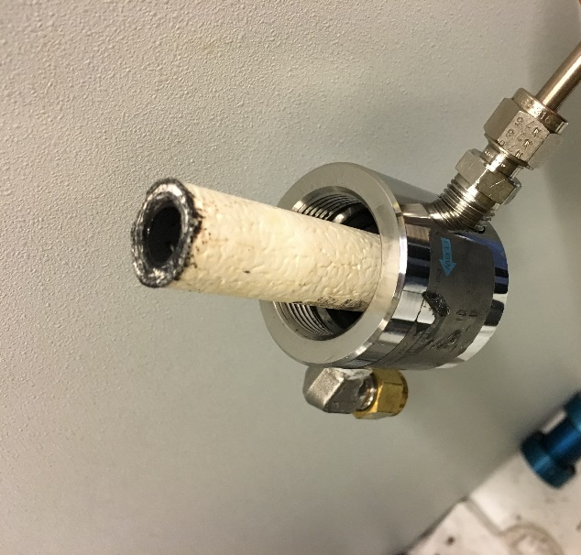
Figure 7. Parker Balston Model 85 Sintered Metal Filter

3.3.2 Regulated emissions experiment procedure
As can be seen in Figure 8, HORIBA emission analyzer connected with the main experiment part. There are 9 kinds of gases need to be delivered into the analyzer during the analyzing process. O₂, N₂, compressed air, He, these 4 kinds of gases should continuous supply all the time and keep the pressure at 2 bar, while others like NO, CH₄, CO₂, CO-HIGH and CO-LOW were only needed at the beginning of the experiment, the pressure of these gases should be kept at 1-1.5 bar.

Before burning the barbecue firelighters, the software on computer should start to record and real-time monitoring the results first, and then start the analyzer and record the time using a timer, timer is used for comparing the time with the record of the software. Next, using hotplate to burn the barbecue firelighter. After finish the experiment, stopping the software and the timer.
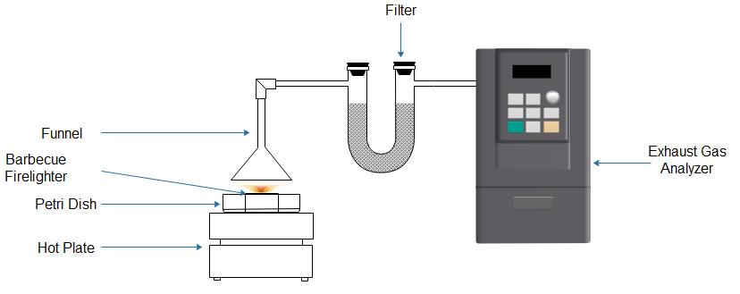
Figure 8. Regulated emissions experiment design

3.3.3 Unregulated emissions experiment procedure
In this experiment, syringe would be used to collect the same volume (30mL) of gas to make the sample for GC-MS. Dichloromethane was the solvent to dissolve PAHs in barbecue firelighter emissions. Dichloromethane is a colorless, volatile liquid with a mild sweet aroma, its high volatility makes it an acute inhalation hazard and it can also be absorbed through the skin. Therefore, the sample making process need to be done in fume cupboard. Same volume (1mL) dichloromethane was measured and filled into the vials. In order to prevent the samples from contamination, syringe and its needle should be changed after finished the experiment of each group. Syringe size is 10mL, which means it needed to inject three times into the vial. Drawing the syringe three times between each injection to make sure the syringe could collect 10mL barbecue firelighter emissions.

GC-MS experiment was using Agilent 7890B/5977A GC-MS which equipped with an Agilent Masshunter Workstation software (version B.06.00). GC-MS experiment setup are listed in Table 4. The SIM mode was used to achieve quick identification of the preselected ion peaks. Identification of the components of the barbecue firelighters samples were carried out by comparing holding times for each component in the samples with standard group under the same experimental conditions. Identification of the compounds was verified by comparing the molecule weight of each component or the retention times of the barbecue firelighters samples with the standard group. Standard group was the sample which consist of several pure PAHs and had been verified by a series of experiments in the laboratory.

Table 4. GC-MS experiment parameters
device | Agilent 7890B/5977A GC-MS
column | RESTEK 17Sil MS 30m×250μm×0.25μm
column control mode | Flow: 1.9899mL/min constant flow  Pressure: 21.2psi  Average velocity: 42.224cm/sec  Holdup time: 1.1842min  Post run: 2mL/min
ALS | Injection volume: 1μL  Injection type: standard 0.2μL  Solvent wash: draw 300μL/min, dispense 6000μL/min  Sample wash: draw 300μL/min, dispense 6000μL/min
inlet | Mode: split  Split ratio: 30:1  Split flow: 39.798mL/min  Heater: 290°C  Pressure: 21.2psi  Total flow: 44.788mL/min  Septum purge flow: 3mL/min  Gas saver: 20mL/min after 2 minutes
carrier gas | Helium
temperature program | Oven temperature: 65°C  Equilibration time: 0.25min  Maximum oven temperature: 340°C  Initial 65°C, hold 0.5min, then from 65°C to 220°C at 15°C/min, hold 1 min, then from 220°C to 330°C at 4°C/min, hold 0.5min

Experiment process are listed in Figure 9, DCM group was the pure Dichloromethane. Before testing standard group, DCM group was tested first because this was the way to confirm the column was not contaminated. After the confirmation, standard group was tested and then DCM group would be injected into the GC-MS again to confirm there was no substances in the standard group remain in the column. Then, the barbecue firelighters sample would be tested till the Quickfire Firelighters sample finished. Next, DCM group would be used for contamination test. Then the last barbecue firelighters sample would be tested and the DCM group would be used again for the final confirmation.

Figure 9. GC-MS experiment process

As it was mentioned above, DCM group was used to confirm the column was not contaminated. Thus, before checking the results of unregulated emissions, the results of DCM group need to be checked first. As shown in Figure 10 (a)-(d), the curves for each DCM group are clean, although there are several small peaks, the area of the peaks can be ignored because the content of these impurities is low compared with the content of experimental product. In general, the DCM group results show that the GC-MS was not contaminated, the results of unregulated emissions was credible.
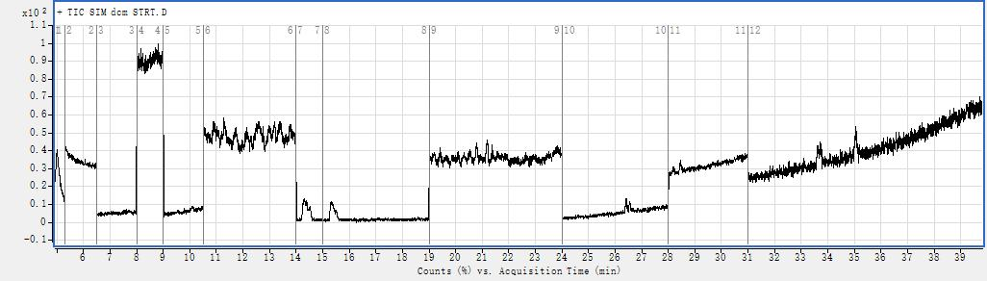
(a)
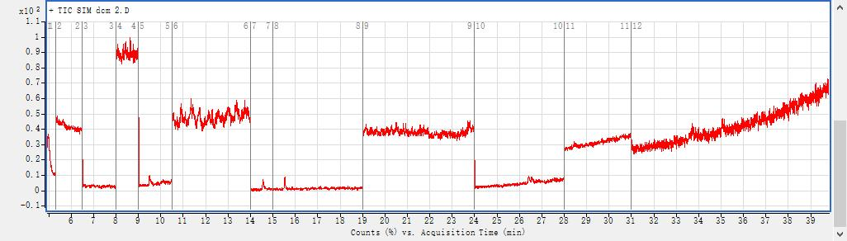
(b)
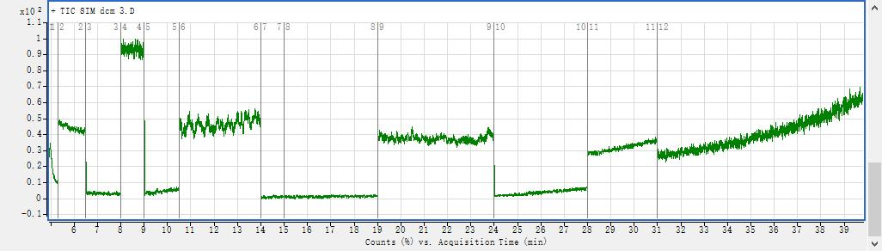
(c)
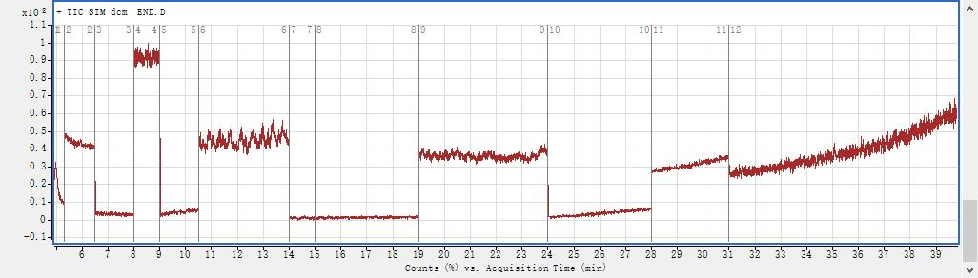
(d)
Figure 10. GC-MS results of DCM group. (a) DCM group at the beginning of GC-MS experiment. (b) DCM group after standard group. (c) DCM group after 5 barbecue firelighers group. (d) DCM group at the end.

The standard group was set to compare with unregulated emissions of barbecue firelighters and identify the PAHs included in barbecue firelighters emissions. There are two ways to identify PAHs in the emissions, one is using different PAHs have different molecule weight to identify different PAHs, but the problem is some different PAHs have the same molecule weight, another one is using the principle of different PAHs have different peak time to identify PAHs. In this GC-MS experiment, two methods were combined for higher accuracy. The composition of standard group can be seen in Table 5 and the GC-MS results of standard group can be seen in Figure 11.

Table 5. The composition of standard sample
compound | molecular weight | peak time (min)
naphthalene | 128.18 | 5.626
acenaphthylene | 152.20 | 8.413
acenaphthene | 154.20 | 8.630
fluorene | 166.23 | 9.468
phenanthrene | 178.24 | 11.319
anthracene | 178.24 | 11.386
fluoranthene | 202.26 | 14.530
pyrene | 202.26 | 15.509
benz(a)anthracene | 228.30 | 20.764
chrysene | 228.30 | 21.157
benzo(b)fluoranthene | 252.32 | 26.352
benzo(k)fluoranthene | 252.32 | 26.515
benzo(a)pyrene | 252.32 | 28.419
indeno(1,2,3-cd)pyrene | 276.34 | 33.579
dibenz(a,h)anthracene | 278.35 | 33.676
benzo(g,h,i)perylene | 276.34 | 35.012

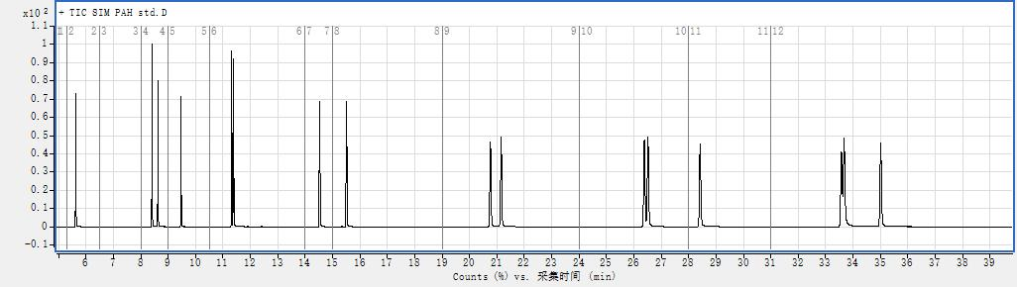
Figure 11. GC-MS experiment results of standard group

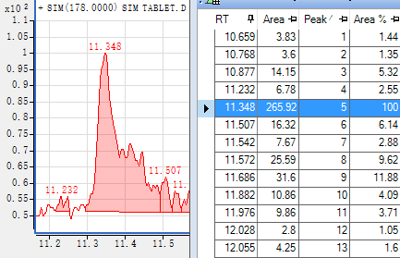
(a)
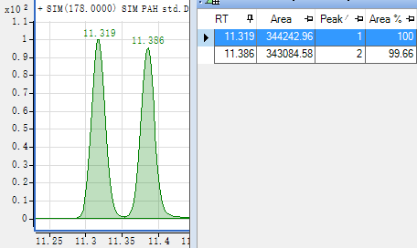
(b)
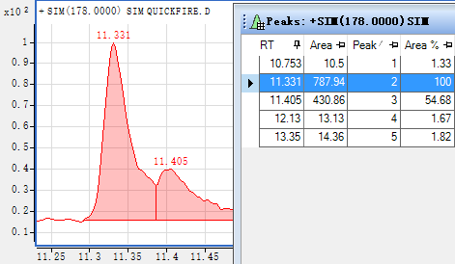
(c)
Figure 12. Comparision among Highlander Solid Fuel, standard group and Quickfire Firelighters. (a) The peak are of Highlander Solid Fuel. (b) The peak area of standard group. (c) The peak area of Quickfire Firelighters

Some principles need to be made during identifing PAHs in the emission of barbecue firelighters because there were plenty of impurities or other unregulated emissions which from barbecue firelighters combustion can be detected by GC-MS. In some results of GC-MS experiment, for example, the results of Highlander Solid Fuel Tablets actually shows 2 peaks, one has been analyzed is acenaphthylene, another one appears between 11 minutes and 12 minutes and the molecule weight is 178. Using Agilent Masshunter to zoom in and there is indeed a peak that much higher than others at 11.348min. But the integration peak list in Agilent Masshunter shows that the area of the peak at 11.348min accounts for 100%, and the area reaches 265.92 which is much higher than the area of the peaks next to it, as shown in Figure 12(a). However, comparing with the area of the peak in standard group, like Figure 12(b) shows, the area of the peak in standard group at this time reaches 344242.96, which is almost 1295 times higher than the area of the peak for Highlander Solid Fuel Tablets. Meanwhile, comparing the area of peak for Highlander Solid Fuel Tablets with other barbecue firelighters, for example, Quickfire Firelighters. As shown in Figure 12(c), the peak area at 11.331min reaches 787.94, which is around 3 times higher than the area of the peak of Highlander Solid Fuel Tablets. Therefore, although the experiment results shows there are 2 peaks, the second peak of Highlander can be ignored because the area of the peak is much smaller than others.

The principle is important to anlayze and identify PAHs in barbecue firelighters emissions. This GC-MS experiment mainly focus on identify PAHs, but the compositions of barbecue firelighters emission are complicated, it may include other substances like VOCs. As the results of GC-MS shows that there are many peaks that are not included in the results of standard group are detected. These peaks may be the imuprities and of course it could be the PAHs that standard dose not included, or it might be other substances.

Results and Discussion

4.1 Experiment preparation

4.1.1 Barbecue firelighter properties
As mentioned above, the properties of six different barbecue firelighters can be seen in Table 6:

Table 6. The compositions and properties of test barbecue firelighters
name | composition | smoke point (°C) | ignition point (°C)
Nature CO₂ Neutral Firelighters | 35% wood fibers and 65% bio oil | 398 | 505
Big-K Eco-Friendly Firelighters | Vegetable wax and renewable resources | 350 | 515
Flamers Firelighter | Wood and paraffin wax | 266 | 517
Tinderflame Quick Start Firelighters | Paraffin, recycled cardboard and combustible oils | 360 | 498
Quickfire Firelighters | Kerosene and wax | 335 | —
Highlander Solid Fuel Tablets | Urotropine | 317 | —

As can be seen from the Table 6, Flamers Firelighter needs the highest temperature (517°C) for its combustion, the ignition point of others except Quickfire Firelighters and Highlander Solid Fuel Tablets are all around 500°C. Quickfire Firelighters and Highlander Solid Fuel Tablets have different properties compared with other barbecue firelighters. They cannot be ignited by hotplate, experiment showed the experiment phenomena was totally different when ignited them with hotplate and lighter. When using a lighter to ignite Quickfire Firelighters and Highlander Solid Fuel Tablets, they would burn and have visible flame and smoke. While using hotplate to ignite them, these barbecue firelighters only released strong smoke and their color changed from white to black, but no visible flame. During the real barbecue activities, visible flame was required to ignite wood and coal. In order to simulate real condition of barbecue activities, these two especial barbecue firelighters need to be ignited by lighter.

4.1.2 Calorimeter experiment
The results of calorimeter experiment can be seen in Table 7.

Table 7. Barbecue firelighters calorimeter experiment results
name | sample weight 1 (g) | calorie value 1 (J/g) | sample weight 2 (g) | calorie value 2 (J/g)
Nature CO₂ Neutral Firelighters | 0.1354 | 27970 | 0.1629 | 28798
Big-K Eco-Friendly Firelighters | 0.1386 | 30755 | 0.1464 | 30766
Flamers Firelighter | 0.1577 | 32257 | 0.1405 | 33341
Tinderflame Quick Start Firelighters | 0.1985 | 33566 | 0.1791 | 33213
Quickfire Firelighters | 0.2072 | 40884 | 0.1895 | 39399
Highlander Solid Fuel Tablets | 0.5028 | 30821 | 0.5130 | 30602

As can be seen from Table 7, calorie values 1 and 2 are quite similar, it shows the experiment was successful and the calorie of barbecue firelighters was measured. After finishing this experiment, the samples for the next experiments can be made.

The practical mass and burning time of six kinds of barbecue firelighters using the same caloric value can be seen in Table 8.

Table 8. The mass of different barbecue firelighters and its burning time
name | average caloric value (J/g) | theory mass (g) | real mass (g) | relative error | burning time (min)
Nature CO₂ Neutral Firelighters | 28384 | 5.7813 | 5.7813 | 0 | 11:06.40
Big-K Eco-Friendly Firelighters | 30760.5 | 5.3346 | 5.3364 | 0.03% | 12:35.98
Flamers Firelighter | 32794 | 5.0038 | 5.0048 | 0.02% | 11:36.51
Tinderflame Quick Start Firelighters | 33389.5 | 4.9146 | 4.9151 | 0.01% | 11:55.39
Quickfire Firelighters | 40141.5 | 4.0879 | 4.0870 | 0.02% | 3:51.40
Highlander Solid Fuel Tablets | 30711.5 | 5.3431 | 5.3442 | 0.02% | 6:28.75

It is manifest from the Table 8 that Quickfire Firelighters burned for the shortest time among these barbecue firelighters, but it still lasted over 3 minutes which is enough for next experiments. It is undeniable that Quickfire Firelighters has the highest average caloric value, more energy will be released compared with other barbecue firelighters with same mass. The relative error gives an indication of how good a measurement is relative to the mass of the thing being measured. In general, the relative error is more reflective of the credibility of the measurement. According to Table 8, the relative error of the mass of different barbecue firelighters is very small, the results of this experiment are acceptable.

4.2 Regulated emission experiment
Figure 13. Regulated emissions of Nature CO₂ Neutral Firelighters

The results of each barbecue firelighter’s emissions are shown in Figure 13-18. Regulated emission experiment mainly measured NO_{x}, THC, CO and CO₂ from the emission of barbecue firelighters, experiment results showed that the time of experiment process which the timer recorded and HORIBA exhaust gas analyzer recorded was relatively same, which means the regulated emission experiment was successful. The experiment process can be divided into three stages, prior stage, fire stage and end stage. Prior stage began at the HORIBA software started to record the experiment results, barbecue firelighters were heated by the hotplate, the temperature of the hotplate was still rising. At this stage, only some visible smoke could be collected by HORIBA. Most importantly, two barbecue firelighters, Quickfire Firelighters and Highlander Solid Fuel Tablets, were different from others, they would be ignited by the lighter directly, so the time of the prior stage would be very short. When the temperature reached the ignition point of barbecue firelighters, the fire stage would start. HORIBA would collect the emissions of barbecue firelighters which came from the flame and smoke. After that, the firelighter would be burned completely, this stage was called end stage.

For Nature CO₂ Neutral Firelighters, according to the timer, the prior stage ended at 5 minutes and 10 seconds, which was around 306 seconds. As can be seen in Figure 13, THC experienced a significant increase from 0 to 306 seconds, while NO_{x}, CO and CO₂ was slightly increased. When the barbecue firelighter started burning, a large amount of CO₂ were measured, CO and THC were also increased rapidly, whereas NO_{x} raised slowly. All of them reached their own peak value during the fire stage. The maximum of THC concentration that can be measured by HORIBA was 5300ppm, the figure describes that THC overflowed from 318 to 376 seconds. Then the regulated emissions concentration declined and closed to 0 at the end of the experiment. The line graph illustrates that mainly THC was emitted from Nature CO₂ Neutral Firelighters compared with NO_{x} (56.073ppm), and CO₂ accounted for 14.553% of the emissions which was much bigger than CO (1.6771%).

Figure 14. Regulated emissions of Big-K Eco-Friendly Firelighters

As for Big-K Eco-Friendly Firelighters, the fire stage began at 3 minutes and 46 seconds, which was around 208s. It can be seen from Figure 14 that THC of the emissions had already reached its own peak before fire stage began, which is different with the former group, and it kept for nearly 150 seconds. CO₂ had a little delay but it reached at high percentage in a short time, CO showed an upward trend at the same time but it dropped quickly after reaching its peak. The percentage of CO (4.1815%) and CO₂ (15.995%) were much higher than Nature CO2 Neutral Firelighters. The same condition also happened to NO_{x}, but the concentration of NO_{x} remained at low level, about 207.09ppm.

Figure 15. Regulated emissions of Flamers Firelighter

Similarly, Flamers Firelighter also had low level of NO_{x} according to Figure 15, approximately at 171.3ppm, even lower than Big-K firelighters. Unlike others trend of the experiment results, some big fluctuation occurred to Flamers Firelighter’s curve. In particularly, the percentage of CO and CO₂ decreased heavily at around 300 seconds. Timer showed the fire stage started at 209 seconds, then the firelighter started burning. The line of THC and CO showed a symmetry trend, which means both THC and CO could have similar increasing and decreasing ratio. In general, the shape of the curve had reached the target of experiment, the peak concentration of CO and CO₂ had been measured by HORIBA, which was 4.9714% and 15.963% respectively.

Figure 16. Regulated emissions of Tinderflame Quick Start Firelighters

On the contrary, Tinderflame Quick Start Firelighters had a very smooth line graph as shown in Figure 16. Just like the firelighters’ name, quick start, THC, NO_{x}, CO and CO₂ all reached their peak value in a short period of time. The fire stage started when 180 seconds passed. Different with other firelighters, the emission of Tinderflame Quick Start Firelighters decrease very fast. As shown in the diagram, after reaching the peak value, THC, CO and CO₂ declined rapidly, especially the percentage of CO plunged to 0 within approximately 100 seconds. For Tinderflame Quick Start Firelighters, CO accounted for 4.767% of the emissions, while CO₂ constituted 13.704% of the emissions. As for NO_{x}, the concentration was still at low level like former barbecue firelighters, approximately 118.58ppm.

Figure 17. Regulated emissions of Quickfire Firelighters

The rest two barbecue firelighters are different with previous four firelighters. As shown in Figure 17, Quickfire Firelighters started burning from 40.29 seconds, THC, CO and CO₂ reached their maximum concentration in a short time, the peak value of CO was 3.7339% while CO₂ accounted for 12.282% of the emissions. High level of regulated emissions continued for about 215 seconds, especially THC and CO₂. NO_{x} reached its peak later when other emissions started to decrease, the peak value of NO_{x} was 587.81ppm, which was over 10 times of Nature CO₂ Neutral Firelighters. THC emissions of Quickfire Firelighters experienced a sharp increase, while the decreasing ratio was much smaller than other barbecue firelighters. THC emission stopped when the Quickfire firelighters burned out, at around 2000ppm. THC contributed the primary concentration of regulated emissions of Quickfire barbecue firelighters.

Figure 18. Regulated emissions of Highlander Solid Fuel Tablets

When it comes to Highlander Solid Fuel Tablets, the flame started at 66.6 seconds, a little later than Quickfire Firelighters, but the concentration of NO_{x} reached its first peak at 105.8 seconds of 1395.4ppm as Figure 18 describes. At the same time, CO₂ soared to 12.656% of emissions. Then followed by THC and CO. A noticeable phenomenon is that high concentration of NO_{x} continued from the start burning stage to the end, the time during NO_{x} emitted was nearly 483 seconds. CO was the gas that latest start emitted but it was the earliest one to end the emit process. Different with other barbecue firelighters, THC increased dramatically at the beginning of the experiment, then it decreased as fast as its increasing ratio, and reached its peak when barbecue firelighter started burning.

Figure 13-18 shows the 4 regulated emissions that included in each different barbecue firelighters. In order to study the same regulated emission of 6 different barbecue firelighters, comparison of each regulated emission of different barbecue firelighters need to be made. The results can be seen in Figure 19-22.

Figure 19 is the percentage of CO among these different barbecue firelighters. It can be clearly seen from the line graph that Flamers Firelighters had the highest percentage of CO (4.9714%) during the experiment. Then followed by Tinderflame Quick Start Firelighters and Big-K Eco-Friendly Firelighters, CO accounted for 4.767% and 4.1815% of the emissions respectively. CO emitted from Quickfire Firelighters and Highlander Solid Fuel Tablets were keeping at medium level, the percentage of CO was 3.7339% and 3.1501%. Nature CO₂ Neutral Firelighters had the lowest percentage of CO, which was 1.9923% of the emissions. However, although Tinderflame Quick Start Firelighters, Flamers Firelighters and Big-K Eco-Friendly Firelighters had higher percentage of CO emissions, they stopped emitting CO in a short while, whereas Quickfire Firelighters and Highlander Solid Fuel Tablets was keeping emitting CO for a long time, 187 seconds for Quickfire Firelighters and 177 seconds for Highlander Solid Fuel Tablets.

Figure 20 shows the percentage of CO₂ of six different barbecue firelighters. As can be seen from the diagram, six different barbecue firelighters all emitted high level of CO₂ which compared with the percentage of CO, especially Big-K Eco-Friendly Firelighters and Flamers Firelighters. These two barbecue firelighters had quite similar CO₂ concentrations, 15.995% for Big-K and 15.963% for Flamers. Then followed by Nature CO₂ Neutral Firelighters and Tinderflame Quick Start Firelighters, the CO₂ accounted for 14.553% and 13.704% respectively. Likewise, Quickfire Firelighters and Highlander Solid Fuel Tablets had the lowest CO₂ emissions, but Highlander was the most durable barbecue firelighters on CO₂ emissions, the CO₂ emission time for Highlander was nearly 500 seconds, and most of the time this kind of barbecue firelighter kept at high level CO₂ emission.

According to the previous figures of each barbecue firelighter, NO_{x} concentration always much lower than THC and most of the time its position is located at the bottom of the line graph. Figure 21 shows the concentration of NO_{x} of different barbecue firelighters. Highlander Solid Fuel Tablets is the most obvious one in the line graph. The figure shows that Highlander Solid Fuel Tablets emitted 1395.4ppm NO_{x} during the experiment process and continued for the longest time, approximately 483 seconds. While Nature CO₂ Neutral Firelighters emitted 61.526ppm NO_{x} and it is the smallest concentration figure among six barbecue firelighters. Quickfire Firelighters is the second one that emitted 587.81ppm NO_{x}. Then followed by Big-K Eco-Friendly Firelighters, the concentration of NO_{x} was 207.09ppm. Besides, Flamers Firelighters and Tinderflame Quick Start Firelighters were located at lowest position and they had similar concentration of NO_{x}, 117.3ppm for Big-K and 118.58ppm for Tinderflame.

As for THC, Figure 22 describes the concentration of THC in the emission of six different barbecue firelighters. It is clear that all the THC of barbecue firelighters overflowed at 5300ppm, but according to the width of peaks and the trend of curves, the peak value of THC can be predicted roughly. In the line graph, Big-K Eco-Friendly Firelighters, Flamers Firelighter and Tinderflame Quick Start Firelighters shows the similar trend of increasing and decreasing, the line graph of them almost overlapped. Nature CO₂ Neutral Firelighters may not stayed at peak concentration of THC for a long time, but it released THC steadily from the experiment start to the end. Similarly, Highlander Solid Fuel Tablets has two peaks in the line graph, but did not keep long time at the peak value. This kind of firelighters emitted THC to the air continually, from the experiment start to the end, around 595 seconds. Quickfire Firelighters is the fastest firelighters that reached the peak of THC emissions, THC reached its peak when the firelighters were burned and it did not have to gradually increase like other barbecue firelighters.
Figure 19. CO concentration of barbecue firelighters
Figure 20. CO₂ concentration of barbecue firelighters
Figure 21. NO_{x} concentration of barbecue firelighters
Figure 22. THC concentration of barbecue firelighters
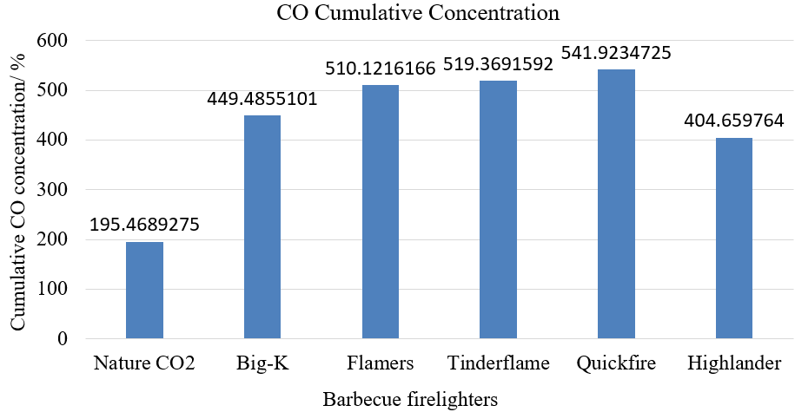
(a)
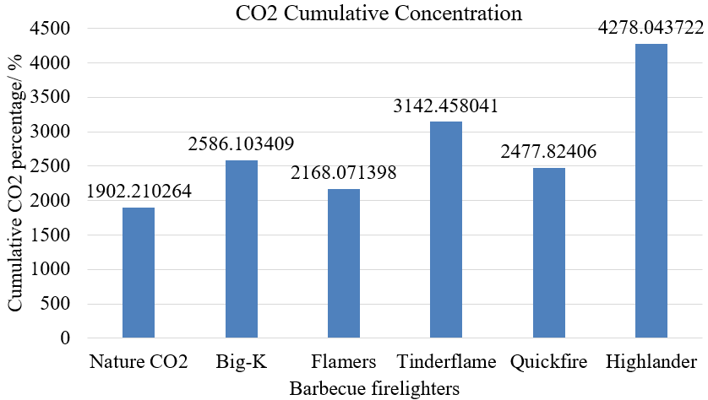
(b)
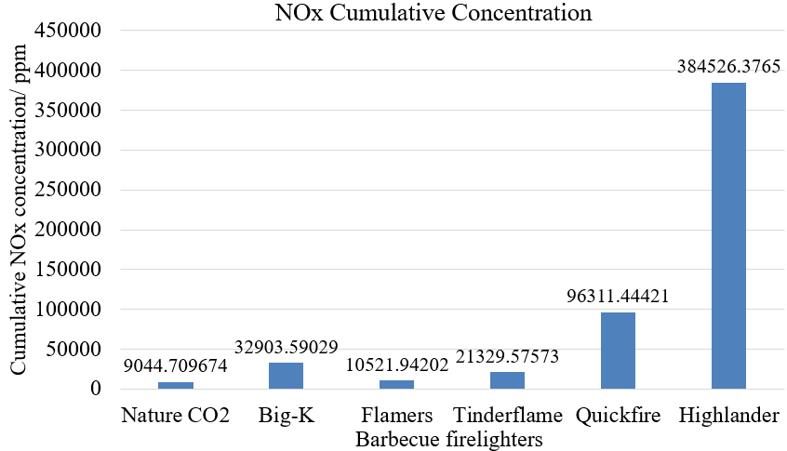
(c)
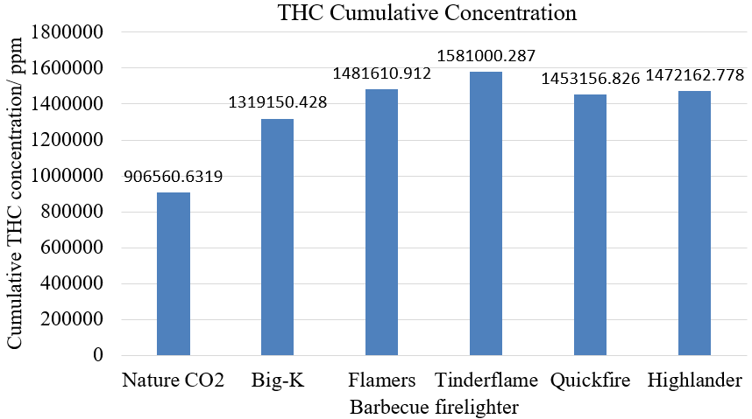
(d)
Figure 23. Cumulative regulated emissions concentration. (a) CO cumulative concentration. (b) CO₂ cumulative concentration. (c) NO_{x} cumulative concentration. (d) THC cumulative concentration.

As shown in Figure 23, the cumulative bar chart is the summation of each regulated emissions from six different barbecue firelighters in 700 seconds, in other words, it is the integral of regulated emission curve and time, it shows the relationship between combustion time and emission concentration. Figure 23(a) shows the CO cumulative concentration of barbecue firelighters, Quickfire Firelighters released the highest amount of CO during its combustion process as expected. Flamers Firelighters and Tinderflame have similar cumulative percentage of CO, then followed by Big-K Eco-friendly Firelighters and Highlander Solid Tablets, while Nature CO₂ Neutral Firelighters emitted the lowest amount of CO during 700 seconds.

Figure 23(b) shows the CO₂ cumulative concentration of barbecue firelighters. Obviously, Highlander Solid Fuel Tablets emitted the highest cumulative percentage of CO₂ in 700 seconds, while Nature CO₂ Neutral Firelighters has lowest CO₂ emission. Tinderflame Quick Start Firelighters emitted the second highest concentration of CO2 during its combustion process. Then followed by Big-K Eco-Friendly Firelighters, Quickfire Firelighters and Flamers Firelighters.

As for Figure 23(c), it is clear that Highlander Solid Fuel Tablets has the highest concentration NO_{x} emission in 700s, around 384526.38ppm NO_{x} was emitted during its combustion process, and it is almost 43 times higher than Nature CO₂ Neutral Firelighters, which has the lowest cumulative concentration of NO_{x} emission (9044.71ppm). Quickfire Firelighters is the second one that emitted 96311.44ppm NO_{x}, then followed by Big-K Eco-Friendly Firelighters and Tinderflame Quick Start Firelighters, they emitted 32903.59ppm and 21329.58ppm cumulative NO_{x} respectively. Flamers Firelighter has 10521.94ppm NO_{x} emissions in 700 seconds.

It can be seen from Figure 23(d) that six barbecue firelighters all emitted high cumulative concentration of THC in 700 seconds, especially Tinderflame Quick Start Firelighters (1581000.29ppm). Flamers Firelighters, Quickfire firelighters and Highlander Solid Fuel Tablets have similar concentration of THC. Then followed by Big-K Eco-Friendly Firelighters (1319150.43ppm). Nature CO₂ Neutral Firelighters has the lowest cumulative concentration of THC, around 906560.63ppm in 700 seconds.

Obviously, a large quantity of CO, CO₂ and NO_{x} were produced when the fire stage began according to Figure 13-18, while THC was emitted during the whole combustion process and might reach its peak value when the flame appeared. The results of regulated emission experiment indicate that CO, CO₂ and NO_{x} have relationship with barbecue firelighter combustion, the concentration of these gases increased when barbecue firelighters started to burn. As for THC, it was produced along with the entire combustion process which may came from the pyrolysis of barbecue firelighters compositions.

It is interesting when the composition of barbecue firelighters and the regulated emissions were connected to study the relationship between them. For example, Flamers Firelighters are made of wood and paraffin wax, this kind of barbecue firelighters have totally different appearance with others, it like the wood slice are glued together by using wax shell. The line graph of Flamers Firelighters is the most unstable one, especially for CO and CO₂. One thing that would be helpful to explain the fluctuation is that Flamer Firelighters has a very thick paraffin wax shell. The paraffin wax shell was supposed to be the reason why the percentage of CO and CO₂ decreased, wood started burning after the wax shell burned which may be protected before the shell burned out, in other words, it was need several seconds to ignite the wood inside of the wax shell. Meanwhile, according to Figure 19 and 20, although CO and CO₂ of Flamers Firelighters fluctuated from high percent to low percent, this kind of barbecue firelighters still emitted the highest percentage of CO and high level of CO₂. Wood combustion is actually the wood cellulose combustion, the molecule formula of wood cellulose is (C₆H₁₀O₅)n. It is clear that wood cellulose only has carbon, hydrogen and oxygen. Wood combustion will release water when the temperature goes to 100°C, when the temperature continue goes up to 180°C, CO, CH₄ and CH₃OH will be released. This is the wood incomplete combustion process, this process may happen when the oxygen for wood combustion is not enough. While the complete process will happen when there has enough oxygen and the temperature of wood combustion is high enough. The productions of wood complete combustion are only CO₂ and H₂O. It can be explained that why Flamers Firelighters, Tinderflame Quick Start Firelighters or even there is only 35% wood contained Nature CO₂ Neutral Firelighters and Big-K Eco-Friendly Firelighters all have high peak percentage of CO and CO₂ emissions.

Although the composition of Big-K Eco-Friendly Firelighters may be the trade secrets and the manufacturer only mentioned vegetable wax and renewable resources, it can be inferred that Big-K firelighters are mainly made of wood. As for Nature CO₂ Neutral Firelighters, 35% wood and 65% biologic oil mainly contributes to CO and CO₂ emissions, according to Figure 19, this kind of barbecue firelighters have lowest percentage of CO in its emissions, this may because the flammable biologic oil plays the role of ignition, it makes the temperature goes up very fast and avoid long time incomplete combustion process, therefore, less CO is produced from the barbecue firelighter combustion. Biologic oil like biologic ethanol releases a lot of CO₂ and H₂O during the complete combustion process, this is the main resource of experiment results.

When it comes to Quickfire Firelighters which are made of kerosene and wax. Kerosene is extracted from petroleum, so it only contains carbon and hydrogen. It explained that why Quickfire Firelighters emissions have the high concentration of THC, CO and CO₂. Thus, wax of Quickfire Firelighters is highly suspected to be the source of NO_{x}, the percentage of NO_{x} in the emissions cannot be ignored. Besides, Quickfire Firelighters have the highest caloric value but the combustion of it only lasts about 5 minutes and 30 seconds under the same caloric value condition. However, according to Figure 17, THC emitted over 5300ppm for over 4 minutes, CO₂ emitted over 10% for nearly 4 minutes, CO emitted over 2% for 2 minutes and 36 seconds and NO_{x} emitted over 300ppm for 3 minutes and 31 seconds. The figure shows this kind of barbecue firelighters emitted all the regulated emissions at very high level during the most of the combustion time which may quite harmful to human health. As for Highlander Solid Fuel Tablets, the molecule formula of urotropine (hexamethylenetetramine) is C₆H₁₂N₄ and it contributes the highest NO_{x} concentration among these six different barbecue firelighters. The most significant emissions from urotropine are THC and NO_{x} because it has high molecule weight of carbon and nitrogen.

In terms of cumulative concentration, although wood based barbecue firelighters have higher peak value of regulated emissions, the cumulative concentration of regulated emissions shows that wood based barbecue firelighters have lower toxic emissions produced during its combustion process, while kerosene and urotropine based barbecue firelighters produced more toxic emissions, especially Highlander Solid Fuel Tablets.

The impact of toxic emissions on human health has been discussed in 2.3. Regulated emissions will damage the lungs and may cause headache, dizziness, vertigo and even death. CO primarily reacts with hemoglobin and HbCO is formed, it will stopping the blood to carrying oxygen and causes adverse effects like human tissue asphyxia. CO₂ is classified as asphyxiant gas, When people exposure at high concentration of CO₂, they will feel headache, vertigo, loss of consciousness, vomiting or even death if there is no oxygen for the people immediately. NO_{x} is the generic term of NO and NO₂ which may combined with water to form nitric acid and nitrite, they will stimulate and corrosive sensitive lung tissue, causing pneumonedema. THC can spread over large area on lung surface and lead to severe necrotizing pneumonia. Meanwhile, hydrocarbons have great effect on respiratory system, central nervous system, gastro intestinal system.

4.3 Unregulated emissions experiment
For Nature CO₂ Neutral Firelighters, the experiment results are shown in Figure 24 (a)-(d).
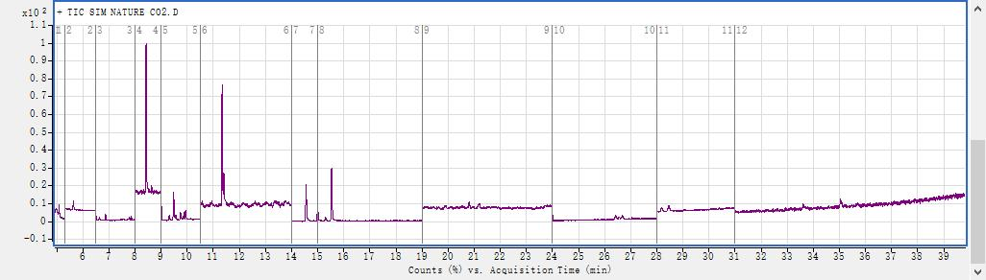
(a)
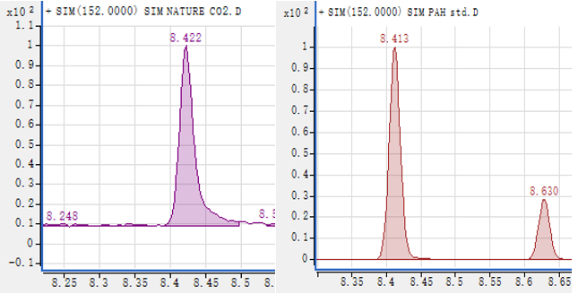
(b)

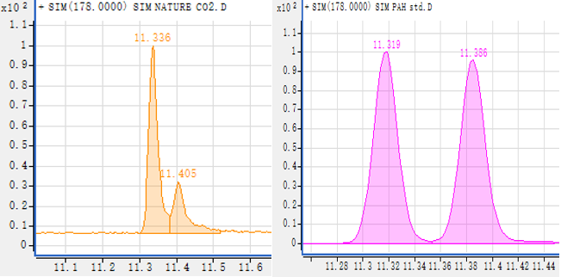

(c)

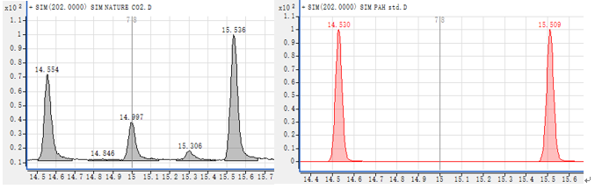
(d)
Figure 24. GC-MS results of Nature CO₂ Neutral Firelighters. (a) Whole experiment results. (b) Peak 152. Firelighters left, standard right. (c) Peak 178. Firelighters left, standard right. (d) Peak 202. Firelighters left, standard right.

According to Figure 24(a), there are mainly 4 peaks in the diagram, the time of peak 1 is between 8min to 9 min. Similarly, peak 2 between 11 min to 12 min, peak 3 between 14 min to 15 min, peak 4 between 15 min to 16 min. It can be seen in Table 5 that peak 1 could be acenaphthylene (8.413min) or acenaphthene (8.630min), so using Agilent Masshunter software to extract chromatograms to identify peak 1. As shown in Figure 24(b), the molecule weight of peak 1 is 152 and the peak time is 8.422min, it is close to standard 8.413min, so it should be acenaphthylene. Then using the same method to identify peak 2, Table 5 shows it could be phenanthrene (11.319min) or anthracene (11.386min), both phenanthrene and anthracene have the same molecule weight (178), so Figure 24(c) shows the peak time of peak 2 is 11.336min and peak 3 is 11.405min, so both of them are included in the emission of Nature CO₂ Neutral Firelighters. Likewise, Table 5 shows it may be fluoranthene (14.530min) and pyrene (15.509min) in peak 3 and 4 respectively, Figure 24(d) shows that the molecule weight of peak 3 and 4 is 202, the peak time of peak 4 and 5 is 14.554min and 15.536min so fluoranthene and pyrene are included in the emissions.

The same analysis of experiment results can be applied to other barbecue firelighters. The experiment results are shown in Figure 25 (a)-(e).
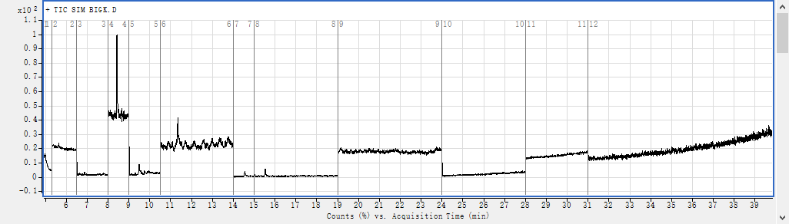
(a)
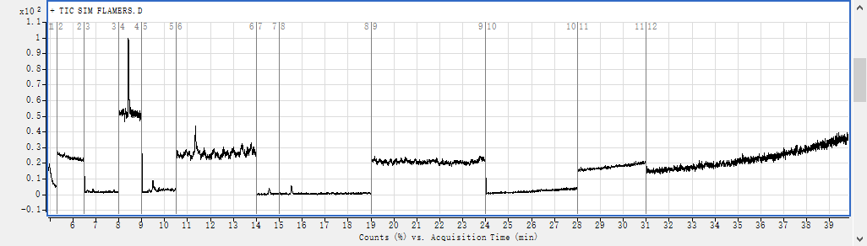
(b)
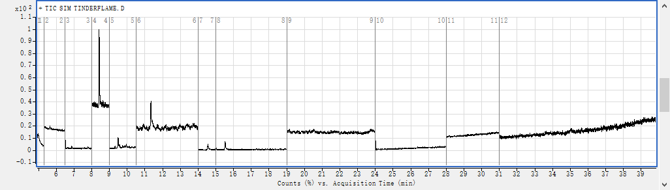
(c)
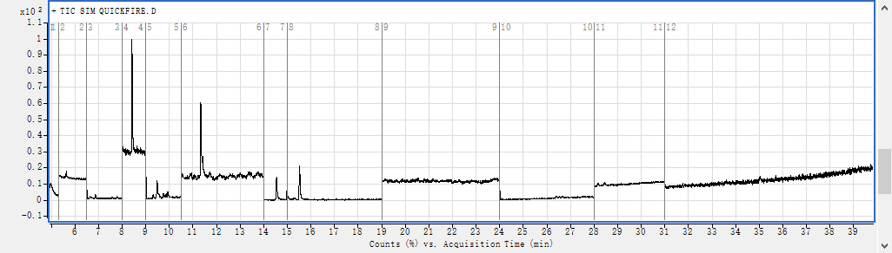
(d)
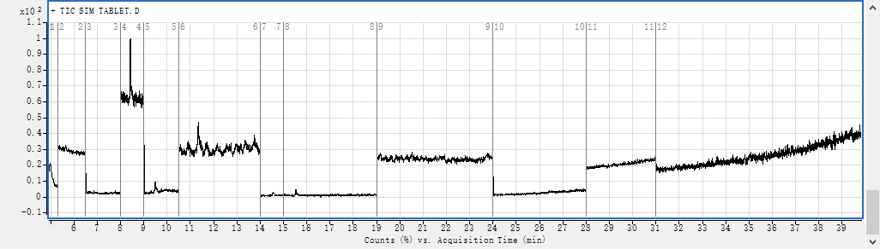
(e)
Figure 25. GC-MS results of Barbecue Firelighters. (a) Big-K Eco-Friendly Firelighters. (b) Flamers Firelighters. (c) Tinderflame Quick Start Firelighters. (d) Quickfire Firelighters. (e) Highlander Solid Fuel Tablets.

It can be seen from Figure 25(a) that the expriment result of Big-K Eco-Friendly Firelighters mainly has 2 peaks in the diagram, the time of peak 1 is between 8min to 9 min. Similarly, peak 2 between 11 min to 12 min. Using the same analysis method and found that it should be acenaphthylene and phenanthrene. For Flamers Firelighters. As shown in Figure 25(b), it mainly has 2 peaks in the diagram, the time of peak 1 is between 8min to 9 min. Similarly, peak 2 between 11 min to 12 min. When using Agilent Masshunter to anlayze it, it can be confirmed that acenaphthylene, phenanthrene and anthracene are included in the emission of Flamers Firelighters.

For Tinderflame Quick Start Firelighters, it can be seen from Figure 25(c) that it mainly has 2 peaks in the diagram, the time of peak 1 is between 8min to 9 min. Similarly, acenaphthylene and phenanthrene are included in the emission of Tinderflame Quick Start Firelighters. For Quickfire Firelighters, according to Figure 25(d), there are mainly 4 peaks in the diagram, the time of peak 1 is between 8min to 9 min. Likewise, acenaphthylene, phenanthrene, anthracene, fluoranthene and pyrene are included in the emissions. For Highlander Solid Fuel Tablets, as shown in Figure 25(e) that there are mainly 1 peaks in the diagram, the time of peak 1 is between 8min to 9 min. Using the same method found that only acenaphthylene included in its emission.

To make the experiment results more clear, Figure 26 is made for discussion.

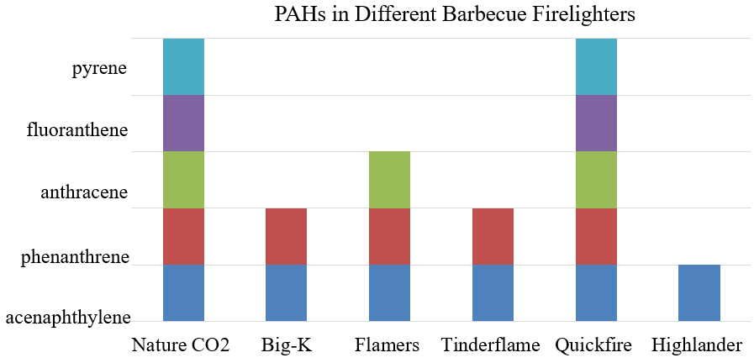
Figure 26. PAHs in different barbecue firelighters emissions

As for the results of GC-MS experiments, research shows PAHs fromed from incompleted combustion of coal, petroleum, wood, tobacco and organic compounds. In general, PAHs are colorless, white or between yellow and green. It have pleasant and faint odor. Typically, people will not expose to one specific PAH, but always a mixture of PAHs. But each of the PAHs in barbecue firelighters emissions will be picked out to study their toxicity and impact on human health.

The toxicity of PAHs on human health has been discussed in 2.3, many PAHs are potentially carcinogenic and mutagenic. Research shows that priority PAHs and their derivatives have a dioxin-like potency. Pyrene is the most important carcinogenic PAHs and is product of combustion processes, plenty of evidence shows that it associated with lung cancer. Long-term expose to PAHs may cause cancer, immunotoxic and respiratory troubles.

Conclusion
The results of regulated emission and unregulated emission experiments show that plenty of toxic emissions will be released when combusting the most commonly used barbecue firelighters.

- Barbecue firelighters release a large quantity of THC, CO₂, and different concentration of CO and NO_{x}.

- The compostitions of barbecue firelightes associate with the toxic emissions, wood based barbecue firelighters mainly contribute to CO and CO₂, paraffin and kerosene based barbecue firelighters will release more THC, firelighters that are made of urotropine will emitting higher concentration of NO_{x}.

- Considering about the toxicity of combustion emissions, high concentration of CO, CO₂, NO_{x} and THC or long-term expose to low level of these toxic emissions will make great damage to human health. Although the concentration of some regulated emissions usually much lower and the combustion time of barbecue firelighters usually short, there is no denying that people will use more than one barbecue firelighter in their barbecue, which means plenty of toxic emissions will be released in a very short time and more damage may caused on human health.

- The suggestion of using barbecue firelighter is it would be better using it outdoors or under a ventilated condition, for example, using the exhauster.

- For unregulated emissions, mainly the PAHs from barbecue firelighter combustion, acenaphthylene, phenanthrene, anthracene, fluoranthene and pyrene were identified from the emissions of barbecue firelighter by using GC-MS.

- The toxicity of PAHs usually appears as a mixture of different PAHs. They were one of the first atmospheric pollutants to be identified as carcinogenic and mutagenic. Long term poisoning of PAHs is barely studied in human and animals, public information shows that the toxicity of most PAHs is inferred from structrally similar substances. The PAHs of experiment results can be absorbed by all routes like inhalation and dermal contact, which means barbecue firelighters emission can easily do damage on human health. However, PAHs are ubiquitous in natural environment, but human activities broke the balance of PAHs in the entironment. Therefore, long term impact of PAHs on human health is more important and meaningful.

- As for barbecue firelighters, the regulated emission and unregulated emission experiment results show that wood based barbecue firelighters have less damage on human health compared with kerosene based and urotropine based barbecue firelighters. From the economic term, wood based barbecue firlighters are expensive, it is good for domestic barbecue activites, but not suitable for commercial use. While kerosene based and urotropine based barbecue firelighters are much cheaper, but the using environment of these kinds of firelighters need to be paid attention to, the damage on human health need to be decreased.

Future work
The future work of this project is using GC-MS to quantify the concentration of PAHs in barbecue firelighters emissions. Identifying PAHs in barbecue firelighters emissions used the area of peaks, these data only illustrates the roughly the contributions among peaks, but it will not shows the specific concentration of each PAH. It would be helpful to comparing the PAHs concentration from the emission of barbecue firelighters if the concentration of PAHs is known. More useful information not only for regulated and unregulated emissions, but also the information for barbecue firelighter selection will be unscrambled. Using mathematics methods to quantify the concentrations of PAHs will make the results more specific, and this reasearch will has more pratical meaning.

On the other hand, the relationship between PAHs emission and the contribution of composition of barbecue firelilghters were barely researched. Papers about PAHs resources only mentioned that it mainly from natural resources such as combustion (forest fires and volcanoes) and biosynthesis (sediment diagenesis, tar pits, and biological conversion of biogenic precursors) , and anthropogenic resources like domestic heating, refuse burning, and agricultural and industrial activities. The future work should pay attention to analyze the contribution of different firelighters’ materials, the results of the research may helpful for environmental pollution control and selecting materials of barbecue firelighters.

References
[1] Pausas, J. G., & Keeley, J. E. (2009). A burning story: the role of fire in the history of life. BioScience, 59(7), 593-601.
[2] “Firelighter” Cambridgedictionary.Com, 2017, http://dictionary.cambridge.org/dictionary/english/firelighter?a=british
[3] Gurjar, B. R., Molina, L. T., & Ojha, C. S. P. (Eds.). (2010). Air pollution: health and environmental impacts. CRC press.
[4] Wu, C. C., Bao, L. J., Guo, Y., Li, S. M., & Zeng, E. Y. (2015). Barbecue Fumes: An overlooked source of health hazards in outdoor settings?. Environmental science & technology, 49(17), 10607-10615.
[5] Kabir, E., Kim, K. H., Ahn, J. W., Hong, O. F., & Sohn, J. R. (2010). Barbecue charcoal combustion as a potential source of aromatic volatile organic compounds and carbonyls. Journal of hazardous materials, 174(1), 492-499.
[6] Huang, H. L., Lee, W. M. G., & Wu, F. S. (2016). Emissions of air pollutants from indoor charcoal barbecue. Journal of hazardous materials, 302, 198-207.
[7] Cooper, J. A. (1980). Environmental impact of residential wood combustion emissions and its implications. Journal of the Air Pollution Control Association, 30(8), 855-861.
[8] Mumford, J. L., Helmes, C. T., Lee, X., Seidenberg, J., & Nesnow, S. (1990). Mouse skin tumorigenicity studies of indoor coal and wood combustion emissions from homes of residents in Xuan Wei, China with high lung cancer mortality. Carcinogenesis, 11(3), 397-403.
[9] Schauer, J. J., Kleeman, M. J., Cass, G. R., & Simoneit, B. R. (2001). Measurement of emissions from air pollution sources. 3. C1− C29 organic compounds from fireplace combustion of wood. Environmental Science & Technology, 35(9), 1716-1728.
[10] Wang, Y. D., Al-Shemmeri, T., Eames, P., McMullan, J., Hewitt, N., Huang, Y., & Rezvani, S. (2006). An experimental investigation of the performance and gaseous exhaust emissions of a diesel engine using blends of a vegetable oil. Applied Thermal Engineering, 26(14), 1684-1691.
[11] Graboski, M. S., & McCormick, R. L. (1998). Combustion of fat and vegetable oil derived fuels in diesel engines. Progress in energy and combustion science, 24(2), 125-164.
[12] Kerosene. (2017, July 23). In Wikipedia, the Free Encyclopedia. Retrieved 14:33, July 26, 2017, from https://en.wikipedia.org/w/index.php?title=Special:CiteThisPage&page=Kerosene&id=791889017
[13] Lam, N. L., Smith, K. R., Gauthier, A., & Bates, M. N. (2012). Kerosene: a review of household uses and their hazards in low-and middle-income countries. Journal of Toxicology and Environmental Health, Part B, 15(6), 396-432.
[14] Dreyfors, J. M., Jones, S. B., & SAYED, Y. (1989). Hexamethylenetetramine: a review. The American Industrial Hygiene Association Journal, 50(11), 579-585.
[15] Kim, K. H., Jahan, S. A., Kabir, E., & Brown, R. J. (2013). A review of airborne polycyclic aromatic hydrocarbons (PAHs) and their human health effects. Environment international, 60, 71-80.
[16] White, P. A. (2002). The genotoxicity of priority polycyclic aromatic hydrocarbons in complex mixtures. Mutation research/genetic toxicology and environmental mutagenesis, 515(1), 85-98.
[17] Mølhave, L. (1991). Volatile organic compounds, indoor air quality and health. Indoor Air, 1(4), 357-376.
[18] Jensen, L. K., Larsen, A., M⊘ lhave, L., Hansen, M. K., & Knudsen, B. (2001). Health evaluation of volatile organic compound (VOC) emissions from wood and wood-based materials. Archives of Environmental Health: An International Journal, 56(5), 419-432.
[19] Omaye, S. T. (2002). Metabolic modulation of carbon monoxide toxicity. Toxicology, 180(2), 139-150.
[20] Blumenthal, I. (2001). Carbon monoxide poisoning. Journal of the royal society of medicine, 94(6), 270-272.
[21] “Nitric oxide: Toxicity - OpenAnesthesia.” Openanesthesia.org, 2017, https://www.openanesthesia.org/nitric_oxide_toxicity/
[22] Sparkman, O. D., Penton, Z., & Kitson, F. G. (2011). Gas chromatography and mass spectrometry: a practical guide. Academic Press.
[23] Caplain, I., Cazier, F., Nouali, H., Mercier, A., Déchaux, J. C., Nollet, V., & Vidon, R. (2006). Emissions of unregulated pollutants from European gasoline and diesel passenger cars. Atmospheric Environment, 40(31), 5954-5966.
[24] Poulopoulos, S. G., Samaras, D. P., & Philippopoulos, C. J. (2001). Regulated and unregulated emissions from an internal combustion engine operating on ethanol-containing fuels. Atmospheric environment, 35(26), 4399-4406.
[25] Mannino, M. R., & Orecchio, S. (2008). Polycyclic aromatic hydrocarbons (PAHs) in indoor dust matter of Palermo (Italy) area: extraction, GC–MS analysis, distribution and sources. Atmospheric Environment, 42(8), 1801-1817.
[26] Jira, W. (2004). A GC/MS method for the determination of carcinogenic polycyclic aromatic hydrocarbons (PAH) in smoked meat products and liquid smokes. European Food Research and Technology, 218(2), 208-212.
[27] “Nature CO2 Neutral Firelighters- Nature of Barbecuing.” Natureofbarbecuing.Com, 2017, http://www.natureofbarbecuing.com/firelighters-and-accessories/nature-co2-neutral-firelighters.aspx
[28] “Big-K Eco-Friendly Firelighters” Bigkproducts.Com, 2017, http://www.bigk.co.uk/Product-Eco-Friendly-Firelighters---FSC-Recycled-100_516.aspx
[29] “Flamers” Certainlywood.Com, 2017, https://www.certainlywood.co.uk/flamers
[30] Mokhatab, S. (2011). Greening of Petroleum Operations: The Science of Sustainable Energy Production.
[31] “Fisher Scientific™ Isotemp™ Stirring Hotplate” Fishersci.co.uk, 2017, https://www.fishersci.co.uk/shop/products/fisher-scientific-isotemp-hotplate-stirrer/15363518
[32] “IKA” Ika.Com, 2017, https://www.ika.com/laboratory-equipment/products/calorimeters/products/2649/c-1
[33] “HORIBA- Standard Emissions” Horiba.Com, 2017, http://www.horiba.com/uk/automotive-test-systems/products/emission-measurement-systems/analytical-systems/standard-emissions
[34] “Agilent Gas Chromatography and Mass Spectrometry Products” Agilent.Com, 2017, http://www.agilent.com/en/products/gas-chromatography/gc-systems/7890b-gc#literature
[35] Goldstein, M. (2008). Carbon monoxide poisoning. Journal of Emergency Nursing, 34(6), 538-542.
[36] Prockop, L. D., & Chichkova, R. I. (2007). Carbon monoxide intoxication: an updated review. Journal of the neurological sciences, 262(1), 122-130.
[37] Williams, H. I. (1958). Carbon dioxide poisoning. British medical journal, 2(5103), 1012.
[38] Law, J., Watkins, S., & Alexander, D. (2010). In-flight carbon dioxide exposures and related symptoms: association, susceptibility, and operational implications. NASA Technical Paper, 216126.
[39] Omidvarborna, H., Kumar, A., & Kim, D. S. (2015). NO x emissions from low-temperature combustion of biodiesel made of various feedstocks and blends. Fuel Processing Technology, 140, 113-118.
[40] Riess, J. (1998). Nox: how nitrogen oxides affect the way we live and breathe. US Environmental Protection Agency, Office of Air Quality Planning and Standards.
[41] Sankar, J. (2010). Hydrocarbon Poisoning. Indian Journal of Emergency Pediatrics, 2(2).
[42] Cooper Sr, A. R. (1996). Cooper's toxic exposures desk reference with CD-ROM. CRC Press.
[43] Roelofs, D., Bicho, R. C., de Boer, T. E., Castro‐Ferreira, M. P., Montagne‐Wajer, K., van Gestel, C. A., ... & Amorim, M. J. (2016). Mechanisms of phenanthrene toxicity in the soil invertebrate, Enchytraeus crypticus. Environmental Toxicology and Chemistry, 35(11), 2713-2720.
[44] Bonnet, J. L., Guiraud, P., Dusser, M., Kadri, M., Laffosse, J., Steiman, R., & Bohatier, J. (2005). Assessment of anthracene toxicity toward environmental eukaryotic microorganisms: Tetrahymena pyriformis and selected micromycetes. Ecotoxicology and environmental safety, 60(1), 87-100.
[45] Šepič, E., Bricelj, M., & Leskovšek, H. (2003). Toxicity of fluoranthene and its biodegradation metabolites to aquatic organisms. Chemosphere, 52(7), 1125-1133.
[46] Hoover, R. (2014). Need to Track Organic Nano-Particles Across the Universe? NASA's Got an App for That. NASA. Retrieved February, 22.
[47] US Department of Health and Human Services. (1995). Toxicological profile for polycyclic aromatic hydrocarbons. Agency for Toxic Substances and Disease Registry, Atlanta, Ge., USA, 19.

Appendices
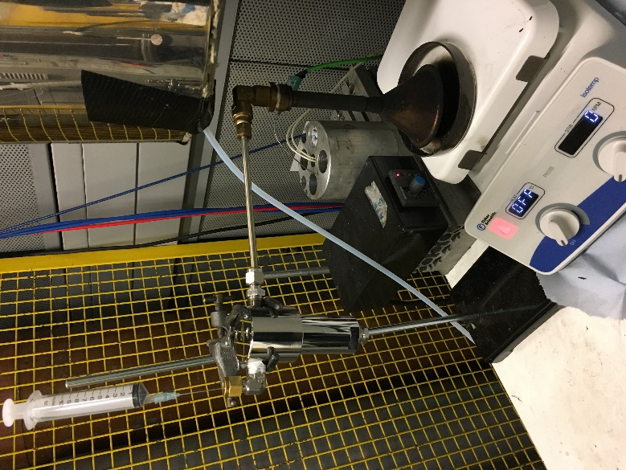
Figure 27. The experimental instruments design

