**How it is for victims?**

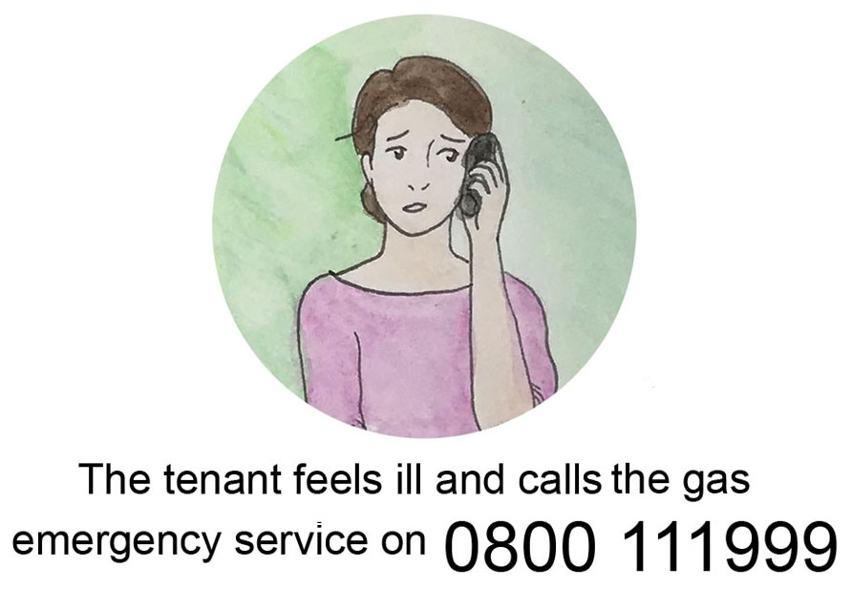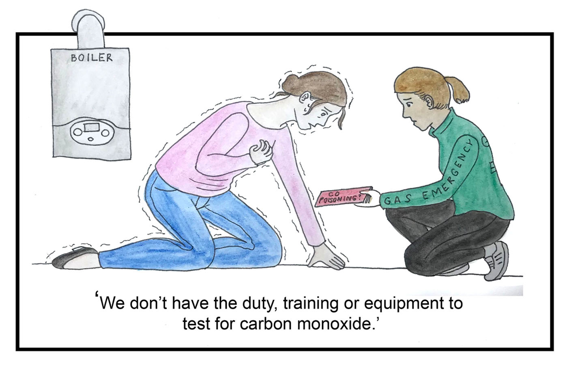

The CO will have usually dispersed by the time the ‘First Call Operator’ (FCO) arrives. The FCO will turn the gas off & check next door but will not reconnect, relight & test gas appliances for CO. The FCO may advise you to go to A&E or your GP.

Over the charity’s 25 years, survivors have consistently told us that breath or blood tests aren’t carried out for several hours, often several days, by which time the CO will have usually left the blood.

If gas work has been done in the last 6 months by a Registered Gas Engineer (RGE), the Gas Safe Register (GSR) will send a GSR inspector to inspect the appliance and test it for CO. The customer needs to request this free service. The GSR will also inspect suspected faults made by a non-registered engineer (<https://tinyurl.com/rxoohoq>).

Pictures by Chihiro, competition winner 2013-14

© Copyright CO-Gas Safety 2020

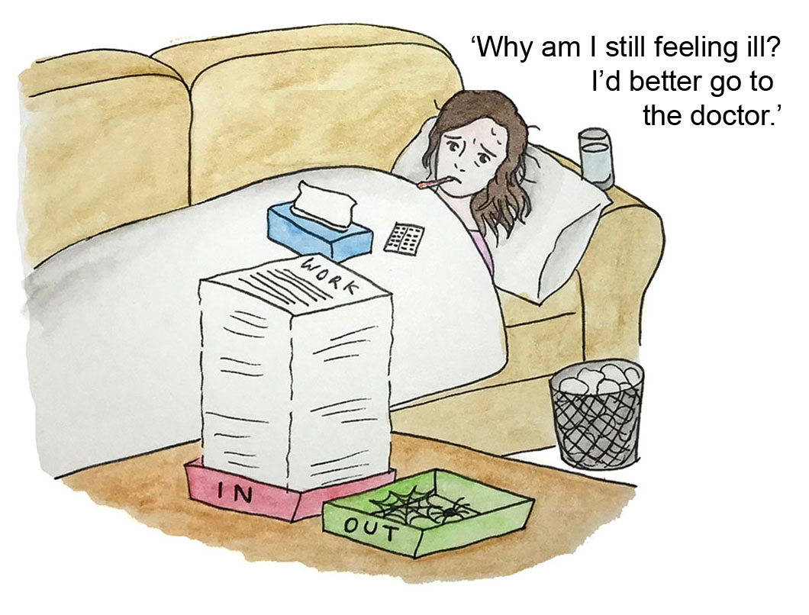

If you suspect a carbon monoxide (CO) leak open all the windows and doors and turn everything off. Unlike gas, you can’t smell, taste, see or hear CO

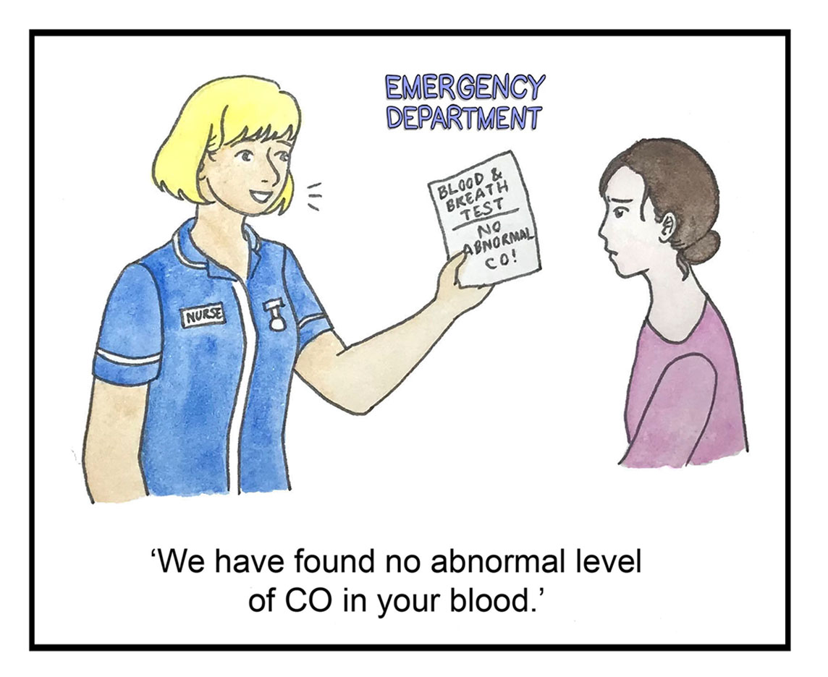

Even when tested negative for CO and with all gas appliances turned off, survivors can report still feeling ill. It can take time for CO to cause injury and/or possible exposure from unsuspected appliance.

