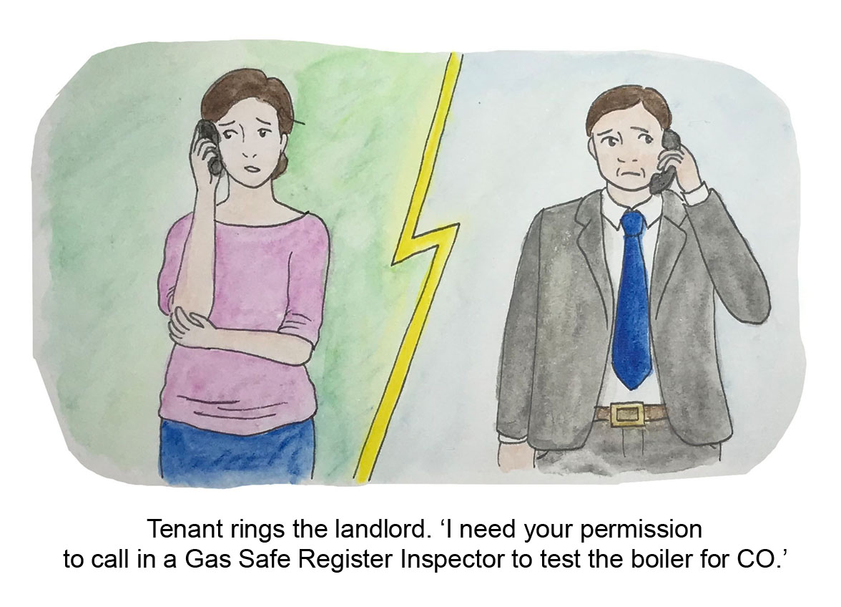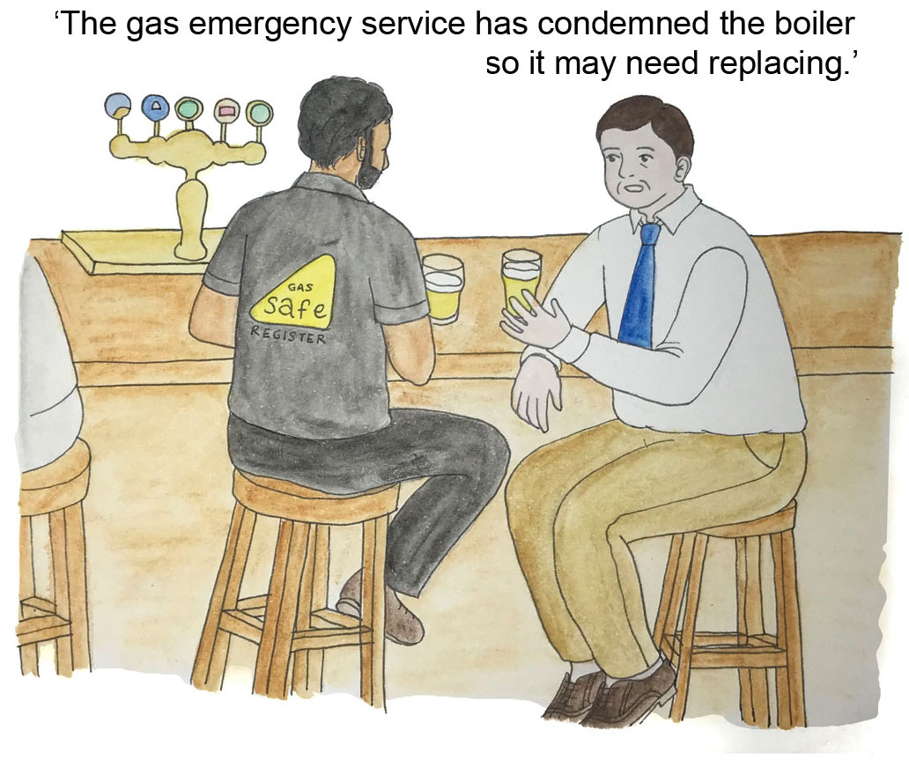

Deaths and injuries from unintentional CO poisoning cost the UK taxpayer £178 million per year (<https://tinyurl.com/tebksgo>).

Simple Government measures could prevent tragedies & cost to taxpayer.

A solicitor won’t generally take on a tenant’s claim for damages unless there is sufficient evidence of CO and its effect on their health. See <https://www.newlawjournal.co.uk/content/co-the-hidden-dangers>

If the survivor is a tenant, the Gas Safe Register inspector will not test an appliance for CO without the landlord’s permission (<https://tinyurl.com/wvppdxg>). Tenants are frightened of being evicted if they ask. RGEs seem to think GSR’s policy applies to them too. Even if tenants do ask, the evidence may disappear. It is almost impossible for the average person to find &/or pay for a qualified independent gas expert to test. for CO.

Servicing/taking the boiler out destroys evidence because the emissions from the appliance & its flue cannot now be tested for CO. It is important for medical treatment to know how much CO a survivor is likely to have been exposed to

in PPM. i.e. Parts Per Million.

Pictures by Chihiro, competition winner 2013-14

© Copyright CO-Gas Safety 2020

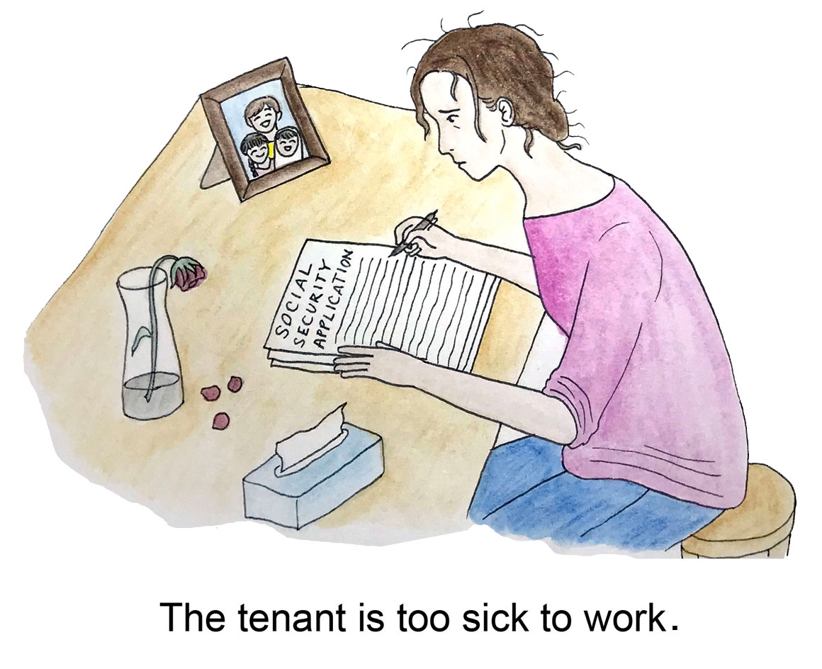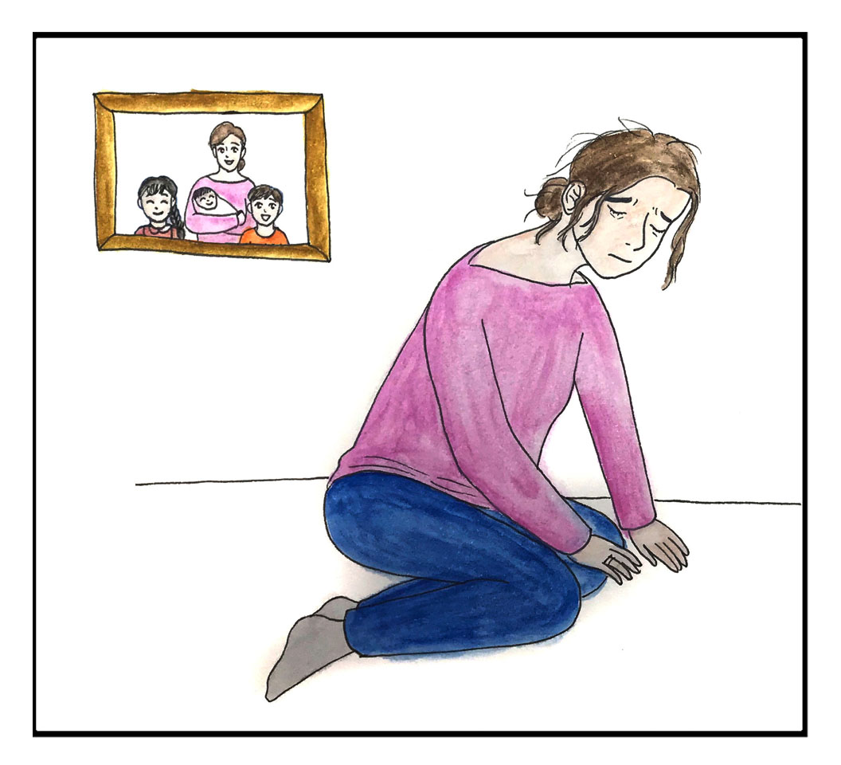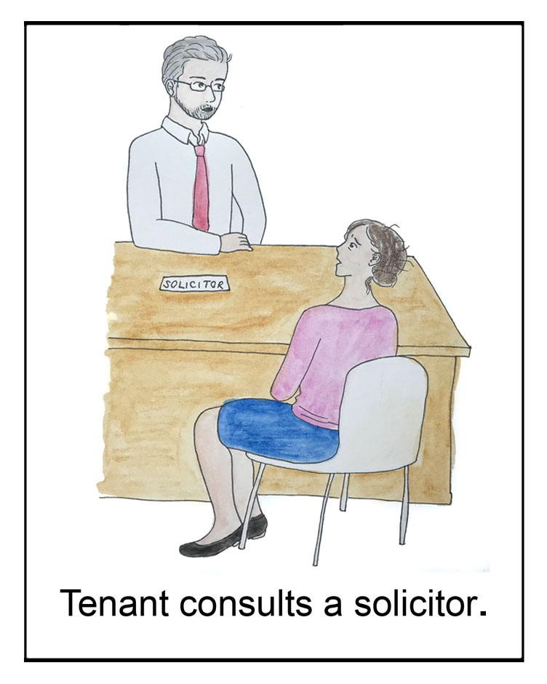

Survivors may become very ill and lose their jobs or housing. They are often disbelieved even by the GP, friends and family. Proof of PPM of CO in writing would change this.

