CO-Gas Safety Unintentional Carbon Monoxide Poisoning Case Study

**SANDRA SMITH, Long-term exposure in 1986**

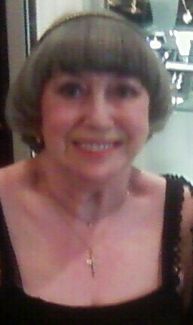**Age:** Exposure at 43, symptoms ongoing for decades

**Fuel:** Mains gas

**Appliance & Location:** Central heating boiler & fire in her home

**Notes by CO-Gas Safety:** Sandra Smith, Carbon Monoxide Support, Barnsley, first contacted Stephanie Trotter around 20 years ago to tell Stephanie about her poisoning. She had been doing what she could to survive and to raise awareness ever since, despite her poor health. Stephanie is very grateful to this survivor for all her support to the work of CO-Gas Safety and also to Stephanie over the years. Sadly, Sandra has recently passed away and her husband has helped us to conclude this case study, initially written by Sandra herself.

*Sandra Smith*

**Thirty years ago – we moved to the house in 1978**

When we moved to the house in 1978 where we are still living in now I had heard that the lady who owned it had been poorly. We had bought and had fitted a new gas fire in 1986, but when it came to be fitted the fitter refused because he said that the flue was not suitable. We had the remedial work done and the fire was duly fitted. Over a 9-month period in 1986/1987, I got what I now believe to be chronic CO poisoning. This started with ‘flu-like symptoms’; also the muscles over my ears were swollen and sore; then I had a red rash down both sides of my neck; a big blotch on my left foot; my tongue was blue and I felt like I was walking on ‘sponge.’ i.e. off balance! Also, my normally shiny hair had gone dull. These symptoms did, however, clear up to some extent when I went on holiday.

Then one day I thought I could smell something from the gas fire. I called a big reputable firm which was CORGI registered and had fitted the fire initially. A man came and did a smoke test to test the flue. I was in the living room and the smoke didn’t go up the flue. The next thing I knew was that I was outside because the fitter had taken me there, because I had fainted. The gas fitter who repaired the fire told me that my symptoms were those of CO poisoning.

**I wasn’t advised to go to a doctor but went eventually because I felt so ill**

The fitter didn’t tell me to go to the doctor but eventually I decided to call one and made an appointment because I felt so ill. However, when I related what had happened to my doctor, he said that he had ‘Seen CO poisoning; it kills you or it doesn’t and it wears off when you get into the fresh air’! In any event he had a ‘plane to catch’! My symptoms were dismissed as ‘psychosomatic’. It was about this time I felt the need to have the doors and windows open, as often as possible. I am pretty sure people, and particularly women, are being sectioned when they are in fact suffering from the effects of carbon monoxide poisoning.

**Referred to a consultant**

I was referred to a consultant in Sheffield, who asked if I had ever worked with toxic chemicals. This was the nearest anyone got to any diagnosis.

**Foreign Accent syndrome**

One of the reasons people couldn’t work out what was wrong was that the damage to my brain caused by CO gave me foreign accent syndrome (please see *www.utdallas.edu/research/FAS*) My accent was a mixture of Scottish, Welsh and Geordie but when I contacted a speech training teacher she told me that I had a lilt and in her opinion was Pakistani, as she had taught enough Pakistani doctors’ children to recognise it. This was over the telephone and she confirmed this again when we met face to face.

**No witnesses or evidence**

Once the gas fire had been put right, I had no witnesses to confirm that the fire had been faulty. Unfortunately, in my opinion I just became part of a ‘cover up’ as, obviously, the fitter who had told me about the CO poisoning was not going to confirm it, in case he lost his job. It was just as if I had committed a crime, instead of having a gas fire fitted!

Several tests were done and the powers that be (the so-called experts) decided that it was the boiler which was at fault, as it had not been serviced for about 14 months. The firm duly serviced the boiler but after about 3 weeks the symptoms returned, so we called them in again. The fitter said that unfortunately the fitter who had serviced the boiler had accidentally punctured a seal with his screwdriver (who says lightning can’t strike twice?).

**My life was ruined**

My health was ruined, my reputation ruined, my marriage ruined, and my life was just about ruined. I was left with a balance problem and muscle problems. I did, however, purchase one of the detectors available then. This consisted of a cardboard strip with a centre piece, which was supposed to change colour in the presence of carbon monoxide!

Over the years I have watched, read and listened to articles about CO poisoning with interest. By the late 1990s I still had balance and muscle problems. By that time though I had acquired two of the new battery-operated detectors, so felt safer. I also had a computer and the Internet was expanding rapidly. I contacted CO-Gas Safety, and they have been a really big help - thank you very much indeed.

**What I have learned**

**(a)**Doctors are taught very little about the effects of toxic gasses. I took articles about chronic CO to doctors but sadly I don’t think they read them, thus compounding their ignorance. In fact I showed a doctor on a home visit an article which Mrs Trotter had emailed to me about a case in Hull, and after reading it she dismissed it by saying, sarcastically in my opinion, ’Oh she is not a professional’ to which my husband replied ‘no, she has just had 20 years’ experience of dealing with cases’.

**(b)** It was around this time, I think, that I discovered that chronic CO poisoning is like having ‘The Bends’. Also, that CO has a ‘Half-life’. This gas halves in the body every four hours for seven days, does its damage, then leaves! A pathologist once told me that whilst this gas remains in your body, you will react to its presence.

**(c)** Apparently, dogs can be a very good indicator of the presence of dreadful CO. If you possess a dog and it suddenly stops lying in front of the gas fire, then you could have a problem. I say this because our dog at the time had stopped lying in front of the fire when it was lit. After it had been put right she was back in front of it again.

**(d)** Always try to have a small window open if you have a gas appliance lit.

**(e)** If you think you have been exposed to CO poisoning, you might try asking your doctor to organise a COHb test at A&E. This way you should be able to prove you’ve been poisoned. I have been told that CO can leave the blood and breath quickly, so there is a danger of a false negative result to this test*.* It is therefore safer to test the appliance if you can. The problem for a survivor is firstly how to find someone to test the appliance with the correct qualifications to give evidence in court later, if necessary, and secondly, how to obtain a test without changing the appliance.

**(g)** Please buy at least one CO alarm to EN 50291 standard from a reputable supplier. However, CO alarms even to EN 50291 are designed not alarm for 120 minutes at about 30 parts per million of CO in the surrounding air. This means that although they seem excellent at saving lives, CO-Gas Safety tells me that they have come across one or two people with a good CO alarm to EN 50291 who have complained of symptoms of CO.

Please also be aware that gas fires and boilers are not the only culprits. We had a kitchen make-over in 1996 and were persuaded to have new gas hobs fitted. We reported to the firm doing the work that we could smell gas when the hob was lit. Despite their best efforts they could not seem to cure the problem and therefore called in an engineer from the suppliers. When he arrived, he opened his toolbox and he had a new universal joint. Once this had been fitted the problem disappeared.

**October 2017 update**

Thirty years have passed now, I have still got a balance problem, muscle problems and also breathing problems! Despite all the publicity and valiant work of dedicated people - trying to get the message across - there is still, it would seem, some of the ‘It will never happen to me’ attitude. It really saddened me recently to read an article in a national newspaper about CO poisoning. It was the same old story - no detector, the doctor didn’t recognise symptoms etc. **Luckily nobody got hurt this time!**

**Thank you**

Thank you for reading this. If you haven’t already got an alarm to EN 50291, I hope you will be encouraged to buy one. After all, my only crime was to have a new gas fire fitted. I found out the hard way that gas fitters are human; they have ‘off days’. They can, and do, make mistakes!

With best wishes, Sandra Smith; a survivor.

**From Robert Smith, Sandra’s husband –** It is now 2019 and since Sandra wrote this she has unfortunately and very sadly passed away. Sandra had previously sent this account to Mrs Trotter but asked her not to publish it straight away because, on reflection, she did not want any publicity. I now, unfortunately, have my own problems inasmuch that I have been diagnosed as having white matter disease in my frontal and parietal lobes, which causes balance problems. Accident and Emergency doctor and CO expert John Henry told Mrs Trotter that he had sent symptoms of CO to 200 GPs and asked what could have caused these symptoms. Many sensible suggestions were made but not one GP suggested CO as a cause.

In 2007 Sandra & I went to one of the CO Awareness Week sessions organised by Lynn Griffiths of CO Awareness. This was held in the Welsh National Assembly in Cardiff. On the same platform was a man in a wheelchair, who related his story. Prior to moving in with his partner he had been fit and healthy but unfortunately there was a problem with a flue in the property and they both suffered chronic CO poisoning, which resulted in him now having to use a wheelchair. At the same meeting, after Sandra had related our experience, a man approached both Sandra and I and introduced himself as being from the Federation of Small Installers. He said that when that particular gas fire was being brought on to the market they tried to stop it, as they knew it could cause problems. He tried hard to raise this issue with the authorities but got nowhere.

When we got back from Cardiff, I went to work the next day. During the day Sandra rang me to say that she was switching the boiler off because she was experiencing CO symptoms. It was at this point that we decided enough was enough and that we were going to go all electric. Fortunately it was a relatively mild winter as we did not get the new boiler installed until May. One man, supposedly a surveyor, had the effrontery to say that you can’t get CO poisoning from the new combi boilers – naturally his firm did not get the job, and I sent him away with a flea in his ear.

Sandra has tried to highlight the problems of CO poisoning and was doing so even when she was in hospital. Let us hope the message went home to some of the people she spoke to.

At least you shouldn’t get CO poisoning from an electric boiler and, even though they are costlier to run, we had peace of mind. When the old boiler was eventually taken out we discovered that there was a split in the seal, and one of the prongs on the flue outlet had broken off and birds had been getting into the back of the boiler, which was evidenced by feathers and bird crap. The house is now all electric and the gas meter has been removed.

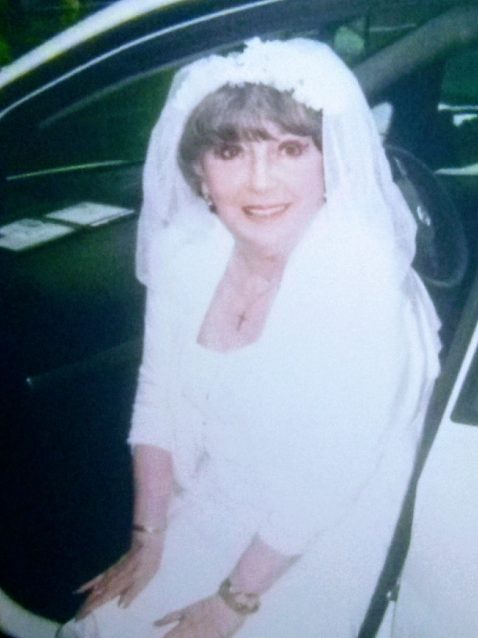This picture was taken about 5 years ago when Sandra was 71 years old and it was for a *Sound of Music* screening. Sandra decided to go as the bride since her own wedding dress was styled on the one in the film.

Robert Smith

**Note by Stephanie Trotter, CO-Gas Safety** Doesn’t Sandra look stunningly beautiful in this picture? She was always brave & caring: a good friend to the charity, to the cause of raising awareness of the dangers of carbon monoxide poisoning and a good friend to me. She cheered me when I was depressed at the lack of progress in preventing these avoidable tragedies.

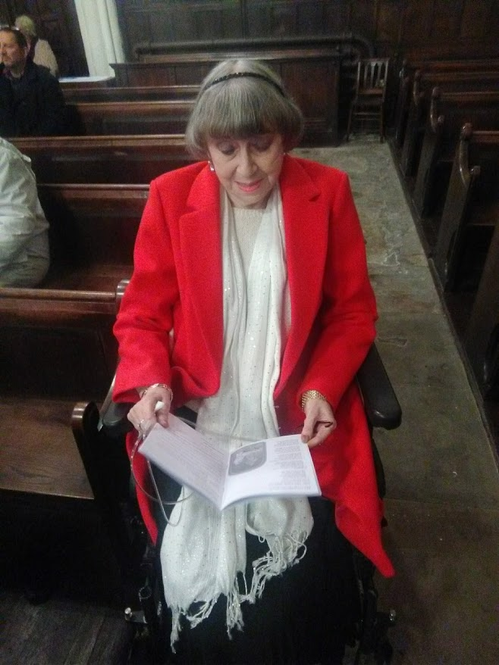

Sandra Smith at a carol service in December 2018 - she will be greatly missed