Avoid dying or being injured from carbon monoxide poisoning
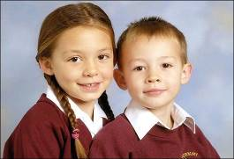

Christi and Bobby Shepherd tragically died of carbon monoxide in 2006 in Corfu while on a Thomas Cook holiday.

What is carbon monoxide (CO)?

A deadly gas that can be emitted from faulty cooking, heating or any other appliances (e.g. generators) powered by any carbon based fuel that burns.
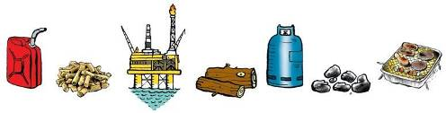

Fuels include gas, coal, wood, petrol, diesel etc.

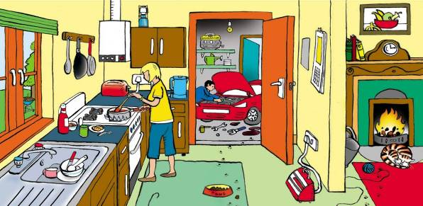

Can you identify potential sources of carbon monoxide in the picture above? For the answers go to http://www.co-gassafety.co.uk/answers/

CO cannot be sensed using human senses of smell, taste, sight or touch.

Less than 2% of CO in the air can kill in between one and three minutes.

http://www.hse.gov.uk/foi/internalops/hid_circs/technical_osd/spc_tech_osd_30/spctecosd30.pdf

(Paragraph 74 table 23 page 26)
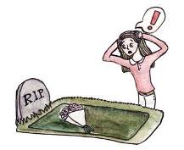

Firefighters when talking about CO in smoke (which you can smell) say it takes only three breaths, the first you don’t know

there’s a problem, the second you might suspect there’s something wrong but by the third you are unable to take any action.

CO alone being emitted from cooking and heating appliances* has no smell .
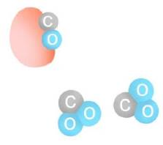
* or anything powered by carbon based fuel e.g. pressure washers powered by gasoline with electric start that can accidentally start by itself see https://tv6.news/recall-warning-this-popular-power-washer-can-accidentally-poison-you/

Why is CO so lethal?

Because it binds to the haemoglobin in the blood which normally carries oxygen so it suffocates.

What is the difference between CO and CO2?

CO2 consists of one atom of carbon and two of oxygen.

CO also contains one atom of carbon but only one atom of oxygen. CO is emitted when there is a lack of oxygen at the flame.
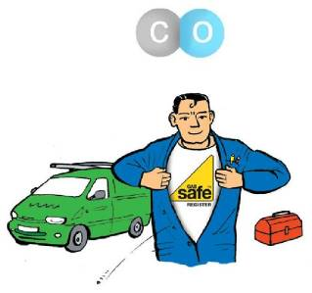

How do you prevent CO in your home?

- Install all cooking and heating appliances correctly according to manufacturer’s instructions using properly qualified people. With gas they must be Gas Safe Registered and qualified to work on your type of appliance.

- Maintain your appliances regularly according to manufacturer’s instructions using qualified people.

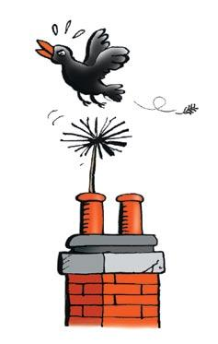
- Have chimneys and flues swept and checked by a sweep
belonging to a recognised trade organisation.

- Ensure adequate ventilation. Don’t block grilles which were put in to ventilate a fire etc.

- As an extra safeguard (e.g.to protect against a bird’s nest falling down the chimney) buy and fit a CO alarm to EN 50291 from
a reputable supplier.

Low levels of CO over a long period can make people ill but GPs rarely diagnose this as CO. Symptoms of low level poisoning include:-
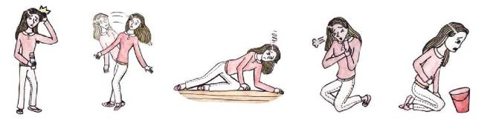

HEADACHES DIZZINESS TIREDNESS BREATHLESSNESS NAUSEA

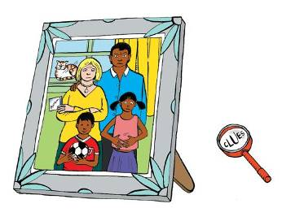
and generally feeling unwell & depressed similar to many viral illnesses including Covid-19.

Different members of the family can suffer different symptoms

Please make sure you’re safe from CO and other products of combustion.

In an emergency, please ring 0800 111 999
for the Gas Emergency Service but
please be aware they do not test the air or
emissions from gas appliances for carbon monoxide as standard.

Please watch our one minute film about Sue who had carbon monoxide poisoning – could save your life or that of a loved one http://www.co-gassafety.co.uk/one-survivors-story/ & see our animation https://drive.google.com/file/d/1KA6tdwlDml0-yZtmJm4B8SQR0V_E72jz/view?usp=sharing

Open air carbon monoxide poisoning – deaths in the USA – boats/swim platforms
Little Andy Free, aged nine, had been “curled up” at the back of his family’s Malibu Skier at Lake Eufaula in Oklahoma in early June 2020, “slowly dying” of open air carbon monoxide poisoning his devastated mom wrote on Facebook https://tinyurl.com/yv5ndsj7

CO-Gas Safety is an independent registered charity run almost entirely by volunteers, offering free and confidential help and advice to victims and their families.

We are especially interested in helping those who have lost a loved one or who are suffering. To get in touch please email office@co-gassafety.co.uk

You can also telephone or text Stephanie Trotter on 07803 088688. If she can’t talk to you, please leave your name, number and email address and she will call you back. Stephanie will do her utmost to contact you and help, especially in emergencies & for anyone who has lost a loved one.
Stephanie will try to be accessible to help you at all times, but if she is not available you can contact a solicitor for free initial legal advice. It is vital to preserve evidence. Please see contact details which we will put up if necessary on our website at www.co-gassafety.co.uk
Account of the Corfu case by Stephanie Trotter OBE
Back in 2006 and before CO was announced as a cause of death of Christi and Bobby, I telephoned the hospital in Greece to suggest testing the dead children and, if the cause of death was CO, I urged that hyperbaric oxygen be given to the father Neil Shepherd and his then fiancé Ruth Beatson. Those I spoke to said they didn’t speak English so a Greek friend kindly tried but also with little success. I telephoned the relatives with the same advice and spoke to Ruth’s father who kindly reminded me about this at the inquest.
Later, I recommended that gas expert Harry Rogers undertake an examination of the boiler that killed the children. Harry gave evidence at the inquest. I also recommended the barrister, Leslie Thomas, now QC. In our opinion, without Harry’s evidence, Leslie’s skill and the parents’ courage and determination, the facts would not have emerged. I also wrote to the British police on the 3rd November 2006.

This all arose from our experience of victims who, not knowing what to do, called to ask for independent and impartial help.

The inquest verdict was unlawful killing and the jury found a breach of Thomas Cook’s duty of care. For more on the case, please go to the following links:
http://news.sky.com/story/goodwill-payout-to-family-of-corfu-children-10358646
http://www.independent.co.uk/news/business/analysis-and-features/carbon-monoxide-deaths-from-a-tragedy-to-a-corporate-disaster-for-thomas-cook-10259735.html
The Coroner made his recommendations public on 6th October 2015
http://www.co-gassafety.co.uk/corfu-inquest-hm-coroner-david-hinchliffs-reg-28-report-to-prevent-future-deaths/

CO-Gas Safety almost certainly has the best data on unintentional deaths and injuries from CO from all fuels in the UK from 1995.The charity received £50,000 in 2015 from Thomas Cook thanks to the parents of the Corfu children. However, the charity’s costs are roughly £30-35,000 a year and that is with it being run almost completely by volunteers with a little paid help for the data. However, the charity’s costs are approx. £35,000 and is run completely by volunteers except for the help we use to collate our data. We received £100,000 from a donor at Christmas 2020. Please see http://www.co-gassafety.co.uk/information/co-gas-safetys-statistics-of-deaths-and-injuries/ and download our years of data from 1995 & our pie charts, updated yearly.

CO-Gas Safety has lobbied for public warnings about CO since 1995.
Company Registration No. 03084435 Charity Registration No. 1048370

Sponsored by Kane International

Illustrations of CO symptoms and grave by competition winner Chihiro.
All other illustrations by John O’Leary http://www.johnolearyillustration.co.uk
©Copyright CO-Gas Safety 2021

For further information please see www.co-gassafety.co.uk
Email office@co-gassafety.co.uk

