
Avoid dying or being injured from carbon monoxide poisoning


Christi and Bobby Shepherd tragically died of carbon monoxide in 2006
in Corfu while on a Thomas Cook holiday.

What is carbon monoxide (CO)?

A deadly gas that can be emitted from faulty cooking, heating or any other appliances (e.g. generators) powered by any carbon-based fuel that burns.
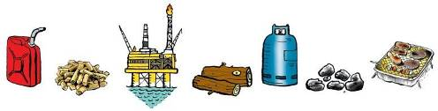

Fuels include gas, coal, wood, petrol, diesel etc.

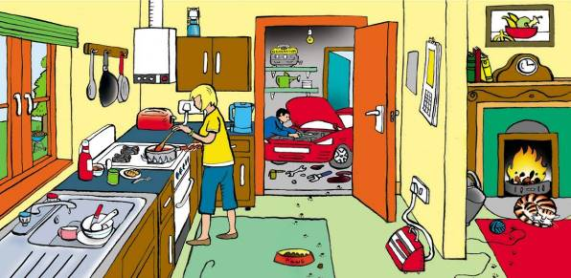

Can you identify potential sources of carbon monoxide in the picture above? For the answers go to http://www.co-gassafety.co.uk/answers/

CO cannot be sensed using human senses of smell, taste, sight or touch.

Less than 2% of CO in the air can kill in under three minutes.
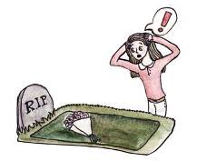
http://www.hse.gov.uk/foi/internalops/hid_circs/technical_osd/spc_tech_osd_30/spctecosd30.pdf
(Paragraph 74 table 23 page 26)

Firefighters, when talking about CO in smoke, say it takes only three breaths; the first you don’t know there’s a problem,
the second you might suspect there’s something wrong,
but by the third you are unable to take any action.

However, it is the smoke that they can smell, not CO.
When CO alone is emitted from cooking and heating appliances,
there is no smell to warn you.

And remember, CO is also produced by engines and other appliances that burn petrol, diesel or liquid fuels (power tools, vehicles, camping equipment).

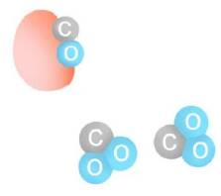
Why is CO so lethal?

Because it binds to the haemoglobin in the blood which normally carries oxygen so it suffocates.

What is the difference between CO and CO²?

CO² consists of one atom of carbon and two of oxygen.

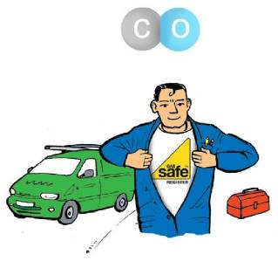
CO also contains one atom of carbon but only one atom of oxygen. CO is emitted when there is a lack of oxygen at the flame.

How do you prevent CO in your home?

- Install all cooking and heating appliances correctly, according to manufacturer’s instructions and using properly qualified people. With gas, UK law states that they must be Gas Safe Registered and specifically qualified to work on the type of appliance you have (cooker, fire, boiler etc).

- Maintain your appliances regularly, according to manufacturer’s instructions and using qualified people. The training and registration body for solid fuel is Hetas (www.hetas.co.uk) and for oil is Oftec (www.oftec.co.uk).
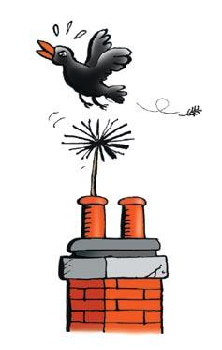
- Have chimneys and flues swept and checked by a sweep
belonging to a recognised trade organisation.

- Ensure adequate ventilation. Don’t block grilles which were put in to ventilate a fire, i.e. provide oxygen.

- As an extra safeguard (e.g.to protect against a bird’s nest falling down the chimney) buy and fit a CO alarm to BS EN 50291 bought direct from a reputable supplier NOT the internet. Get the alarm out of the box and pull the tab to connect the battery. There are now CO alarms with downloadable data & audio links e.g. AICO.

Low levels of CO over a long period can make people ill but GPs rarely diagnose this as CO. Symptoms of low level poisoning include:-

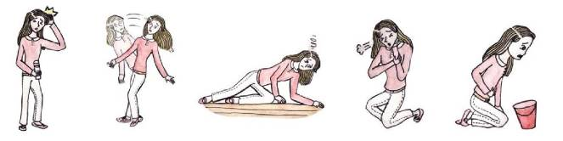

HEADACHES DIZZINESS TIREDNESS BREATHLESSNESS NAUSEA

and generally feeling unwell & depressed similar to many viral illnesses including Covid.
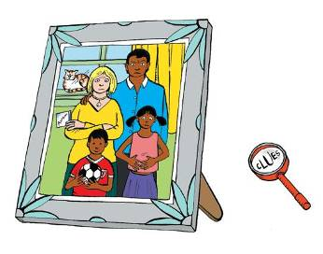
Different members of the family can suffer different symptoms

Please make sure you’re safe from CO and other products of combustion.

In an emergency, please ring 0800 111 999
for the Gas Emergency Service but please be
aware they do not test the air or emissions from
gas appliances for carbon monoxide as standard.

Please watch our one-minute film about Sue who had carbon monoxide poisoning – could save your life or that of a loved one.
https://www.co-gassafety.co.uk/one-survivors-story/
see our animation here https://www.co-gassafety.co.uk/animation/
For case studies see https://www.co-gassafety.co.uk/case-studies/

Open air carbon monoxide poisoning – 2 in the UK on land & 4 deaths in the USA which were boats/swim platforms etc. e.g. Maisy Livingston aged 11 sat too close to a boat engine emitting carbon monoxide and then fell overboard into a Wisconsin lake, losing her life. https://www.themirror.com/news/us-news/autopsy-finds-strange-cause-death-1314653
CO-Gas Safety is an independent registered charity run almost entirely by volunteers, offering free and confidential help and advice to victims and their families.
We are especially interested in helping those who have lost a loved one or who are suffering. To get in touch please email office@co-gassafety.co.uk

You can also telephone or text Stephanie Trotter on 07803 088688. If she can’t talk to you, please leave your name, number and email address and she will call you back. Stephanie will do her utmost to contact you and help, especially in emergencies & for anyone who has lost a loved one.
Stephanie will try to be accessible to help you at all times, but if she is not available you can contact a solicitor for free initial legal advice. It is vital to preserve evidence. Please see contact details which we will put, if necessary, on our website at www.co-gassafety.co.uk

Account of the Corfu case by Stephanie Trotter OBE
Back in 2006 and before CO was announced as a cause of death of Christi and Bobby, I telephoned the hospital in Greece to suggest testing the dead children and, if the cause of death was CO, I urged that hyperbaric oxygen be given to the father Neil Shepherd and his then fiancé Ruth Beatson. Those I spoke to said they didn’t speak English, so a Greek friend kindly tried but also with little success. I telephoned the relatives with the same advice and spoke to Ruth’s father who kindly reminded me about this at the inquest.
Later, I recommended that gas expert Harry Rogers undertake an examination of the boiler that killed the children. Harry gave evidence at the inquest. I also recommended the barrister, Leslie Thomas, now KC. In our opinion, without Harry’s evidence, Leslie’s skill and the parents’ courage and determination, the facts would not have emerged. I also wrote to the British police on the 3rd November 2006.
This all arose from our experience of victims who, not knowing what to do, called to ask for independent and impartial help.
The inquest verdict was unlawful killing and the jury found a breach of Thomas Cook’s duty of care. For more on the case, please go to the following links:
http://news.sky.com/story/goodwill-payout-to-family-of-corfu-children-10358646
http://www.independent.co.uk/news/business/analysis-and-features/carbon-monoxide-deaths-from-a-tragedy-to-a-corporate-disaster-for-thomas-cook-10259735.html
The Coroner made his recommendations public on 6th October 2015
http://www.co-gassafety.co.uk/corfu-inquest-hm-coroner-david-hinchliffs-reg-28-report-to-prevent-future-deaths/

CO-Gas Safety almost certainly has the best data on unintentional deaths and injuries from CO from all fuels in the UK from 1995.The charity received £50,000 in 2015 from Thomas Cook thanks to the parents of the Corfu children. However, the charity’s costs are roughly £30-35,000 a year and that is with it being run almost completely by volunteers with a little paid help for the data. We received £100,000 from a donor at Christmas 2020. After being morally supported almost from launch, we are now being financially supported by Kane International with a regular sum every month which is most helpful. Please see http://www.co-gassafety.co.uk/information/co-gas-safetys-statistics-of-deaths-and-injuries/ and download our years of data from 1995 & our pie charts, updated yearly.

CO-Gas Safety has lobbied for public warnings about CO since 1995.
Also, for the gas emergency service to have a legal duty to test for CO.
We are lobbying for testing for CO whenever practicable.
Company Registration No. 03084435 Charity Registration No. 1048370


Sponsored by Kane International
Illustrations of CO symptoms and grave by competition winner Chihiro.
All other illustrations by John O’Leary http://www.johnolearyillustration.co.uk
©Copyright CO-Gas Safety 2024

Further information www.co-gassafety.co.uk Email office@co-gassafety.co.uk

